Harmonic Analysis of a Three phase Electric Arc Furnace
in Electrical Power System

Amarjeet Singh Asheesh Kumar Singh Ravindra Kumar Singh
Research Scholar Member IEEE Member IEEE Dept. of Electrical Engg Dept. of Electrical Engg Dept. of Electrical Engg
MNNIT Allahabad MNNIT Allahabad MNNIT Allahabad
amarjeet11000@gmail.com asheesh@mnnitac.in rksingh@mnnitac.in

Abstract- Highly nonlinear and time varying loads such as Electric Arc Furnace (EAF) causes power quality problems namly harmonics, flicker and voltage /current unbalances. To analyze the power quality of power system, modeling of Electric Arc Furnace becomes important. This paper presents time domain model of Electric Arc Furnace to analyze its harmonics. The behavior of the model under static and dynamic conditions is studied. Simulation result shows the effect of arc furnace model on voltage/current waveform and percentage harmonic component distribution.

Index terms: Electric Arc Furnace (EAF), Harmonics, Flicker, Furnace modeling, Volt Ampere Characteristic (VIC)

I. INTRODUCTION

The most common task of Electric Arc Furnace is to convert the solid raw materials into liquid crude steel. Arc is a phenomenon created by current flow in a non- conducting media. Normally a pair of electrode (high thermal capacity materials are used to create arc. AC arc furnaces can be single phase or three phase electrode combinations. Single phase can carry one third of power as compared to three phase and therefore low power arc furnaces can be realized by using single phase. A three phase arc furnace is a highly unbalanced, time varying, non-linear load causing problem to the power system quality whereas single phase has all similar property except the unbalancing problem [1] . The power quality [2] is mainly affected by flicker, voltage and current harmonics. Flicker causes voltage fluctuations in the connected electrical network which in turn can affect other users. The effect of voltage flicker [ 3] on the arc furnace voltage is in the frequency range of human vision(4-14 Hz) [ 4] .These effects also reduces the efficiency of power system and also the life of other electrical equipment connected in the electrical network. Increased amount of losses, overheat, noise are other problems are cause of flicker and harmonic generation. Hence, modeling of EAF has attracted many electrical engineers to study its effects on power quality. Modeling of the electric arc furnace can be done both in time domain and transform domain(s-domain or frequency domain).Since the electric arc furnace is a nonlinear and time varying load its operation can be best studied in time domain.Time domain analysis include representation of arc voltage and arc current by its harmonic content. This paper presents linear approximation of VIC of electric arc furnace.The model has been used to study the effect of electric arc furnace on power quality. MATLAB Simulation results are also provided.

II. TYPICAL EAF PROCESS

Initially the furnace is loaded with metal scrap, then the electrodes are lowered over the scrap using a specific regulator and mechanical drive for each of the electrode. The electrodes are connected to the furnace transformers, whose secondary is maintained at 9 taps. The following stages are explained for the melting of scrap [5],[ 6].

Stage 1: The current is initiated by lowering the electrodes over the metal scrap.
Stage 2: Electrodes bore through the scrap to form a pool of liquid metal.
Stage 3: Electrical arc is lengthened by increasing the voltage to maximum power.
Stage 4: Arc length is changed so that the shorter arc will deliver a higher portion of its heat to the metal below the electrode.
Stage 5: Chemical treatments to improve steel quality are done under low power to maintain the liquid state.
Stage 6: The process is ended and the liquid metal is transferred.
No two cycles of the arc voltage and current waveforms are identical during the random movement of scrap material at melting stage. The impact of such a large, highly varying loads has a direct impact on the power quality [7] of the interconnected power system. The abrupt initiation and interruption of current flow provides a source of harmonic currents and causes disturbance to high-impedance circuits [8]. Voltage and current waves deviate from symmetrical sinusoidal patterns. Disturbances are worst during early meltdown, and they occur at varying frequencies. Generation of harmonics result in further flicker and equipment on the power system may also be damaged.. Harmonics contribute to wave distortion and to the increase in effective inductive reactance. This increase is often in the 10 to 15% range and has been reported as high as 25%. Current into the furnace is therefore less than what would be expected from calculations based on sinusoidal wave shapes, and losses in frequency-sensitive equipment such as transformers [9] are higher than the sinusoidal wave shape would produce. Normally, the initial period of melting causes the most electrical disturbances. As the scrap temperature begins to rise, a liquid pool forms, and disturbances begin to diminish. This is generally about 10 minutes after power-on and can vary depending on power levels and practices. After about 20 minutes, most electric furnaces will have begun converting scrap to liquid metal. Hence, wide swings in disturbances will diminish considerably. When sufficient molten metal exists, the length of the arc is shortened by an adjustment to the electrode regulators.

III.ENERGY DIAGRAM:

The energy diagram [10] shown in Figure1 indicates that 70% of the total energy is electrical, the remainder being chemical energy arising from the oxidation elements such as carbon, iron, and silicon and the burning of natural gas with oxy-fuel burners. About 53 % of the total energy leaves the furnace in the liquid steel, while the remainder is lost to slag, waste gas, or cooling.

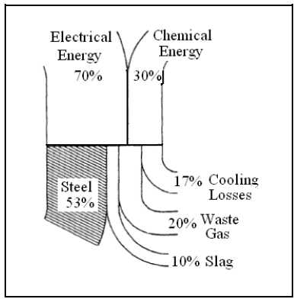

Figure 1: Energy Pattern in Electric Arc Furnace

IV. ARC FURNACE ELECTRIC CIRCUIT

In order to analyze different arc furnace models, a single phase arc furnace system is studied. The system is shown in Fig2.

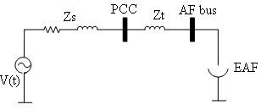
Figure.2. Arc Furnace system configuration

In figure 1, Z_{S} represents the system impedance, bus PCC represents the point of common coupling, and bus AF is the low voltage side of the transformer whose impedance is given as Z_{t}
Table 1 Electrical Installation Parameters

^{S.N.} | ^{Electrical Installations} | ^{Ratings}
₁ | _{HV Network} | _{2200MVA,X/R=9}
₂ | _{Step Down Transformer} | _{132/33/11KV,}  _{Zcc=13%, X/R=36}
₃ | _{Medium Voltage Cable} | _{0.112Ohm,}  _{Rc=0.032Ohm}
₄ | _{Capacitor Bank} | _{33kv,70Mvar}
₅ | _{Series Reactor} | Xr = 3.1 _{Ohm},  Xr/Rr = 195
₆ | _{Furnace Transformer} | 11/(0.530 kV, 20 MVA  Zcc = 5.7 %,
₇ | _{Electrode & Flexible Leads} | Xe = 2.4 mohm,  Re = 0.34 mohm

The V-I characteristic of AC Electric Arc Furnace is shown in figure 3.

Figure.3. Actual V-I characteristic of EAF

Electric Arc furnace has four major regions of operation as shown in figure 2

Area 1:

$\frac{di}{dt}$>0, v& i> 0 (1)

Area 2:

$\frac{di}{dt}$<0, v& i> 0 (2)

Area 3:

$\frac{di}{dt}$<0, v& i <0 (3)

Area 4:

$\frac{di}{dt}$>0, v& i <0 (4)

V. MODELING OF ELECTRIC ARC FURNACE IN TIME DOMAIN

In this paper piecewise linearization method is used to obtain time domain model [11] of EAF as shown in figure 4.

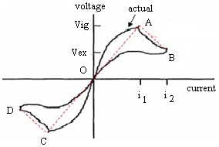

Figure 4. Actual and piece-wise linear approximation of V-I characteristic of EAF.

Electric Arc Furnace Model

The actual V-I characteristic of EAF can be approximated by the following mathematical linear model.

V= $\left\{\begin{aligned}r_{1}i -i_{1}≤i<i_{1} \\ r_{2}i+v_{ig}(1-\frac{r_{2}}{r_{1}}) i_{1}≤i<i_{2} \\ r_{2}i-v_{ig}\left(1-\frac{r_{2}}{r_{1}}\right){ -i}_{2}≤i<{-i}_{1}\end{aligned}\right.$ (5)
Where r₁, r₂ are the slope of lines OA and AB respectively.

$i_{1}= \frac{V_{ig}}{r_{1}}$(6)

$i_{2}=\frac{V_{ex}}{r_{2}}- V_{ig}\left(\frac{1}{r_{2}}- \frac{1}{r_{1}}\right)$(7)

Where,

$V_{ig}$, $V_{ex}$ are arc ignition and arc extinction voltage respectively.

Model Parameters of arc furnace under consideration are
v_{ig} = 350.75V
v_{ex} = 289.75V
r1 = 0.05ohm
r2 = -0.76mohm
i₁ = 7015A
I ₂= 87.278KA

Figure.5. Static V-I characteristic for EAF model.

EAF is modeled according to model presented and simulated in MATLAB. Figure 5 shows the static V-I characteristic of arc furnace and a MATLAB diagram has been shown in Fig 6.

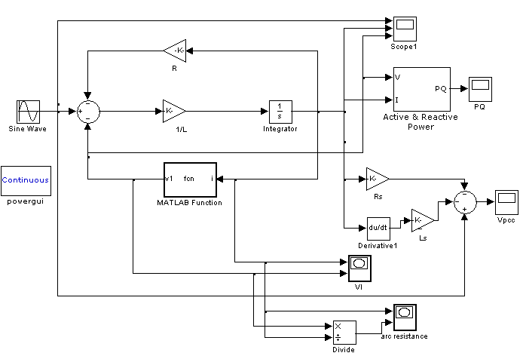

Figure 6. MATLAB diagram of EAF

VI. SIMULATION RESULTS

The simulated results during melting and refining have been presented as follows.

- Melting (Source Voltage = 500 Volts)
i) ARC CURRENT WAVEFORM

Figure.7. Arc Current of model .

ii) ARC VOLTAGE WAVEFORM

Figure 8. Arc Voltage of model.

iii) ARC V-I CHARACTERISTIC

Figure 9. VIC of mode of arc .

iv) ARC VOLTAGE AND ARC CURRENT.

Figure 10. Arc Voltage and Arc Current
of model.

v) ACTIVE POWER (P) AND REACTIVE
POWER (Q).

Figure.11. Active Power(P) and Reactive Power(Q) flow of model.

vi) FFT ANALYSIS OF ARC VOLTAGE WAVEFORM.

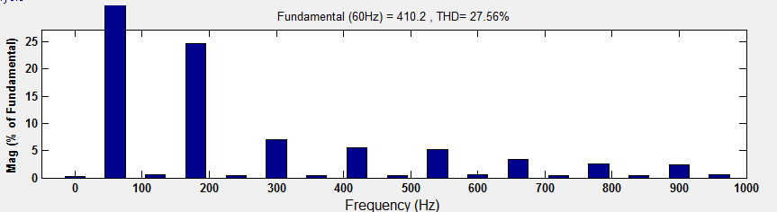

Figure12. Simulated harmonic content of Arc Voltage of EAF model .

vii) FFT ANALYSIS OF ARC CURRENT WAVEFORM

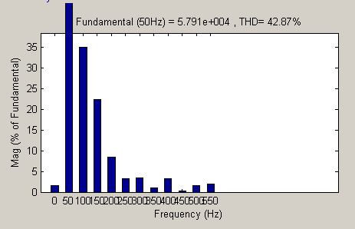

Figure 13. Simulated harmonic content of Arc Voltage of EAF model

viii) FFT ANALYSIS OF VOLTAGE (PCC) WAVEFORM

Figure 14 Simulated harmonic content of Voltage Vpcc

Table 2. Arc Voltage Harmonic content as a percentage of fundamental.

Harmonic | Arc Furnace Model
Fundamental(V) | 373.52
3rd (%) | 60.58
5th (%) | 26.70
7th (%) | 29.17
9th (%) | 27.56
11th(%) | 29.95

Table 3. Arc Current Harmonic content as a percentage of fundamental.

Harmonic | Arc Furnace Model
Fundamental(KA) | 57913.92
3rd(%) | 12982.34
5th(%) | 1883.00
7th(%) | 622.22
9th(%) | 167.80
11th(%) | 1119.14

Table 4. Harmonic content of Voltage at point of common coupling (VPCC) as a percentage of fundamental.

Harmonic | Arc Furnace Model
Fundamental(KA) | 441.11
3rd(%) | 13.85
5th(%) | 2.97
7th(%) | 4.16
9th(%) | 2.01
11th(%) | 2.32
13th(%) | 1.42

- Refining (Source Voltage = 470 Volts)

i) ARC CURRENT WAVEFORM

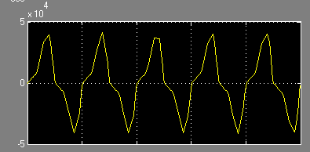
Figure.15: Arc Current during refining

ii) ARC VOLTAGE WAVEFORM

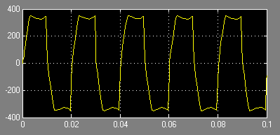
Figure 16: Arc Voltage during refining
iii) V-I CHARACTERISTICS OF ARC
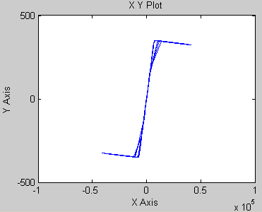
Figure 17: VIC model of EAF during refining
iv) ACTIVE POWER & REACTIVE POWER
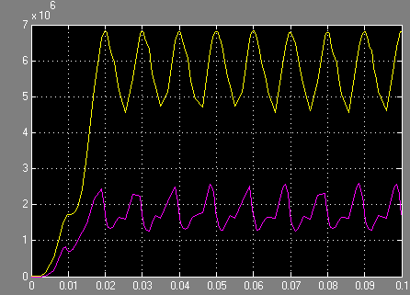
Figure 18. Active Power(P) and Reactive Power(Q) flow of model during refining.

v) FFT ANALYSIS OF ARC VOLTAGE WAVEFORM
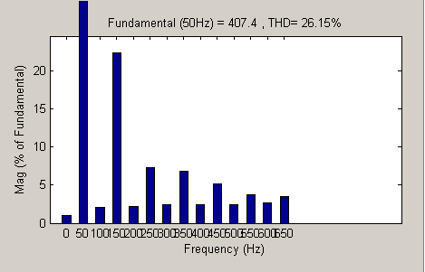
Figure 19. FFT Analysis of Arc Voltage waveform during refining

vi) FFT ANALYSIS OF ARC CURRENT WAVEFORM
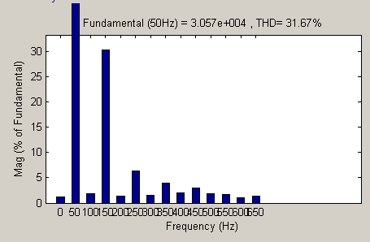

Figure.20. FFT Analysis of Arc Current waveform during refining

vii) FFT ANALYSIS OF VOLTAGE (PCC) WAVEFORM

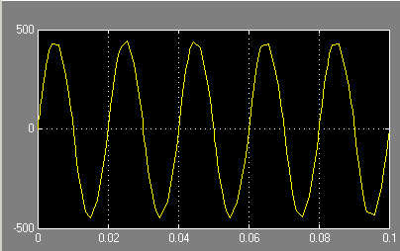

Figure 21. FFT Analysis of Voltage (VPCC) Waveform during refining.

vii) FFT ANALYSIS OF VOLTAGE (VPCC) WAVEFORM

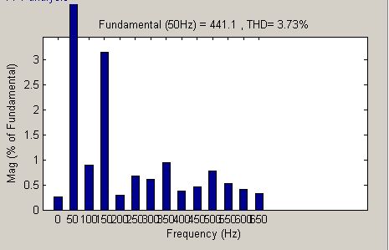

Figure 22. Simulated harmonic content of Voltage Vpcc

Table 5. Arc Voltage Harmonic content as a percentage of fundamental.

Harmonic | Arc Furnace Model
Fundamental(V) | 407.38
3rd (%) | 90.93
5th (%) | 29.75
7th (%) | 27.76
9th (%) | 20.89
11th(%) | 15.16
13th (%) | 14.22

Table 6. Arc Current Harmonic content as a percentage of fundamental.

Harmonic | Arc Furnace Model
Fundamental(KA) | 30574.38
3rd(%) | 9254.03
5th(%) | 1965.83
7th(%) | 1206.00
9th(%) | 923.42
11th(%) | 528.92
13th(%) | 412.46

Table 7. Harmonic content of Voltage at point of common coupling (VPCC) as a percentage of fundamental.

Harmonic | Arc Furnace Model
Fundamental(V) | 441.11
3rd(%) | 13.85
5th(%) | 2.97
7th(%) | 4.16
9th(%) | 2.01
11th(%) | 2.32
13th(%) | 1.42

VII. CONCLUSION:
Electric Arc furnace is modeled in time domain. The modeling is based on V-I characteristic. The purpose of the model of the Electric Arc Furnace is to carefully analysis the impact power quality at the point of common coupling (PCC) where an arc furnace for steel melting with alternating current is connected. By measurements of Flicker, harmonics content in voltage and current, active and reactive power and power factor, the preservation of the reference levels for the supply voltage and emission for the furnace as a customer are evaluated. Most utilities and power customers are facing the power quality problem produced by electric arc furnaces. Therefore there is a need of a correct link of the electrical model to which the power quality impact is considered. The correct link enables an accurate evaluation of the different mitigation possibilities.
Once the harmonic content in voltage, current and at the point of common coupling (PCC) is known, the accurate remedy arrangement with suitable technology to keep the harmonic content within limits can be designed.

REFERENCES:

[1]Youssef A. Mobarak Electric Engineering Department High Institute of Energ, South Valley University “Arc Furnace Loads Voltage Stability”

[2] Mehdi Torabian Esfahani, Behrooz VAHIDI “Electric arc furnace power quality improvement by applying a new digital and predicted-based TSC control
[3] Deepthisree M., Illango K., Kirthika Devi V. S. “Voltage Flicker Mitigation in Electric Arc Furnace using D-STATCOM “
[4] Mahdi Banejad, Rahmat-Allah Hooshmand and Mahdi Torabian Esfahani “Exponential -Hyperbolic Model for Actual Operating Conditions of Three Phase Arc Furnaces “American Journal of Applied Sciences 6 (8): 1539-1547, 2009 ISSN 1546-9239 © 2009 Science Publications
[5] Zheng T, Makram EB. “An adaptive arc furnace model. IEEE Transactions on Power Delivery”2000;15(3):931–9.

[6] Collantes-Bellido R, Gomez T. “Identification and modelling of a three phase arc furnace for voltage disturbance simulation”. IEEE 1997; 12:1812–7. T.P.D.

[7] A. de Almeida, L. Moreira. J. Delgado “Power Quality Problems and New Solutions”

[8] Horia Andrei, Costin Cepisca and Sorin Grigorescu “Power Quality andElectrical Arc Furnaces”

[9] Michael J. Russell, Consulting Electrical Engineer “The Impact of Mains Impedance on Power Quality” Originally Presented at Power Quality 2000 (Boston, MA) on October 4, 2000

[10] “Power Quality and Electrical Arc Furnaces”
Horia Andrei1, Costin Cepisca and Sorin Grigorescu, Valahia University of Targoviste,2Politehnica University of Bucharest Romania

[11] M. A. Golkar, M. Tavakoli Bina, S. Meshi, A Novel method Arc Furnace Modeling for Flicker Study .

