Design and Fabrication of Fatigue Testing Machine
1 Praveen Kumar Kushwaha, 2 Rahul Rai, 3 Sanjay Tiwari
1, 2 Under Graduate Students, 3Assistant Professor, Dept. Of Mechanical Engineering, B. N. College of Engineering and Technology, Bakshi Ka Talab, Lucknow -226001,India.
ABSTRACT
It has been observed that materials fail under fluctuating stresses at a stress magnitude which is lower than the ultimate tensile strength of the material. Sometimes, the magnitude is even lower than the yield strength. Further, it has been found that the magnitude of the stress causing fatigue failure decreases as the number of stress cycle increases. This machine will determine the endurance strength of the material under the application of cyclic loads. The specimen is subjected to varying repeated forces as compressive and tensile and it will fail after sufficient number of cycles. This phenomenon is repeated under the stress which is less than the first. The results are plotted on the SN curve.
- INTRODUCTION
Fatigue testing machine is used to determine the fatigue strength of materials. Most of the fractures will show that almost all failures occur at stresses below the yield strength of the material. This complex phenomenon is known as “Fatigue”. Fatigue is responsible for 95% of the failures that occur in an industry. Fatigue is a phenomenon of weakening of a material caused by repeated application of loads. It is the progressive, unpredictable and structural damage that take place when a material is subjected to cyclic loading. The nominal maximum stress values that actually cause the material to fail may be much lower than the strength of the material typically quoted as the yield strength or ultimate strength. If the applied loads are greater than a certain threshold value, then microscopic cracks will begin to form at the stress concentrated areas such as grain interface or where there are surface defects. Eventually a crack will reach a critical size, the crack will expand at a faster rate, and the structure will fail.

- COMPONENTS
  - Motor
A Motor is a machine which converts the electrical energy into the mechanical energy in the form of rotational motion. In this testing, we are using single phase Induction Motor of 0.5 HP (0.375 KW) and 1440 rpm.
  - Coupling
Coupling is used for connecting two shafts with each other. In this testing machine we have used a Low Jaw coupling for connecting the motor shaft to the main shaft and transfer the rotational energy from motor to the main shaft.
  - Bearing and its housing
Bearing provides the smooth rotation to all the rotational parts of machine. A Ball Bearing is with 25 mm inner diameter is used and the main shaft is inserted in this. The bearing housing design was implemented by selecting dimensions that will result in smaller minimum bending moment which is desirable shaft geometry in order to produce the required bending moment.
The outer surface of the bearing is fitted in housing, which inner diameter is same as the bearing outer diameter as 47 mm. Two bearings are attached at both ends and two bearings are used for the loading purpose.

  - Frame

A Frame is the main supporting member of the machine which supports all the loads acting upon it. Here we have used Iron square pipe for making frame. The force acted upon this frame is transferred to the all four legs. The frame should be such that it can wear maximum bending moment and vibrations.

  - Testing specimen

A Mild Steel is utilized to prepare the specimen. The specimen total length is 160 mm and 2 mm at each side are inserted in the main shaft. A stress concentration is provided at the center of the specimen which diameter is 6 mm.

2.6 Rotation counter

A rotation counter is used to count the number of rotations. This counts the revolutions of the specimen from the starting of machine to the breaking of the specimen. A six digits rotational counter is used in this testing machine.

- Design
The different parts of the machine are designed as follows:
Frame
Length = 96 cm
Width = 89.5 cm
Height = 75 cm
Distance between two center pipes = 17.5 cm
Legs pipe size : Larger pipe = 3.81 * 3.81 cm
Smaller pipe = 3.175 * 3.175 cm
Thickness of Frame = 3 mm
Motor
Type : Single phase Induction Motor
Power = 0.5 HP ( 0.375 KW )
Speed = 1440 rpm
Current = 5
Frequency = 50 Hz
Coupling
A Low Jaw coupling is used here for connecting the motor shaft to the main shaft.
Main shaft
Outer diameter = 25 mm
Holes are drilled of size = 12 mm
Rotation counter
A five digits Milky Way rotation counter is used for measure the number of rotations.
Specimen
Extreme diameter = 12 mm
Center diameter = 6 mm
Length = 160 mm
This design is taken as standard dimension.

- Fabrication and Assembly
For the designing of this machine, first of all we prepared a frame of square pipes in a specific manner so that it can sustain maximum load and vibration. The whole set-up is on this frame. The main shaft is connected to the motor shaft with a low jaw coupling and a key is inserted between coupling and shaft so that it can rotate without any slipping. A hole is drilled in the main shaft in which the testing specimen is inserted and tightened with the help of bolts. For loading, a weight carrier is hanged at the center of the specimen with a simply supported beam. A stress concentration is provided at the center of the specimen so that the crack formation takes place first at this point. To measure the number of revolutions, a rotation counter is used. Switches, wires and switch board are also attached to the motor.
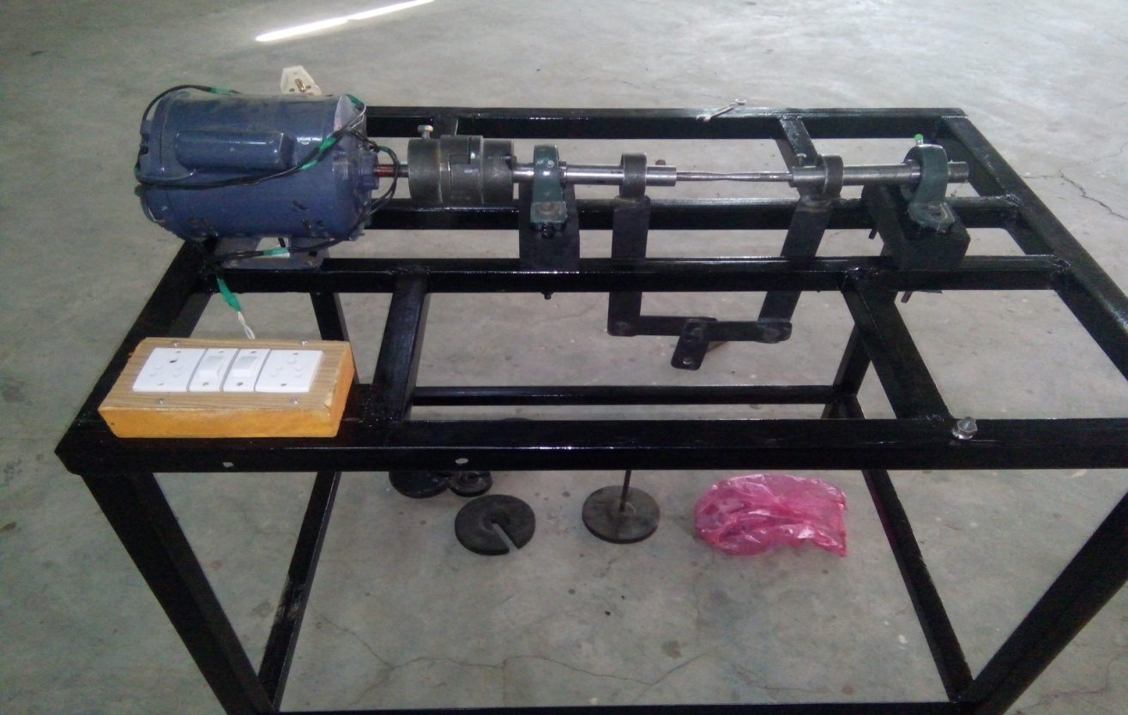
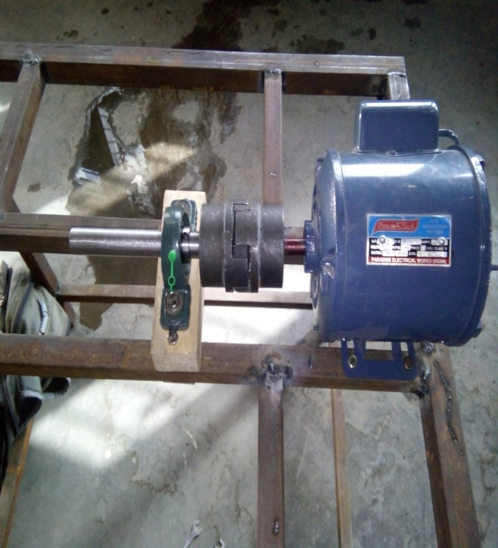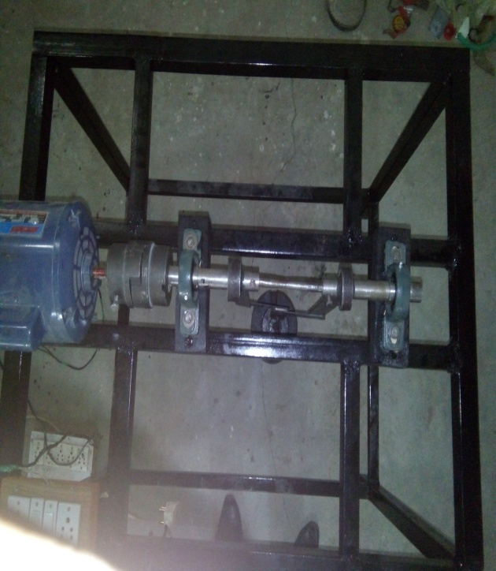

Fig : different views of project

- Working
First of all set the specimen in the main shaft as it is inserted in the holes provided in the main shaft. The bolt is tightened so that the specimen does not acquire the slipping. After that the switch is on, the motor starts rotating. The shaft connected to the motor with the help of coupling also starts rotating. The rotation counter is applied on the main shaft to measure the number of rotations. Initially some heavy load as 300 Newton is applied. The machine is on till the specimen attached does not break. The machine is stop after that and the number of revolutions is counted at that stage. The corresponding value of stress is calculated with applying the specific formula. After that some lower weights are applied and corresponding values of the stresses are measured and a table is prepared. On seeing this table, a graph between stress and number of revolutions is plotted. On seeing this table, the value of endurance strength can be found.
- Testing and Results
After designing the project, the testing is done on this. The different loads are applied on the beam of circular cross-section is subjected to bending moment. Under the action of bending moment, tensile stresses are induced in the upper half of the beam and compressive stresses in the lower half. The maximum tensile stress in the uppermost shaft is equal to the maximum compressive stress in the lowermost shaft. There is zero stress at all shaft in the central horizontal plane passing through the axis of the beam. The results of these tests are plotted by means of an S-N curve in the graphical representation of stress amplitude (S) versus the no of stress cycles (N) before the fatigue failure on a log-log paper.
The Endurance strength of the material used can be calculated by the following formula for the simply supported beam as
$$σ=\frac{8wl}{πd^{3}}$$
Where , w = the load applied in Newton
l = length of the testing specimen
d = centre diameter of the testing shaft (neck diameter)
Here, l = 160 mm
d = 6 mm
On applying the different loads , the different values of the stress can be calculated as
Case 1.
$w_{1}$ = 300 N
$σ_{1}$ = $\frac{8×300×0.16}{π×{0.006}^{3}}$
$σ_{1}$ = 565.88
At this load, the number of revolutions counted by rotation counter $N_{1}$ = 408

Case 2.
$w_{2}$ = 250 N
$σ_{2}$ = $\frac{8×250×0.16}{π×{0.006}^{3}}$
$σ_{2}$ = 471.57
Number of revolutions $N_{2}$ = 682
Case 3.
$W_{3}$ = 200 N
$σ_{3}$ = $\frac{8×200×0.16}{π×0.006}$
$σ_{3}$ = 377.25MPa
Similarly on applying the different loads , the stress values and the corresponding number of revolutions can be calculated and a table can be drawn as given below:

S.N. | Load applied (N) | Stress values (MPa) | Number of revolutions
1 | 300 | 565.88 | 408
2 | 250 | 471.57 | 1260
3 | 200 | 377.25 | 2670
4 | 150 | 282.94 | 10025
5 | 120 | 226.35 | 40580
6 | 100 | 188.62 | 62652
7 | 80 | 150.94 | 75320
8 | 70 | 132.04 | 90598
9 | 50 | 94.31 | ∞
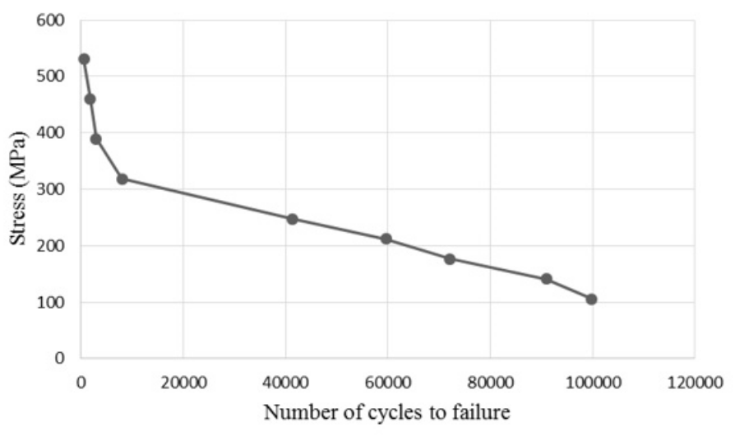
Table: 6.1 Observation for Mild Steel

Fig 6.1 S.N.Curve

From the values obtained TABLE: 6.1 during the testing of the specimen of mild steel , S-N graph is plotted with stress (MPa) on y-axis and number of cycles to failure on x-axis.From the graph it can be noted that with decrease in load the number of cycles to failure increases. Below a particular load limit the number of cycles to failure increases and approaches infinity, this limit is known as endurance limit.From the above graph , the endurance limit of mild steel from the obtained S-N curve is 94.31 MPa. The actual value of endurance limit of mild steel 1080 is 145 MPa. The percentage error between the obtained value and calculated value is 34.95.
- Conclusion
The benefit of the present design is the simplicity of its modeling and ease of understanding. The rotating specimen can be modeled as a simply supported beam. The machine enables the evaluation of the stress life fatigue characteristics of the material analyzed by plotting a graph of bending stress against number of cycles from which the fatigue limit/fatigue strength of the material analyzed can be determined. An affordable and a fully functional educational version of the R. R. Moore Fatigue Testing apparatus that produces dependable results is proposed. The difference between the theoretical and experimental endurance limit maybe due to the additional vibration, size or temperature effects. The study and test conducted so far shows that fatigue failure cannot be predicted accurately since material failure under fatigue are affected not by just reversal loading alone but also the number of revolution (cycle per minute) and fluctuating stress and other factors such as temperature, atmospheric condition, both internal and external defect on material subjected under fatigue stress. Such defect includes inclusion, notch, non-homogeneity and stress concentration. This approach is beneficial for all parties involved including; the researching/collaborating student(s), underclassmen who would benefit from such experiments, and the enthusiastic instructors/ laboratory coordinators who may be fighting with budgetary issues. However, although we have not yet achieved an impressive level of “accuracy”, we can clearly conclude that the results are approximately correct as the fatigue properties depend on several other factors such as temperature, surface finish, endurance limit, size factor etc.
- Reference
(1). Martin K Vincent, Vipin Varghese V., SuneethSukumaran; Fabrication and analysis of Fatigue Testing Machine; The International Journal of Engineering and Science (IJES) PP -15-19 || 2016 || ISSN (e): 2319 – 1813 ISSN (p): 2319 – 1805.

(2). Dagang Wang, XiaofanJia, D. Zhang and Songquan Wang, "A fretting fatigue tester for steel wires and its measuring system," Mechanic Automation and Control Engineering (MACE), 2010 International Conference on, Wuhan, 2010, pp. 2398-2401.

(3). GbasouzorAustineIkechukwu, Member, IAENG, OkekeOgochukwuClementina and Chima Lazarus Onyebuchi; Design and Characterization of a Fatigue Testing
Machine Proceedings of the World Congress on Engineering and Computer Science 2013 Vol I
WCECS 2013, 23-25 October, 2013, San Francisco, USA.

(4). GbasouzorAustineIkechukwu, OgochukwuClementina and Chima Lazarus Onyebuchi; Design and Characterization of a Fatigue Testing Machine; Proceedings of the World Congress on Engineering and Computer Science 2013 Vol I WCECS 2013, 23-25 October, 2013.

(5). Design of Machine Elements by V.B.Bhandari, M.C.Graw Hill Education publication.

(6). Theory of Machine by S.S.Rattan, M.C.Graw Hill Education publication.


Mr. Praveen Kumar Kushwaha is doing his B.Tech degree (2014-2018) in Mechanical Engineering at B. N. College of Engineering & Technology , Affiliated to Dr. A. P. J. Abdul Kalam Technical University Lucknow (226001), Uttar Pradesh, India.



Mr. Rahul Rai is doing his B.Tech degree (2014-2018) in Mechanical Engineering at B. N. College of Engineering & Technology , Affiliated to Dr. A.P.J. Abdul Kalam Technical University Lucknow (226001), Uttar Pradesh, India.


Mr. Sanjay Tiwari is working as Assistant Professor in Dept. of
Mechanical Engineering at B. N. College of Engineering & Technology , Affiliated to Dr. A.P.J. Abdul Kalam Technical University Lucknow (226001), Uttar Pradesh, India.

