Evaluation of Mechanical propertiesof Stir Cast Al- 7010 SiC Metal Matrix Composites

Prameet Vats¹ , Rakesh Kumar Bharti² , Ripuranjan singh³ , K.G. Sinha⁴
¹Research Scholar, SRIMT, Lucknow (prameetvats@gmail.com)
²Research Scholar, SRIMT, Lucknow (brakeshkumar824@gmail.com)
³Assistant Professor, SRIMT, Lucknow (ripuranjansingh999@gmail.com)
⁴ Assistant professor, SMS Lucknow (kgsinha.2007@rediffmail.com)

ABSTRACT

Now-a-days more of the industries are moving towards the metal matrix because of its superiority behaviour such as in aeronautical, navigation space research & medical. It also plays a vital role in automobile, sports equipment and electronics due to their favourable properties like light weight, high strength and low coefficient of thermal expansion. The aluminium 7010 is mostly used in aerospace industries. The Al7010 has the high strength and moderate hardness but its properties can be improves by mixing some refractory materials such SiC. Different mechanical tests were conducted viz. Hardness test, Impact test & water corrosion test presented by varying the weight fractions of SiC.In this work a composite will develop by adding silicon carbide in Aluminium-7010 metal in ratio 2%, 5% and 7% by weight. The composite is prepared by melt stir casting technique in appropriate size (15*50*100) mm.
Keywords-Aluminium-7010, silicon carbide (SiC), MMC’s, Stir casting technique,Hardness test, Impact test & water corrosion test.

1. INTRODUCTION
Metal Matrix Composite (MMC) is a combination of metal and hard particles (Reinforcement) to obtain the desired properties. The MMC’s Metal Matrix Composites (MMC’s) have very lightweight, high strength, and stiffness andexhibit greater resistance to corrosion. The MMC’s have very good mechanical properties .The MMC’s are used in various engineering application as well as domestic application. Metal matrix composites have nearly isotropic properties when compared to long fiber reinforced composite. But the mechanical behaviour of the compositedepends on the matrix material composition,size, and weight fraction of thereinforcement and method utilized tomanufacture the composite. The homogeneous distribution of silicon carbide particle is also a very important in composites to obtain the uniform properties. Thereare various methods to produce the metal composites but stir friction casting method is mostly used in manufacturing of MMC’s.Hashim et al. [1] reported that the distribution of thereinforcement material in the matrix must beuniform and the wettability or bondingbetween these substances should beoptimized.
Stir friction casting also helps in homogenous distribution of hardest materials during manufacturing of metal composites.The distribution of the reinforcement particles in the matrixalloy is influenced by several factors such asrheological behaviour of the matrix melt, theparticle incorporation method, interaction ofparticles and the matrix before, during, andafter mixing [2].Non homogeneous particle distribution is one of the greatest problemsin casting of metal matrix composites [3].

2. MATERIALS AND PROPERTIES
In this experiment I am using aluminium alloy (Al-7010) and silicon carbide (SiC).Aluminium-7010 is a high strength aluminium alloy that is designed for applications where strength to weight ratios are important.It can be strengthened and hardened by cold working or heat treatment. The Composition of Al-7010 is given below-
Metal name | % composition
Al | 89.9
Si | 0.142
Fe | 0.192
Cu | 1.56
Mn | 0.034
Mg | 2.23
Cr | 0.223
Ni | 0.0075
Zn | 5.51
Ti | 0.050

Table.1: composition of Al-7010
Silicon Carbide is a refractory material (high melting point) and it has excellent thermal conductivity and low thermal expansion, consequently it displays good thermal shock resistance. Silicon Carbide is produced using the Acheson process which involves heating silica sand and carbon to high temperatures in an Acheson graphite resistance furnace. Due to High hardness, corrosion resistance and stiffness it lead to a wide range of application.so in Aluminium Metal Matrix Composites the Silicon Carbide is used to improve its Mechanical Properties such as hardness, tensile strength and impact resistance. So I have purchase aluminium alloy (Al-7010) as raw material from the Parshwanath Metal Mumbai, Maharashtra and silicon carbide from silicon carbide from Snam Abrasives Pvt. Ltd. Tamilnadu, INDIA.
METHODOLOGY:
To prepare the specimen for test I have first prepare the Sheet of aluminium 7010 and Silicon carbide by stir frictioncasting method.Stir casting route is a liquid phase processing method in which the reinforcing particles like short fibers or ceramic particles are dispersed into molten melt, further uniform mixing is achieved by the action of stirring.This method is significantly used for up to 30% reinforcement particles incorporation in to the molten matrix [4-6]. .The procedure to manufacture a metal matrix is illustrated by the following steps as shown in the above figure. The matrix material is placed inside the crucible and allowed to melt at a desired temperature. After melting, the vortex is formed by the stirring action of the mechanical stirrer. In order to avert the oxides formation, inert gas atmosphere is recommended. Then reinforcement particles are added in the molten matrix simultaneously. The stirring action is continued up to uniform dispersion of the particles. Hence the molten matrix with reinforced particles is poured into a preheated die. After solidification, the metal matrix composite is obtained from the die.

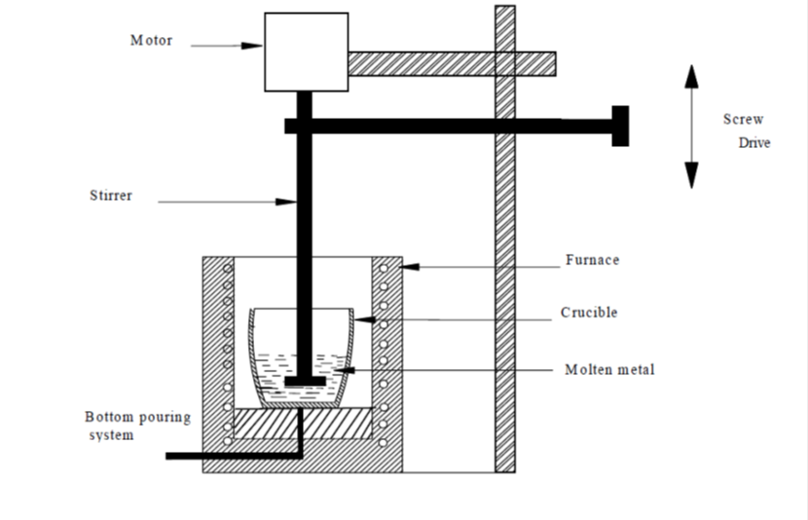
Figure 1: manufacturing of MMCs by stir casting
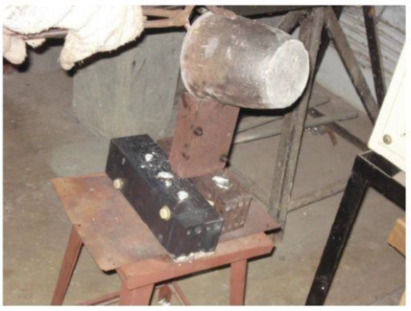

Figure 1.2:Photographic view of pouring the molten metal into the die

So by Stir casting method a proper uniform metal composite is obtainedthe Photographic views of casted samples given above.

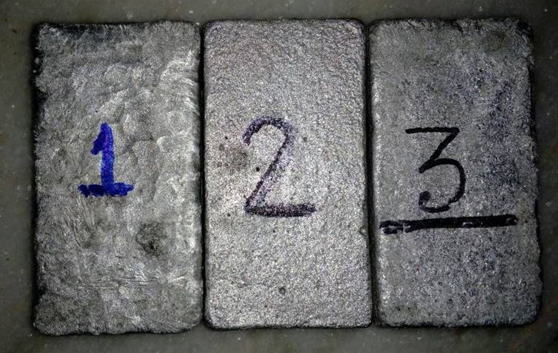

Figure 1.3:Photographic views of casted samples
TESTING SAMPLES PREPARATION:
After preparing the sheet all testing are prepared with the help of lathe machine and grinding machine and file.
Impact Test Specimen:-the impact test specimens have special dimensions as per ASTM Standard. The hardness test can be conducted in following two ways.
Izod impact testing is an ASTM standard method of determining the impact resistance of materials. A pivoting arm is raised to a specific height (constant potential energy) and then released. The arm swings down hitting the sample, breaking the specimen.In the Izod impact test, the test piece is a cantilever, clamped upright in an anvil, with a V-notch at the level of the top of the clamp.
The Charpy impact test, also known as the Charpy V-notch test, is a standardized high strain-rate test which determines the amount of energy absorbed by a material during fractureThe principle of the test differs from that of the Izod test in that the test piece is tested as a beam supported at each end; a notch is cut across the middle of one face, and the striker hits the opposite face directly behind the notch.

Figure 1.4:Izod test Specimen dimension
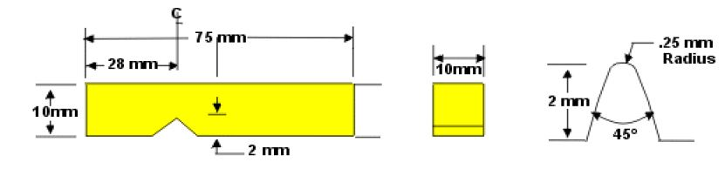

Figure 1.5:Charpy test Specimen dimension

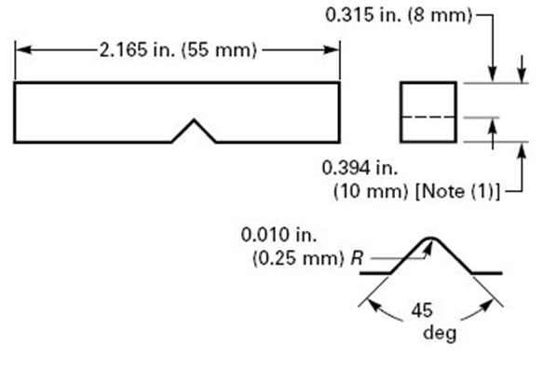
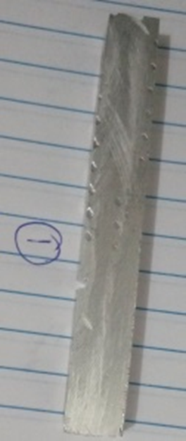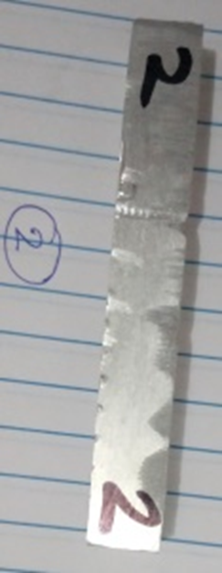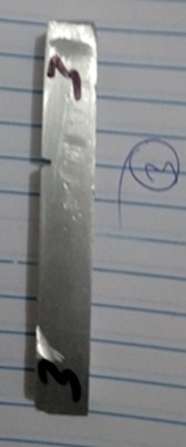
Figure1.6: Photographic views of Izod test specimen

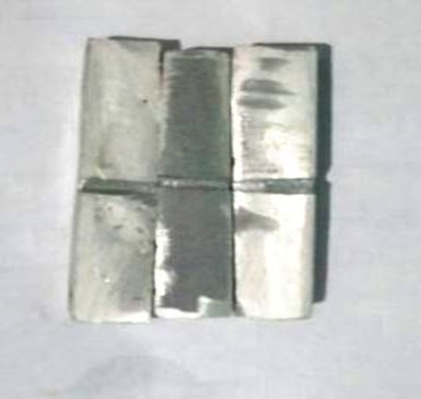
Figure 1.7: Photographic views of Charpy test specimen
Hardness Test Specimen: -Hardness testing measures a material’s strength by determining resistance to penetration hardness testing can be carried out by two methods.The Brinell Hardness Test can be applied to almost any metallic material and is the method most commonly used to test castings and forgings that have a grain structure too coarse for other hardness testing methods. During the test, a carbide ball indenter is pressed into the sample with accurately controlled force for a specific amount of time. When removed, the material has a round indent that is measured to calculate material hardness according to a formula [5-9]
In Rockwell Hardnesstest, a minor load is applied to either a diamond cone or a steel ball indenter positioned on the test material’s surface to establish a zero reference position.
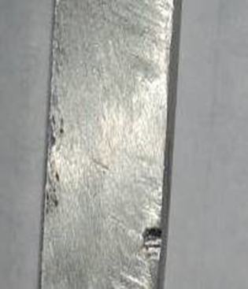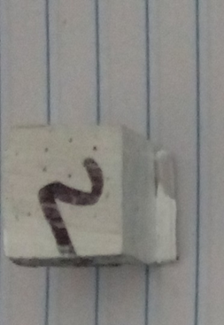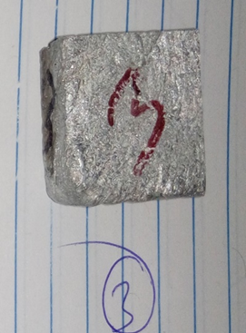
Figure 1.8: Photographic views of hardness testspecimen
Compression testSpecimen:
Specimens can either be blocks or cylinders. For ASTM, the typical blocks are 12.7 x 12.7 x 25.4mm. And the cylinders are 12.7mmin diameter and 25.4mm long. The end surfaces of the sample are polished using coarse SiC grinding papers before starting the compression test.

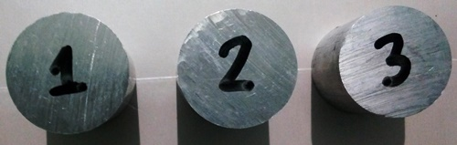Figure 1.9: Photographic views of Compression testspecimen

TESTING RESULTS:
Rockwell hardness test:-the readings of Rockwell hardness testis given below
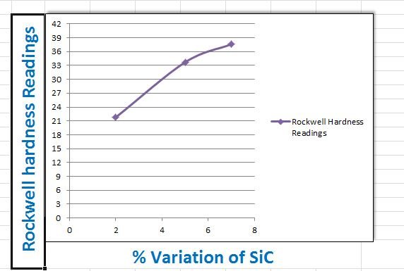

Figure 1.10: readings of Rockwell hardness test
In Rockwell hardness test it shows that by increasing the silicon carbide the hardness of silicon carbide increases.

Izod Impact Test:
The impact strength is also a very important property of material. The Izod impact test readings are given below.
And it shows that whenever the percentage of silicon carbide is increases then the impact strength of matrix is decreases.

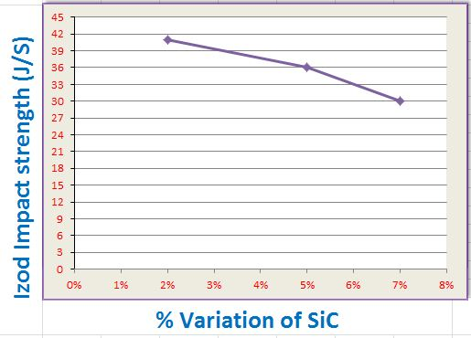Figure 1.11: readings of Izod Impact test

Compression test:
compressive strength of the virgin alloy as well as the MMC specimens are measured using universal testing machinein this end surfaces of the sample are polished using coarse SiC grinding papers before starting the compression test. The specimen is placed between two flat dies and the die surfaces are lubricated with a small quantity of zinc serrate powder to reduce the friction between the specimens and die surfaces during compression.

Specimen No. | SiC Mixture (%) | Compression Strength  (N/mm²)
1 | 0 | 470 N/mm²
2 | 2 | 476N/mm²
3 | 5 | 485 N/mm²
4 | 7 | 496 N/mm²

Table.2: Compression test result

FUTURE SCOPE
In our research work there are many possibilities for future work.

- The thermal properties of aluminium 7010 composite can be evaluated because there is no work on this.

- Diamond is also a very hardest material so some specific properties of this composite may be increases by adding the diamond powder so it can be evaluated in future.

- There are also a possibility in Development of MMCs with any other base materials and constituents which has better properties than Al and SiC MMCs.

CONCLUSION:-

The following conclusion are obtain after the performing the testing of specimen.

Hardness (HB) Increases with the increase in weightFraction (2%, 5% and 7%) of SiC particles. Maximum Hardness = 21.8HB and has been obtained at 7 % weight fraction of SiC particles.
Impact Strength (J)decreases with the increase in Weight fraction (2%, 5% and 7%) of SiC particles. Maximum Impact Strength 41 J has been obtained at 2 % weight fraction of SiC particles.
Compressive strengthIncreases with the increase in weightFraction (2%, 5% and 7%) of SiC particles. The Maximum Compressive strength=496 N/mm²and has been obtained at 7 % weight fraction of SiC particles.

REFERENCES
[1] Hashim, J., Looney, L. and Hashmi, M.S.J.,”Metal Matrix Composites: Production by the Stir Casting Method,” Journal of Materials ProcessingTechnology, 92-93: 1-7. 1999.

[2] Hashim, J., Looney, L. and Hashmi, M.S.J., “Particle Distribution in Metal Matrix Composites,” Part-I, Journal ofMaterials Processing Technology, 123: 251- 257. 2002.

[3] Nather, S., Brabazon, D. and Looney, L.,“Simulation of the Stir Casting Process,” Journal of Materials ProcessingTechnology, 143-144: 567-571. 2003.

[4]http://www.science.org.au/nova/059/059key.htm,
[5]https://www.labtesting.com/services/materials-testing/mechanical-testing/hardness-testing/

[6] S. Ramo, G. Padmanabhan, ''fabrication and mechanical properties of aluminium-boron carbide composites '', International Journal of Materials and BiomaterialsApplications, 2(3),(2012), pp.15-18.

[7] Sulaiman, S., Sayuti, M. and Samin, R., “Mechanical Properties of the As- Cast Quartz Particulate Reinforced LM6 Alloy Matrix Composites,” Journal of Material Processing Technology, Vol.01, 2008, pp.731-735.

[8] M.K. Surappa. J. Mater., “Fabrication of Al-Al2O3/Grp Metal Matrix Composites 3079,” in Proc. Tech. Vol.63, 1997, pp.325-333.

[9] Hashim, J., Looney, L. and Hashmi, M.S.J., “Particle Distribution in Metal Matrix Composites,” Part-I, Journal of Materials Processing Technology, Vol.123, 2002, pp.251-257.

