Vibrational study and Electronic Parameters of “2-Diphenylphosphanyl-6-fluoro-pyridine”using First Principle

Tanveer Hasan^{1#}, P K Singh² and S H Mehdi³
¹Deptt. of Physics, Shia P.G. College, Lucknow, India.
²Deptt. of Applied Physics, SMS Institute, Lucknow, India.
³Deptt. of Chemistry,Shia P.G. College, Lucknow, India.
#tanveerhasan09@gmail.com, Mob No (+91-9670119504)

Abstract
Vibrational investigations along with theoretical quantum chemical studies on “2-Diphenylphosphanyl-6-fluoro-pyridine (C₁₇H₁₄NFP)” have been carried out. The quantum chemical density functional method at B3LYP/3-21Glevel is used to obtain the equilibrium geometries of the title compound. We have also performed vibrational analysis of the title compound at their equilibrium geometries and established the complete assignments of the significant vibrational modes. Electronic parameters such as HOMO, LUMO and frontier orbital energy band gap, has been calculated. Besides it the thermodynamical parameters like internal thermal energy, entropy and constant volume specific heat capacity have been calculated.

Keywords: C₁₇H₁₄NFP; 2-Diphenylphosphanyl-6-fluoro-pyridine, Quantum chemical calculations; DFT and Vibrational Assignments.

- Introduction
The aim of the present study is to investigate in detail the vibrational spectra of the title molecule “2-Diphenylphosphanyl-6-fluoro-pyridine (C₁₇H₁₄NFP)”, a derivative of pyridine due to its biologically active properties. Pyridine is a heterocyclic aromatic tertiary amine, also called azabenzene and azine, is characterized by a six member ring composed of five carbon atoms and a nitrogen atom which replace one carbon-hydrogen unit in the benzene ring (C₅H₅N). Pyridine is a base with chemical properties similar to tertiary amines. Pyridine and its derivatives are used as solvents and starting material for the synthesis of target compounds for instance insecticides, herbicides, medicines, vitamins, food flavorings, feed additives, dyes, rubber chemicals, explosives, disinfectants, and adhesives. It is also used as a denaturant for antifreeze mixtures, as a dyeing assistant in textiles and in fungicides [1, 2].

2. MATERIALS AND METHODS
The model molecular structure of the title compound is shown fig 1. The title molecule is an asymmetric top with rotational symmetry number equal to 1 and 93 degrees of freedom. The theoretical IR spectra plotted is shown in fig 2.

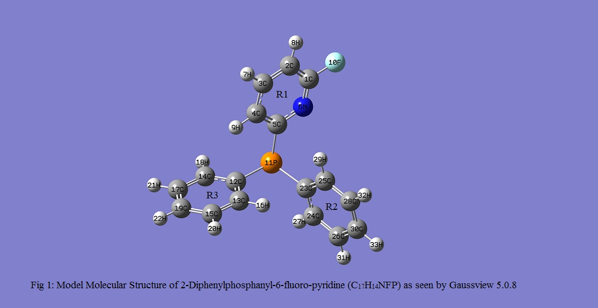
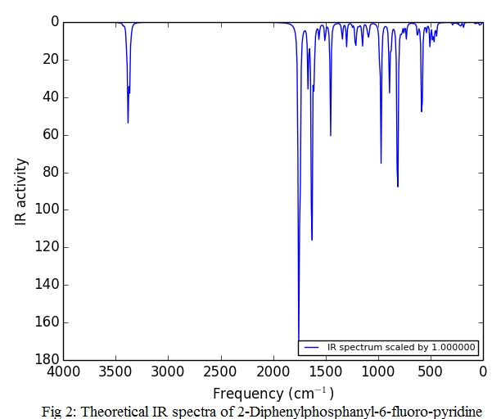

- Result and Discussion
All the calculations were performed on an AMD dual core/2.71 GHz personal computer by the B3LYP [3, 4] method using the 6-31+g(d,p) level basis set of density functional theory. All computations were carried out with the Gaussian 09 package [5] by combining the results of the Gaussview 5.0.8 program package [6] with symmetry considerations and the VEDA 4 program to calculate the PED values [7].
3.1 Geometry Optimization
The optimized geometrical parameters of the title molecule 2-Diphenylphosphanyl-6-fluoro-pyridine are listed in table 1, showing bond lengths and bond angles only. The out of plane and torsional vibrations are not shown for the sake of space and are with the corresponding author. The optimized geometry parameters of the title compound are calculated by the DFT-B3LYP method. The calculations converged to optimized

Table 1 Optimized Parameters of 2-Diphenylphosphanyl-6-fluoro-pyridine (C17H14NFP)
S.No | Parameters | Bond Length (Å) | S.No | Parameters | Bond Angles (Deg)
1 | R(1,2) | 1.3822 | 46 | A(5,4,9) | 120.4392
2 | R(1,6) | 1.2964 | 47 | A(4,5,6) | 121.1044
3 | R(1,10) | 1.3466 | 48 | A(4,5,11) | 125.3575
4 | R(2,3) | 1.3754 | 49 | A(6,5,11) | 113.4681
5 | R(2,8) | 1.0676 | 50 | A(1,6,5) | 119.535
6 | R(3,4) | 1.3921 | 51 | A(5,11,12) | 101.0055
7 | R(3,7) | 1.0712 | 52 | A(5,11,23) | 101.844
8 | R(4,5) | 1.3777 | 53 | A(12,11,23) | 101.8554
9 | R(4,9) | 1.0674 | 54 | A(11,12,13) | 123.7258
10 | R(5,6) | 1.8782 | 55 | A(11,12,14) | 117.2473
11 | R(5,11) | 1.8782 | 56 | A(13,12,14) | 119.0239
12 | R(11,12) | 1.881 | 57 | A(12,13,15) | 120.4121
13 | R(11,23) | 1.8759 | 58 | A(12,13,16) | 119.8261
14 | R(12,13) | 1.3871 | 59 | A(15,13,16) | 119.7598
15 | R(12,14) | 1.3888 | 60 | A(12,14,17) | 120.6793
16 | R(13,15) | 1.3841 | 61 | A(12,14,18) | 119.5354
17 | R(13,16) | 1.0706 | 62 | A(17,14,18) | 119.7835
18 | R(14,17) | 1.384 | 63 | A(13,15,19) | 120.1713
19 | R(14,18) | 1.0728 | 64 | A(13,15,20) | 119.7762
20 | R(15,19) | 1.3843 | 65 | A(19,15,20) | 120.0523
21 | R(15,20) | 1.0721 | 66 | A(14,17,19) | 119.8829
22 | R(17,19) | 1.3837 | 67 | A(14,17,21) | 119.9119
23 | R(17,21) | 1.072 | 68 | A(15,19,17) | 119.8257
24 | R(19,22) | 1.072 | 69 | A(15,19,22) | 120.0891
25 | R(23,24) | 1.3886 | 70 | A(17,19,22) | 120.0839
26 | R(23,25) | 1.386 | 71 | A(11,23,24) | 116.7929
27 | R(24,26) | 1.3828 | 72 | A(11,23,25) | 124.1735
28 | R(24,27) | 1.0726 | 73 | A(24,23,25) | 119.0336
29 | R(25,28) | 1.3847 | 74 | A(23,24,26) | 120.6552
30 | R(25,29) | 1.0699 | 75 | A(23,24,27) | 119.6583
31 | R(26,30) | 1.384 | 76 | A(26,24,27) | 119.6853
32 | R(26,31) | 1.0719 | 77 | A(23,25,28) | 120.4019
33 | R(28,30) | 1.3831 | 78 | A(23,25,29) | 120.1809
34 | R(28,32) | 1.072 | 79 | A(28,25,29) | 119.4144
35 | R(30,33) | 1.0719 | 80 | A(24,26,30) | 119.9514
 | Angle Bending |  | 81 | A(24,26,31) | 119.8475
36 | A(2,1,6) | 124.1166 | 82 | A(30,26,31) | 120.1993
37 | A(2,1,10) | 118.4941 | 83 | A(25,28,30) | 120.1998
38 | A(6,1,10) | 117.3892 | 84 | A(25,28,32) | 119.7076
39 | A(1,2,3) | 116.9298 | 85 | A(30,28,32) | 120.0921
40 | A(1,2,8) | 120.2367 | 86 | A(26,30,28) | 119.7531
41 | A(3,2,8) | 122.8333 | 87 | A(26,30,33) | 120.1188
42 | A(2,3,4) | 119.7956 | 88 | A(28,30,33) | 120.1268
43 | A(2,3,7) | 120.0355
44 | A(3,4,5) | 118.5167
45 | A(3,4,9) | 121.0441

geometries by allowing the relaxation of all the parameters, which also correspond to true energy minima. This is revealed by the absence of any imaginary frequencies in the vibrational spectra calculations. Subsequently the zero point vibrations energy obtained for structure optimization of the title molecule is calculated as 172.99 Kcal/mol.
3.2 Thermodynamic and Electronic Parameters
The thermodynamic functions like internal thermal energy (E), specific heat capacity at constant volume (C_{v}) and entropy (S) are shown in table 2. It is evident from the table 2 that of the total values of E and C_{v}, major contributions are due to the vibrational part. Whereas in the entropy calculated value the contributions of all three parts i.e. translational, rotational and vibrational motions of the atoms in the title molecule are comparable with again the vibrational part got the maximum contribution. This shows the importance of the study of vibrational nature of the molecule.
The frontier molecular orbitals participate in chemical reactions or interactions with other species and their energy gap helps to quantify the chemical reactivity of the molecule. HOMO primarily acts as an electron donor and LUMO acts as an electron acceptor, whereas the HOMO-LUMO energy gap is an important measure of the stability of the compound. Molecule with small values of frontier orbital gap, are more polarizable, with high chemical reactivity and low kinetic stability and is called a soft molecule [8, 9] and vice versa. In our calculations the orbital gap of 2-Diphenylphosphanyl-6-fluoro-pyridine is calculated as 11.26 eV. This shows that table molecule is at higher value of band gap and so less polarizable, less chemical reactivity and high kinetic stability. In the present DFT study the plots of LUMO and HUMO are shown in Fig 3 and Fig 4 respectively and their values are given Table 2. From 2d plot of HOMO (-8.563 eV), it is clear that most of the HOMO is distributed over ring R3 and most of the LUMO (2.755 eV) is distributed over ring R1. The rotational constants are calculated are calculated as 0.35554, 0.277289 and 0.1798 GHz respectively.
Table 2: Thermodynamic and Electronic Parameters of 2-Diphenylphosphanyl-6-fluoro-pyridine
Parameters (Thermal) C_{V} S
KCal/Mol Cal/Mol-Kel Cal/Mol-Kel
Total 182.489 57.621 131.498
Electronic 0.000 0.000 0.000
Translational 0.889 2.981 42.799
Rotational 0.889 2.981 34.158
Vibrational 180.711 51.660 54.541

Zero-point vibrational energy 172.99051 (Kcal/Mol)
Rotational constants (GHZ): 0.35554 0.27789 0.17980
HOMO = -0.31368*27.3 eV=-8.563 eV
LUMO = 0.10093* 27.3 eV=2.755 eV
Energy Band Gap= 11.26 eV
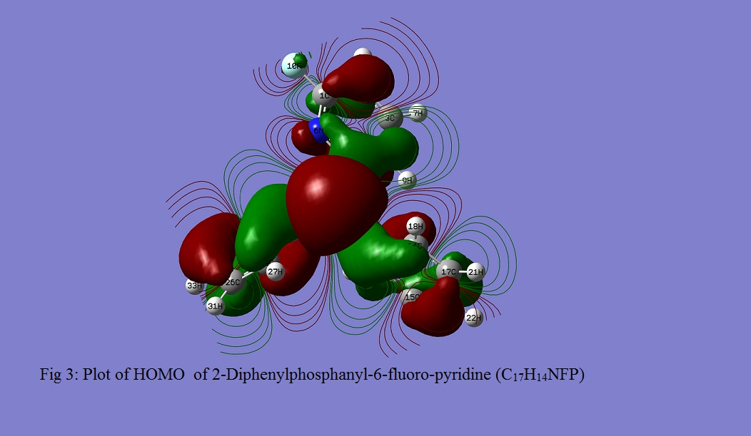
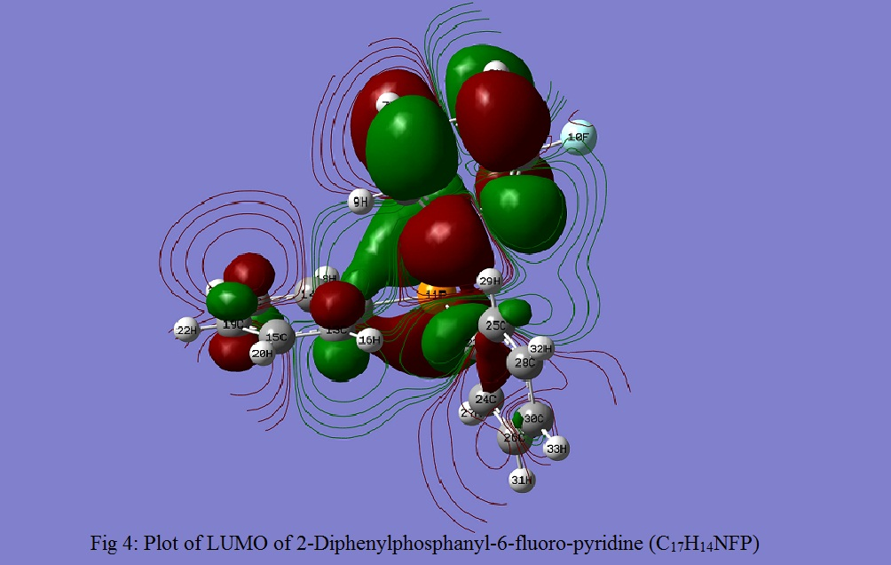
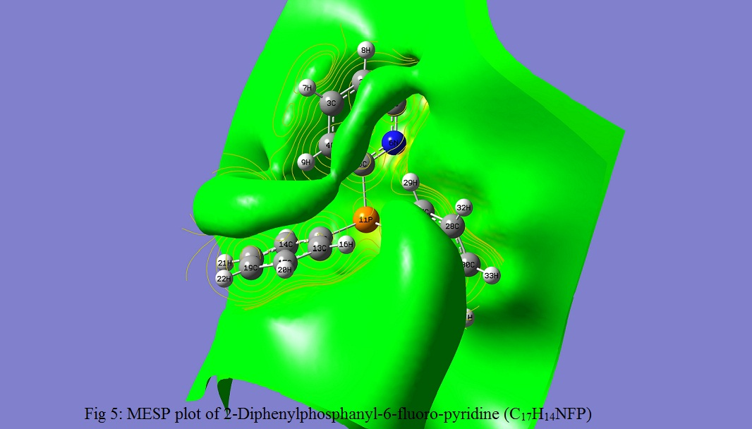
3.3 Vibrational Analysis
The maximum number of potentially active observable fundamentals of a nonlinear compound containing N-atoms is equal to (3N-6) [10]. The title compound “2-Diphenylphosphanyl-6-fluoro-pyridine (C₁₇H₁₄NFP)” contains 34 atoms and hence exhibits 96 normal modes of vibrations. The assignment of the calculated frequency, are supported by the animation of Gauss View 5.0.8, which gives a 3D-view of the vibrational modes. The potential energy distribution (PED) is calculated by VEDA 4 software program. To correct overestimations at the calculated harmonic frequencies an empirical uniform scaling factor of 0.983 up to 1700 cm⁻¹ and 0.958 for above 1700 cm⁻¹ were used [11]. All the vibrational assignments are presented in supplementary table 3.
3.3.1 (C-H) stretch
The aromatic structure rings R1, R2 and of the title compound show the presence of C-H stretching vibration in the region 3300- 3200 cm⁻¹ which is the a bit higher than the characteristic region for the ready identification of C-H stretching vibration [12]. These vibrations are found to be affected due to the position of the substitution.

Table 1 : Frequency assignments for 2-DiphenylPohospanyl-6-Fluoro-Pyridine at B3LYP/6-311G(d,p)
 | in cm^{–1}, with PED % in Square Brackets
 | Calc Freq |  | Theo. Freq | Assignment Modes[PED]
S.No. | Unscaled | Scaled | FTIR
1 | 3430 | 3286 | 3891(w) | ν(C4-H9)[72]+ν(C2-H8)sym[22]
2 | 3425 | 3281 |  | ν(C2-H8)asym-[74]+ ν(C4-H9)sym[25]
3 | 3397 | 3254 | 3345(s) | ν(C25-H29)sym[83]+ν(C28-H32)sym[12]
4 | 3392 | 3250 | 3308(vs) | ν(C13-H16)sym[73]+ν(C15-H20)sym[16]
5 | 3382 | 3240 | 3183(s) | ν(C25-H29)[10]+ν(C26-H31)asym[38]+ν(C26-H31)sym[27]
6 | 3368 | 3227 |  | ν(C24-H27)[31]+ν(C26-H31)[27]
7 | 3356 | 3215 |  | ν(C14-H18)[34]+ν(C15-H20)[38]
8 | 3349 | 3208 | 2849(m) | ν(C14-H18)asym[38]+ν(C19-H22)[20]+ν(C15-H20)[10]
9 | 1763 | 1689 | 1725(vs) | ν(C24=C26)sym[24]
10 | 1746 | 1673 |  | ν(C30=C28)[23]+ν(C23=C25)asym[15]
11 | 1668 | 1640 | 1599(m) | φ(H27-C24-C26)[21]+φ(H29-C25-C28)[19]+ν(C=C)[17]
12 | 1631 | 1603 | 1507(vs) | ν(C4=C5)[10]+ν(F10-C1)[10]
13 | 1609 | 1582 | 1469(wsh) | φ(H22-C19-C15)[31]+φ(H31-C26-C30)[21]φ(H20-C15-C19)[20]+φ(H21-C17-C19)[21]
14 | 1561 | 1534 | 1444(s) | ν(N6-C5)[19]+φ(C4=C5-N6)[16]
15 | 1506 | 1480 | 1408(s) | φ(H27-C24-C26)[33]+φ(H29-C25-C28)[35]
16 | 1452 | 1427 | 1378(m) | ν(F10-C1)[33]+φ(H8-C2-C1)[19]+ν(C2-C3)[11]
17 | 1342 | 1319 |  | ν(C1-N6)[10] +ν(C5-N6)[14]
18 | 1338 | 1315 | 1314(wsh) | φ(H21-C17-C19)[17]+φ(H20-C15-C19)[14]+φ(H18-C14-C17)[18]
19 | 1299 | 1277 | 1309(wsh) | ν(C4-C5)[35]+φ(H9-C4-C3)[13]+ν(P11-C5)[10]+φ(C4-C5-N6)[12]
20 | 1248 | 1227 | 1267(s) | ν(C26-C30)[35] +ν(C17-C19)[12] +ν(C23-C25)[14]
21 | 1218 | 1197 | 1234(s) | φ(C12-P11-C5)[15] + ν(N6-C5)[11]+ φ(C1-C2-C3)[18]
22 | 1202 | 1182 |  | τ(H8-C2-C1-N6)[10]+τ(H7-C3-C4-C5)[32]+τ(H9-C4-C5-P11)[19]+τ(H20-C15-C19-C17)[18]
23 | 1198 | 1178 | 1182(s) | τ(H31-C26-C30-C28)[18]+τ(H33-C30-C28-C25)[28]+τ(H32-C28-C30-C26)[17]
24 | 1188 | 1168 |  | R3-ROCK[13]
25 | 1177 | 1157 | 1148(s) | φ(C1-N6-C5)[25] +τ(H21-C17-C19-C15)[25]+τ(H18-C14-C17-C19)[20]
26 | 1167 | 1147 |  | τ(H29-C25-C28-H30)[20]+ τ(H27-C24-C26-H31[28]
27 | 1149 | 1129 | 1106(vs) | φ(C19-C15-C13)[15]+φ(C12-C14-C17)[13]
28 | 1113 | 1094 |  | τ(H22-C19-C17-C14)[38]+τ(H16-C13-C15-C19[22]
29 | 1104 | 1085 | 1058(wsh) | τ(H33-C30-C28-C25)[13]
30 | 1098 | 1079 | 1013(m) | τ(H9-C4-C5-P11)[48]
31 | 1087 | 1069 |  | φ(C2-C1-N6)[15]+φ(C1-N6-C5)[12]
32 | 1008 | 991 | 984(wsh) | τ(H18-C14-C17-C19)[21]+τ(H20-C15-C19-C17)[29]+τ(H16-C13-C15-C19)[19]
33 | 998 | 981 |  | τ(H29-C25-C28-C30)[24]+τ(H27-C24-C26-C30)[22]+τ(H31-C26-C30-C28)[26]
34 | 986 | 969 | 957(m) | ν(C1-C2)[30]+ν(C1-F10)[21]+ν(P11-C5)[10]
35 | 970 | 954 | 893(s) | τ(H9-C4-C5-P11)[15]+ω(F12-C1-N6-C2)[17]
36 | 893 | 878 |  | τ(H20-C15-C19-C17)[14]+τ(C19-C15-C13-C11)[22]+τ(C19-C15-C13-C11)[22]
37 | 888 | 873 |  | τ(C23-C25-C28-C30)[21]
38 | 872 | 857 | 802(w) | τ(C2-C1-N6-C5)[15]+ω(F10-C1-N6-C2)[23]+τ(H8-C2-C1-N6)[19]
39 | 817 | 803 | 772(s) | τ(H22-C19-C15-C17)[14]+τ(H18-C14-C12-C17)[15]+τ(C19-C15-C13-C12)[23]
40 | 810 | 796 |  | τ(C23-C25-C28-C30)[24]+τ(H33-C30-C28-C25)[18]+τ(H29-C25-C28-C30)[14]
41 | 781 | 768 |  | R2-PUCK[43] + ν(P11-C12)asym[10]+ ν(P11-C23)asym[14]
42 | 772 | 759 | 699(s) | R3-PUCK[27] + ν(P11-C12)[13]
43 | 752 | 739 | 668(wsh) | ν(P11-C5)[10]+ ν(C1-C2)[12]+φ(C1-C2-C3)[34]
44 | 729 | 717 |  | ω(F10-C2-N6-C1)[35]+ ω(C4-P11-N6-C5)[28]+τ(H8-C2-C1-N6)[12]
45 | 713 | 701 | 613(vs) | R3-PUCK[71]
46 | 622 | 611 |  | φ(C6-C1-F10)[13]+φ(C2-C1-N6)[28]+ν(F10-C1)[19]
47 | 584 | 574 |  | ω(P11-C24-C25-C23)[16]+ φ(C12-P11-C23)[13]
48 | 579 | 569 | 522(wsh) | ω(P11-C23-C12-C5)[10] + ω(P11-C24-C25-C23)[13]
49 | 537 | 528 |  | ω(C4-P11-N6-C5)[12]+τ(C3-C2-C1-N6)[17]+τ(C2-C1-N6-C5)[29]
50 | 503 | 494 | 505(s) | φ(N6-C1-F10)[27]+τ(F10-C2-N6-C1)[24]
51 | 478 | 470 | 449(s) | ν(P11-C23)[26]+φ(C23-C25-C28)[10]+φ(C5-P11-C23)[13]
52 | 469 | 461 |  | τ(C17-C19-C15-C13)[23]+τ(C14-C17-C19-C15)[27]
53 | 462 | 454 | 400(msh) | ν(P11-C5)[21]+τ(C24-C26-C30-C28)[16]
54 | 443 | 435 |  | ν(P11-C12)[29]+φ(F10-C1-N6)[14]+ω(H27-C24-C26-C30)[13]
55 | 68 | 67 |  | τ(C13-C12-P11-C23)[68]

3.3.2 C-C stretch
Ring Vibrations. The C–C aromatic stretch known as semi-circle stretching, are calculated at 1689, 1682, 1640, 1603, 1277 and 1224 cm^{–1}. They are in good agreement with the reported frequencies with appropriate PED. The theoretically calculated C–C–C bending and C–C torsional modes have been found to be consistent with the reported values [12].
3.3.3 C-N stretch
The C-N vibrational mode is not easily identified due to the mixing of vibrations of other modes in this region. In the title molecule, the C-N stretching vibrations are calculated at 1277, 1157 and 1069 cm⁻¹. Various bending and torsional vibrations assigned to the ν(C-N) stretching mode are also supported by the literature [13].
3.3.4 C-F stretch
The C-F stretching vibrations are calculated at frequencies 1603, 1427, 969 and 611 cm⁻¹. The corresponding in plane bending and torsional modes are reported in the literature [14, 15].
3.3.5 P- C stretch
The calculated values of P-C stretching mode is obtained at frequencies values 1277, 969, 768, 759, 739,454 and 435 cm⁻¹ with max PED value at 768 cm⁻¹. The frequency range of P-C stretching, in plane bending, out of plane wag and torsional Vibrational modes are reported in the literature [16].
3.3.6 Lower region vibrational modes
The study of low frequency vibrations is of great importance because it provides the information for weak intermolecular interactions, which occurs in enzyme reactions [17]. Study of low frequency modes is also useful for the interpretation of the effect of electromagnetic radiation on biological systems [18]. In the present study, some important calculated lower order vibrational mode are 701, 574 and 569 with assignment R3 puckering, ω(P-C-C-C) out of plane bending with 71%, 16% and 23% PED values. These mode seems to be one of the characteristic modes of the title compound.
In lower range discrepancies are observed in the experimental and theoretical intensity in lower range of frequencies which are due to the impurity of the sample used, intermolecular interactions, anharmonicity and mixing of different modes of vibrations.
4. Conclusion
Present study reports a comprehensive theoretical quantum chemical study on “2-Diphenylphosphanyl-6-fluoro-pyridine (C₁₇H₁₄NFP)”. The molecular geometry, vibrational wave numbers, infrared intensities, electronic and thermodynamic electronic properties of the title molecule have been calculated using DFT (B3LYP) method adopting at 6-31+g(d,p) basis set. Normal modes analysis provides detailed description of the Vibrational spectra of the molecules in question. A good agreement between reported and calculated normal modes of vibrations has been achieved. The aim of this paper is to obtain direct information on lower and higher frequency vibrations of such biological molecule. In the absence of experimental vibrational spectra of the title compound, the theoretically calculated spectra should provide an important path for experimentalists. All the measurements were made for the gas phase.

References
[1] Pyridine, PetroChemTrade, Copyright © 2009-2010, (petrochemt rade.com/xhr /doclink /ty/pdf/ id/ 16_d53c147bf8/.../3989613).
[2] Pyridine and Pyridine Derivatives, Vol. 20, Kirk-Othmer Encyclopedia of Chemical Technology (4th Edition), www.sciencemadness.org. March 2004, ISBN: 978-0-471-48494-3. A.D. Becke, J. Chem. Phys,1993, 98, 5648.
[3] C Lee, W Yang, R G Parr, Phys. Rev. B, 1988, 37, 785.
[4] P Hohenberg, W Kohn, Phys. Rev B, 1964, 136, 13864.
[5] M J. Frisch, et al Gaussian 09; Gaussian, Inc., Pittsburgh, PA, 2009.
[6] A Frisch, A B Nelson, A J Holder, Gauss view, Inc.Pittsburgh PA, 2005.
[7] (a) Jamroz M H, 2004 Vibrational Energy Distribution Analysis, VEDA 4 Program, Warsaw, Poland (b) Jamroz M H 2013 Spectrochim. Acta Part A 114 220.

[8] I Fleming, Frontier Orbitals and Organic Chemical Reactions, John Wiley and Sons, New York, 05–27, (1976).
[9] D Sajan, L Joseph, N Vijayan, M Karabacak, Spectrochim. Acta A, 81, 85–98, (2011).
[10] (a) R M Silverstein, G C Bassler, T C Morrill, 1991 Spectrometric Identification of Organic Compounds, John Wiley and sons; (b) G Socrates, 2001 Infrared and Raman characteristic Group Frequencies-Tables and Charts, Third ed., Wiley. New York.
[11] (a) M Karabacak, M Kurt, M Cinar and A Coruh 2009 Mol.Phys. 107 253 (b) N Sundaraganesan, S Ilakiamani, H Saleem, P M Wojciechowski and D Michalska, 2005 Spectrochim. Acta A 61 2995.
[12] M Arirazhagan and J S Kumar, 2011 Spectrochim. Acta, Part A 82 228.
[13] V Krishnakumar and R J Xavier, 2004 Spectrochim. Acta, A60 709.
[14] K Shobatake, C Postmus, J R Ferraro and K Nakamoto, Appl. Spectrosc. 23(1), 12
(1969).
[15] G M W Kroesen, H J Lee, H Moriguchi, H Motomura, T Shirafuji and K Tachibana, J. Vac. Sci. Technol. A16(1), 225 (1998).
[16] N B Colthup, L H Daly, S E Wiberley ; 1964 Introduction to Infrared and Raman Spectroscopy; Academic Press; New York, p 74, 199, 212, 225, 249, 260, 314, 315.
[17] K C Chou, 1980 J. Biophys. 45 881.
[18] H Frohlich, 1988 In Biological Coherence and Response to External Stimuli (Berlin: Springer).

