An Approach: e-Health System Design
Raghuvendra Pratap Tripathi Ankita Tiwari, Dr. G. R. Mishra, Dr. O. P. Singh
Department of Electronics and Communication Engineering
ASET, Amity University
Lucknow, India
Email: raghvendra5936@gmail.com

ABSTRACT
Now a day’s people are suffering from various diseases, as these diseases increases there is a need of diagnosis increases. People, affected from specific disease need continuous monitoring and detection of the different parameter which are affected by that disease. This problem can be solved by an autonomous embedded system, this system has ability of continuous monitoring of patient’s health. The patient can be observed or monitor from everywhere and also the data can be send to the health care centers where doctors and experts can keep the track of it. By this the importance of embedded system is increases in medical world. This system uses both invasive as well as non-invasive sensors for sensing. The specialized computing and monitoring devices are used for process, transport, and archive and visualize of the acquired data. This idea can be applied for sportsman, rescuers etc. type of professions where the continuous health monitoring is required. The embedded system application for e-health care shows dissimilar needs and characteristic, constitute problems at the computing and communication levels. This design proposes the widespread network based stand that is followed by a distributed approach to combine the embedded system for e-health system. This field uses an autonomous communication module, and determined by personal digital assistants (PDAs) to act as the Master and to interconnect an embedded system to the computer networks. The information is being sent to the main server that take care of the database and provides an access to the database. There is a use of cryptographic algorithms and the protocols in all systems so that data can be secured.
Keywords: Embedded system, e-health, and Biomedical application.

INTRODUCTION
For every country the development is dependent on the people of that place and people can perform well only if they have good health. Now, as everything is transforming into smartness and intelligence i.e. rinse system, security system, home automation, health care system etc. [1]. As the technologies are increasing in our modern life style, new diseases are also increasing in the human society [2]. In last few years as the demand increases of computing and the communication, there has been a large growth in the interest on embedded systems for the biomedical application, but at same time, encouraging and boosting the need and necessity to keep the applications autonomous and portable [3]. The clinical analysis (such as, lactate/glucose analysis), DNA analysis and proteomics analysis for the clinical diagnostics [3] [4], which are for biomedical operations of the clinical analysis, and in the real-time patient monitoring as well as biomedical assistants are given as the example where the portability is also required [3] [5] [6]. Communication with the general purpose computing systems are leading to addition of the wireless devices on embedded systems. Therefore, the embedded systems have to be maintained and designed with the low power communicating sub-systems for the biomedical applications and they have to be easily integrated with the more general distributed computing plots. At the computation as well as communication levels security and reliability issues have to be give preference on those plots [3].
The embedded system is a computer system with a dedicated function, more often with the real time computing constraints, it is hidden inside daily objects, which covers us. The embedded system is a combination of the hardware and the software both. Development of this embedded system has been opening the doors to a large number of applications that are helpful in improving daily life of a human being. Among these systems e-health care applications having more attention [7] [8]. An e-health care system is a wireless networking system which provides the widespread networking and its functionality. For biomedical and biological applications, embedded systems are the most multi-disciplinary research area and it also covers the fields of micro-systems and micro-mechanics [3] [9], the digital signal processing and the signal acquisition, information systems, the computer networks and databases [3] [10].
There are a-lots of trend available in biomedical systems such as an assistive technology for procedures e.g. therapeutic nano-machine, surgical robots, in body devices e.g. defibrillator, pacemaker, infusers for the drug management, and a treatment machine e.g. ventilators, linacs, an advisory systems, imaging /monitoring systems e.g. x-ray, scanners, blood gas, enhanced reality systems for the joint replacement and the micro-surgery. It is also including telesurgery, a telemedicine systems, telesupervision and teleconsultation.
Due to busy schedule of the daily routine, demand of the e-health care is also increasing. The e-health care can supplementary to a long stays in hospitals. The e-health care systems is widespread and very cost-effective solutions without any interrupting everyday activities of patients. Nevertheless, this system can be hampered if the security of data is not so strong enough [9]. The health data are very much sensitive [10] [11] as they are individual in nature [9]. For that reason, it is a very important to attention on the intended to be kept secret of someone’s private information.
The e-health care can be classify in three sections such as managing health of ill patients with the particular prominence on managing the long term condition, medication and implants, managing health of healthy patient such as actors, sportsmen and models and the clinical support from initial to acute service and connections management with other support services, education, accommodation and the social services.

PROPOSED SCHEME
In this paper author proposed some schemes which includes two sections. First section 2.1 presents the basic architecture of e-health care where the complete system is explained by block diagram and in section 2.2 presents the complete architecture of embedded system.

Basic architecture of e-health care
For improvement in e-health care system, the need and demand of wireless communication technologies is strongly increasing in the various areas such as industrial communication as well as in medical support technology.
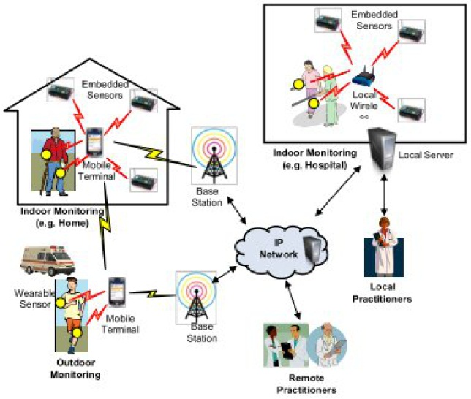
Figure 1: Block diagram of basic architecture of e-health care
As shown in figure 1, there are some master devices like mobile phones or the personal computers, can be connected using the wireless communication network protocols and these devices can also control one or more than one portable embedded system devices like biosensors. These bio-sensors are connected with the person’s or patient’s body by wearable gadgets. These sensors collect data from the patient or the person and sent this data to the required master device. These master devices upload this data to cloud storage. Each and every patient has unique ID to retrieve or access the data from webpage by its help. This data can be compared with the ideal vitals parameter and they are also stored into the cloud as the data crosses threshold value, an email is sent to the various centers such as doctor’s home, hospitals, care taker, pharmacy, etc. and an alarm goes off so that the urgent treatment can be provided to the patient all the calculation is real time so its efficiency is also better that traditional system. There are various other features are also provided in real time such as the patient is in critical condition and there is a need of an ambulance then there is a facility of mobile ambulance is also available, there is an e-card facility can be provided which has all the information about the patient blood pressure, body temperature, heart rate etc. on the basis of real time calculation because the card is updated time to time by the sensing and processing system and many more features are provided.
Some important components of the e-health care architecture are mentioned as following:

Mobile ambulance
In every critical situation, the patient needs to call an ambulance but in the e-health care system there is an auto location detector is available and that is able to sense the location of the patient and locate the hospital in that range if the distance is more than the threshold then first it updates the patient that he/she needs to go to the hospital whether there is a need of ambulance or not and if the response is positive it calls the nearby ambulance. Ambulance may also be provided a wireless communication system which the alarm signal is be sent to an ambulance service. The ambulance have the communication system with the hospitals to send the complete report of patient so that the mentioned time for starting the patient treatment can be reduced as much as possible.

E-card
In e-health care module whenever the patient is being admitted for the treatment, an electronic card with unique ID is prepared and it is given with all the information about patient related to its diagnosis. Further test reports and the treatment related information can be stored in that e-card and on the central web server. It is helpful as the person is referred to the other hospital and at that time the card will provide all the history of the patient treatment as well as all the diagnosis information. As the card is missed in the case of hurry all the information can be retrieved by the central web server by that unique ID.

Online doctors association
As the complete system is connected to the central server the report of the patient is being sent to the doctors or experts who are available online at that time for medical services. As the report are received by the doctors they prescribed the patient all the first aids before going to the hospital this will reduce the problems of the patient. As the available doctors cannot handle the problem the system will send that report to the experts and then the experts respond according to the requirement. This online health care is also helpful for the students of medical they can explore their knowledge by reading all the condition which arrive at real time.

Smart ICU system
As there is not sufficient staff is available in the hospital there is a smart ICU available which monitors the patient continuously in the real time and alarm will be generated as the need of doctor. In smart ICU there is a well-equipped bed is available which has all the tools available which can be required and there is a communication system available which informs the available doctor where that tool is these situations are helpful in as there is a lack of experienced or trained staff or in case of insufficient staff. This system is used for monitoring and record the patient’s vital parameters continuously at every instant and to sending this information to the staff or doctor which are mentioned in patient’s database.

Architecture of embedded system
The embedded system architecture is shown in figure 2. This architecture can be divided in two functional modules which are communication and processing modules. By the help of these two modules, embedded system can interchange information with computing devices, such as PDAs or laptops. These two modules are as follows:
- Communication module
- Sensing and processing module [3].
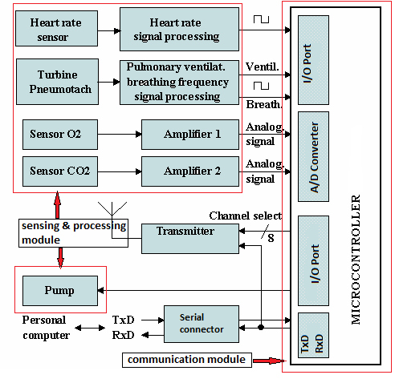
Figure 2: Architecture of embedded system
- Communication module
The communication module of the system includes the microprocessor or microcontroller, communication peripherals devices, and DTM (Data Transfer Manager). Data transfer manager is helpful in managing the communication and sending and receiving the information to and from the sensing and processing module.
- Sensing and processing module
Bio-sensors, sensor interface and signal processor are processed in sensing and processing module. Serial protocols can be used to establish the communication network between embedded modules. Master devices have complete control over these embedded systems and they are also connected to an embedded system.

MERITS OF E-HEALTH CARE SYSTEM
Although e-health care system contain several drawbacks over conventional health care system. But it makes an ease system by which the patient can directly communicate with doctor and that will also reduce time from the conventional methods such as apply for appointment and all methods. The doctors can easily aware about the patients previous health record and it will help during diagnosis. In situation of any direful event, people usually confused and frightened so there is a possibility of forgetting about the previous medical details. At the time of emergency every second is very important and it makes a difference between life and death so this method saves the time.
There are some advantages of e-health care system over conventional method are as follows:
- Reduce Paper Work
In traditional health monitoring system all the details related to the patient are written on paper and stored in the database of the hospital where the patient is treated and as if the time goes on there is a possibility of missing that data and also in some cases is patient has suffer from the same problem again or any new situation caused and if he/she consulted to a new doctor or the new hospital doctor faces the difficulty because they are unware about patient’s previous conditions. So as the digital database is created this type of problem will not appear.
- Improve quality of healthcare
This health care system provides real time monitoring system. Accurate, up to date and full information gives the very high quality of health care with reduced number of errors during diagnoses. In this design, reminders are send by electronic system so it is helpful in providing the real time updates of the system, by this patient can take care of himself. As in conventional system the paper prescription was given so there is a possibility of losing that prescription and the medicines cannot be taken on time, this type of problems are reduced by this e-health care system. As the e-health care system introduces the doctors can directly communicate with pharmacist so the error in understanding the medicines will reduce.
- Improvement in efficiency and productively
This e-health care system is better than the previous used traditional health care system as it is quickly access the information of patient from any location with specified queries also. Interchange between information among clinicians, experts, diagnostic and pharmacies center is trackable and faster by which the reduction in probability of losing the information and following calls. These features of e-health care leads to the great productivity in medical world.

CONCLUSION
Now a days as the things are going to be advance person needs such a smart system which can diagnose the health care problems and this can be possible if embedded devices are used in such as monitoring, diagnosis, telemedicine and managing the patient [13]. As embedded system is used for e-health care system including cloud monitoring and web services, they can provide better solution than the other conventional healthcare systems.
The embedded system architecture which is used for e-health is completely based on autonomous communication and it also supports more than one processing and the sensing using various requirements. Cryptosystems and unique ID can also be used to assure the security when any data needs to be transmitted. The challenges of future could be to innovate and invent the constraints and the compact devices for faster, smarter, reliable and very user friendly [13] the use of e-health systems.

ACKNOWLEDGMENTS
The authors are thankful to Hon’ble C – VI, Mr. Aseem Chauhan (Additional President, RBEF and Chancellor AUR, Jaipur), Maj. General K. K. Ohri (AVSM, Retd.) Pro-VC Amity University, Uttar Pradesh Lucknow, Dr. Anil Kumar, (Director, ASET for their motivation, kind cooperation, and suggestions.

REFERENCES
- Unnati Dhanaliya, Anupam Devani, “Implementation of E-Health Care System using Web Services and Cloud Computing”, in International Conference on Communication and Signal Processing, April 6-8, 2016, India.
- Priya Panneerselvam, “Application Of Embedded System For A Genetic Disease, Sickle Cell Anemia”, Department of Electrical and Electronics Engineering Thiruvalluvar College of Engineering and Technology Vandavasi-604505, Tamilnadu, India.
- Jose Germano, Rui Ramalho, Leonel Sousa, “On the Design of Distributed Autonomous Embedded Systems for Biomedical Applications”, INESC-ID / 1ST, TV Lisbon R. Alves Redol, Lisboa, Portuga.l.
- M. Piedade, L. A. Sousa, T. M. Almeida, J. Germano, B. A. Costa, J. M. Lemos, P. P. Freitas, H. A. Ferreira, and F. A. Cardoso, "A new hand-held microsystem architecture for biological analysis," IEEE Trans. Circuits Syst. Regul. Pap., vol. 53, no. 11, pp. 2384-2395, 2006.
- Tae-Soo Lee, Joo-Hyun Hong, and Myeong-Chan Cho, "Biomedical digital assistant for ubiquitous healthcare", Engineering in Medicine and Biology Society, 2007. EMBS 2007. 29th Annual International Conference of the IEEE, pp. 1790-1793,22-26 Aug. 2007.
- Tae-Soo Lee, Joo-Hyun Hong, and Myeong-Chan Cho, "Biomedical digital assistant for ubiquitous healthcare", Engineering in Medicine and Biology Society, 2007. EMBS 2007. 29th Annual International Conference of the IEEE, pp. 1790-1793,22-26 Aug. 2007.
- A. Halteren, R. Bults, K. Wac, D. Konstantas, I. Widya, N. Dokovski, G. Koprinkov, V. Jones, and R. Herzog, "Mobile patient monitoring: The mobihealth system," The Journal on Information Technology in Healthcare, vol. 2, no. 5, pp. 365-373, October 2004.
- L. Atzori, A. Iera, and G. Morabito, “The internet of things: A survey,”Computer Networks, Elsevier, vol. 54, no. 15, pp. 2787 – 2805, 2010.
- Zaid Alaa Hussien, et.al. “Secure and Efficient E-Health Scheme Based on the Internet of Things” 1Cluster and Grid Computing Laboratory, Services Computing Technology and System Laboratory Basrah, Iraq, 4Huazhong University of Science and Technology.
- P. Dario, M. C. Carrozza, A. Benvenuto, and A. Menciassi, "Microsystems in biomedical applications," Journal of Micromechanics and Microengineering, vol. 10, no. 2, pp. 235-244, 2000.
- E. Joseph and D. Bronzino, The Biomedical Engineering Handbook, 2nd ed. Boca Raton: CRC Press, 2000, ch. 53.
- S. Lim, T. H. Oh, Y. B. Choi, and T. Lakshman, “Security issues on wireless body area network for remote healthcare monitoring,” Proceedings of the IEEE International Conference on Sensor Networks, Ubiquitous, and Trustworthy Computing (SUTC), Newport Beach, CA, UAS, pp. 327–332, 2010.
- M. Li, W. Lou, and K. Ren, “Data security and privacy in wireless body area networks,” IEEE Wireless Communications, vol. 17, no. 1, pp. 51–58, February 2010.
- Priya Panneerselvam, “ Embedded system in biomedical applications: challenges ahead”, in International Journal of Science, Engineering and Technology Research, Volume 3, Issue 9, September 2014.

