Comparative Analysis of different models of Electric Arc Furnace

Amarjeet Singh
SMS Lucknow
Dept of Electrical & Electronics Engineering
amarjeetsingh@smslucknow.com

Abstract- The nonlinear and time varying nature of loads such as of Electric Arc Furnace (EAF) causes power quality problems such as harmonics, flicker and voltage /current unbalances. In order to analyze the power quality of power system containing Electric Arc Furnace, modeling of Electric Arc Furnace (EAF) is necessary. This paper presents different models of Electric Arc Furnace (EAF) to analyze its effect on the power quality. The behavior of these models under static and dynamic conditions is studied. A comparison is also made between these models of electric arc furnace. Simulation result shows the effect of different arc furnace models on voltage/current waveform and percentage harmonic component distribution.

Index terms: Electric Arc Furnace, Flicker, Furnace modeling.

I. Introduction

The most common task of Electric Arc Furnace is to convert the solid raw materials into liquid crude steel. Arc is a phenomenon created by current flow in a non- conducting media. Normally a pair of electrode (high thermal capacity materials) is used to create arc. The electrical arc furnaces are broadly of two types: AC & DC arc furnaces. AC arc furnaces can be single phase or three phase electrode combinations. Single phase can carry one third of power as compared to three phase and therefore low power arc furnaces can be realized by using single phase. A three phase arc furnace is a highly unbalanced, time varying, non-linear load causing problem to the power system quality whereas single phase has all similar property except the unbalancing problem. The power quality is mainly affected by flicker, voltage and current harmonics. Flicker causes voltage fluctuations in the connected electrical network which in turn can affect other users. The effect of voltage flicker on the arc furnace voltage is in the frequency range of human vision(4-14 Hz).These effects also reduces the efficiency of power system and also the life of other electrical equipment connected in the electrical network. Increased amount of losses, overheat, noise are other problems are cause of flicker and harmonic generation. Hence, modeling of EAF has attracted many electrical engineers to study its effects on power quality.
There are many methods to describe the electric arc. The time domain methods based on the differential equations are presented in [1,2]. The balanced steady state equations to describe electric arc furnace are used in [3,4]. Other methods such as using non-linear differential equations [4,5], V-I characteristics [6-7], frequency response [7-8] are used to model the electric arc furnaces. Modeling of the electric arc furnace can be done both in time domain and transform domain(s-domain or frequency domain). Since the electric arc furnace is a nonlinear and time varying load its operation can be best studied in time domain. In transform domain analysis include representation of arc voltage and arc current by its harmonic content. Device or system is normally characterized/modeled by its voltage/current behavior and it is called VI characteristics (VIC).

This paper presents different linear approximation of VIC of electric arc furnace. These models have been used to study the effect of electric arc furnace on power quality. Simulation results are also provided.

II. Arc Furnace Electric Circuit

A single phase arc furnace connected to utility grid at point of common coupling through internal impedance of Z_{s}is shown in fig1.
V(t) and Z_{s} represents the system voltage and impedance respectively and bus AF is the low voltage side of the transformer whose impedance is given as Z_{t}.

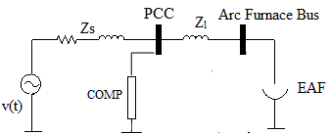
Fig.1. Arc Furnace system Configuration

The V-I characteristic of AC Electric Arc Furnace is empirically evaluated and is shown in fig 2.

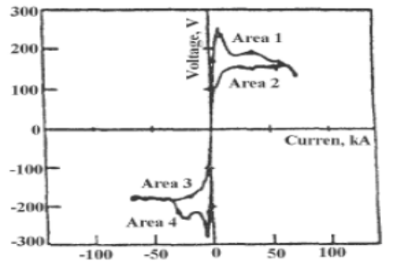

Fig.2. Actual V-I characteristic of EAF. [1]
The empirical VI characteristic of Electric Arc furnace has four major regions of operation as shown in fig 2.

Area 1:

$\frac{di}{dt}$>0, v & i>0 (1)

Area 2:

$\frac{di}{dt}$<0, v & i>0 (2)

Area 3:

$\frac{di}{dt}$<0, v & i<0 (3)

Area 4:

$\frac{di}{dt}$>0, v & i <0 (4)

III. Mathematical Modeling of V-I characteristic of an Electric Arc Furnace

Piecewise linearization method is normally used to obtain models of EAF to approximate VI characteristics as shown in fig 2. Different methods are proposed in literature [12]. In this paper, three models of EAF is taken for analysis and their impact assessment. These are referred as Model 1, Model 2, and Model 3.
- Model 1

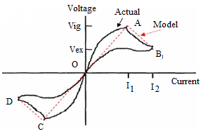

Fig.3. Actual and piece-wise linear approximation of V-I characteristic of EAF. [1]

One of the models has been proposed by [12]. In this model the approximated characteristic spans between area between 1 and 2. The arc voltage varies linearly with arc current till current i₁ and slope of characteristic becomes negative for line AB. This is also true for third quadrant. The actual V-I characteristic of EAF can be approximated by the following mathematical linear model [12].
Let V be the arc voltage at any point on VI characteristic as shown in fig 3.
V= $\left\{\begin{aligned}r_{1}i -i_{1}≤i<i_{1} \\ r_{2}i+v_{ig}(1-\frac{r_{2}}{r_{1}}) i_{1}≤i<i_{2} \\ r_{2}i-v_{ig}\left(1-\frac{r_{2}}{r_{1}}\right){ -i}_{2}≤i<{-i}_{1}\end{aligned}\right.$
(5)
Where r₁, r₂ are the slope of lines OA and AB respectively.i₁and i₂ are boundary current and
$V_{ig}$, $V_{ex}$ are arc ignition and arc extinction voltage respectively.

$i_{1}= \frac{V_{ig}}{r_{1}}$(6)

$i_{2}=\frac{V_{ex}}{r_{2}}- V_{ig}(\frac{1}{r_{2}}- \frac{1}{r_{1}})$ (7)
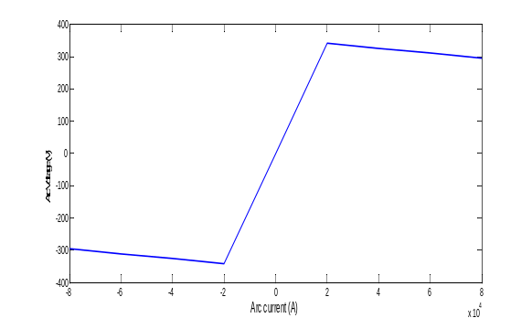

Fig.4. Static V-I characteristic for model 1.

EAF is modeled by equation (5), (6) and (7) and simulated in MATLAB. Fig 4 shows the static V-I characteristic of arc furnace obtained from above equations. This fig also shows that arc resistance for model 1 varies linearly.
- Model 2
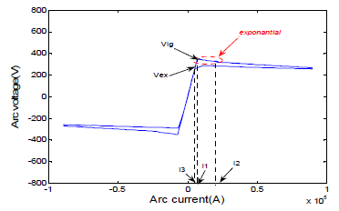
Fig.5.V-I characteristic of arc furnace for model 2.

A more approximate model of arc furnace is proposed in [12] and it is given in fig 5. In this mathematical model arc melting process is divided into three parts. In the first part the voltage magnitude increases from extinction voltage -$V_{ex}$ to ignition voltage${ V}_{ig}$. The arc current changes its polarity from -$i_{3}$to${ i}_{1}$. In the second part there is a sudden exponential voltage drop across the electrode and voltage drops from $V_{ig}$ to $V_{st}.$In this part current there is a very little increase in current from i₁ to i₂. In the third part normal arc melting process takes place. The arc voltage drops linearly and slowly from V_{st} to V_{ex}.
The mathematical equations for the model 2 are shown below [12].

V=$\left\{\begin{aligned}r_{1}i \left(-i_{3}≤i<i_{1}, inc\right)or \\ \left(-i_{1}≤i<i_{3}, dec\right) \\ V_{st}+\left(V_{ig}-V_{st}\right)\exp\left(\frac{i_{1}-i}{i_{T}}\right)i_{1}≤i<i_{2} , inc \\ V_{st}+\left(i-i_{2}\right)r_{2} i≥i_{2}, inc \\ V_{ex}+\left(i-i_{3}\right)r_{3} i≥i_{3}, dec \\ {-V}_{st}+\left(V_{st}-V_{ig}\right)\exp\left(\frac{i_{1}+i}{i_{T}}\right){-i}_{2}≤i<{-i}_{1} ,dec \\ -V_{st}+\left(i+i_{2}\right)r_{2 } i<-i_{2} ,dec \\ \\ {-V}_{ex}+\left(i+i_{3}\right)r_{3} i<-i_{3} ,inc \end{aligned}\right.$ (8)

Where,
i₁=$\frac{V_{ig}}{r_{1}}$(9)

i_{T} = 1.5i₁ (10)
i₂ = 3i₁ (11)
i₃= $\frac{V_{ex}}{r_{1} }$ (12)
where r₁, r₂, r₃ are the corresponding slope of each section. i₁, i_{T ,} i_{2 ,}i₃are boundary currents and $V_{ig}$, $V_{ex}$ are arc ignition and arc extinction voltage respectively.

- Model 3
A third method is proposed in [12] and is shown in fig 6. The Arc melting process can be divided into three parts. In the first part the arc begin to reignite from extinction. The arc voltage and arc current simultaneously reaches at zero crossing point. As the arc voltage equals the reigniting voltage the equivalent circuit act as open circuit. In the second part the arc is ignited and a sudden change is noticed in the voltage waveform at the beginning of arc melting process. The arc voltage falls from V_{ig} to a constant voltage V_{d}. This part of the process is approximated to exponential function with time constant т₁. In the third part of the process the arc begins to extinguish. The arc voltage continues to drop smoothly. This part of the process is also approximated to exponential function with time constant т₂.In this model the EAF is modeled as a current controlled non-linear resistance.
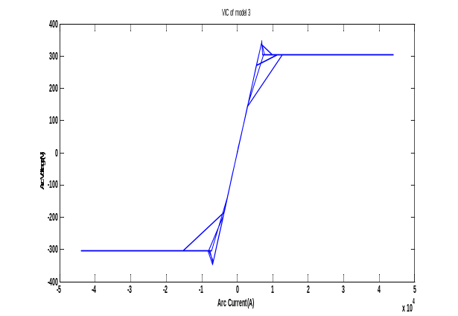

Fig.6. V-I characteristic of arc furnace for model 3.

These are the mathematical equations for model 3[12].
Let R_{a} be the arc resistance at any point in the VI characteristic of EAF as shown in fig 1.

R_{a} = $\left\{\begin{aligned}r_{1} 0≤I<i_{ig}, \frac{dI}{dt}>0 \\ \frac{V_{d}+\left(V_{ig}-V_{d}\right)\exp\left(-\frac{I-I_{ig}}{т_{1}}\right)}{I} I>i_{ig}, \frac{dI}{dt}>0 \\ \frac{V_{t}+\left(V_{ig}-V_{t}\right)\exp\left(-\frac{I}{т_{2}}\right)}{I+i_{ig}}\frac{dI}{dt}<0\end{aligned}, \right.$
(13)

Where,
I =$\left|i(t)\right|$ (14)
V_{ig} = 1.15V_{d} (15)
I_{ig} = $\frac{V_{ig}}{r_{1}}$(16)
V_{t} = $\left[\frac{I_{max}+ i_{ig}}{I_{max}}\right]V_{d }$(17)

IV. Equivalent Arc Resistance.

Variation of current dependent arc resistance is studied for three models. The arc resistance of model 1 varies linearly with arc current. Arc resistance for model 2 and model 3 varies in somewhat similar manner as shown in fig 8. However regions of operation in this curve are difficult to show because of overlapping. Let R be the current dependent arc resistance and I be the arc current then
R=f (I) Where f(I) is non-linear function of current.

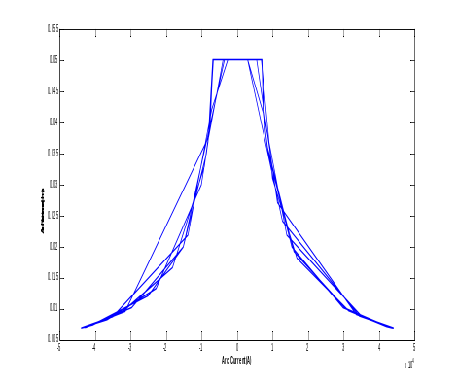
Fig.8. Variation of arc resistance for model 3.

V. Effect of non-linearity of an Electric Arc Furnace

An EAF connected to utility grid at point of common coupling (PC) through internal impedance as shown in fig 1.The simulated results are presented as a comparison of three models of EAF-model 1, model 2, model 3. From fig 9, 10 and 11 we noticed that arc voltage and arc current are out of phase. When arc current reaches at its peak value there is a dip in arc voltage at this instant. In fig 9, 10, 11 source current is scaled to match source voltage and arc voltage. The dip in arc voltage of model 3 is somewhat less than other two models.

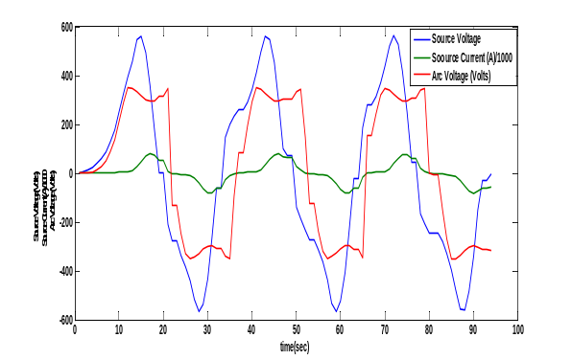

Fig. 9.Source Voltage, Source Current and Arc Voltage for model 1.

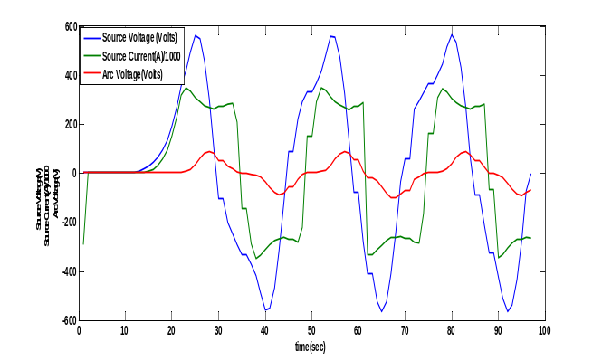
Fig.10. Source Voltage, Source Current and Arc Voltage for model 2.
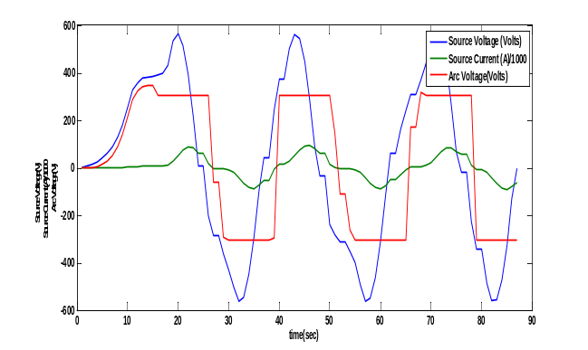

Fig. 9. Source Voltage, Source Current and Arc Voltage for model.

VI. Impact on Real Power (P)/Reactive Power (Q).

The impact on real/reactive power is studied and is shown in fig 10, 11 and 12. The power flow diagram of model 2 is considered to be more accurate as model 2 best fits to EAF VI characteristic. The magnitude of active/reactive power of model 1 is less than of model 2. For model 3 the power flow profile is somewhat similar to model 2. Table I shows the magnitude of active/reactive power for three models taken in this paper. The transient condition for model 1 extends more than model 2 and 3 as shown in fig below.

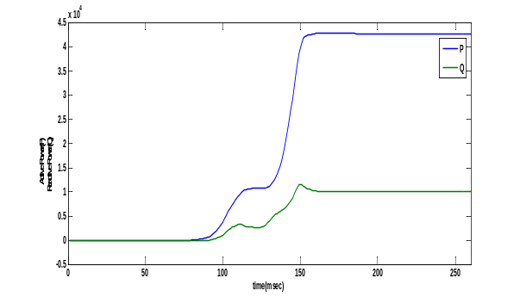
Fig.10. Active Power (P) and Reactive Power (Q) flow of model 1.
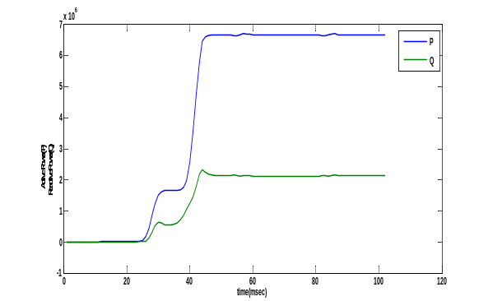
Fig.11. Active Power (P) and Reactive Power (Q) flow of model 2
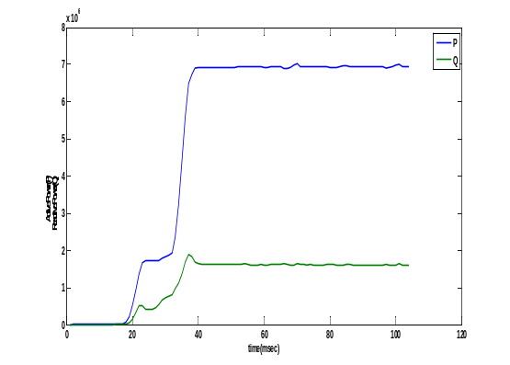
Fig.12. Active Power (P) and Reactive Power (Q) flow of model 3.

VII. Harmonic Analysis
A.FFT Analysis of Arc Voltage Waveform.

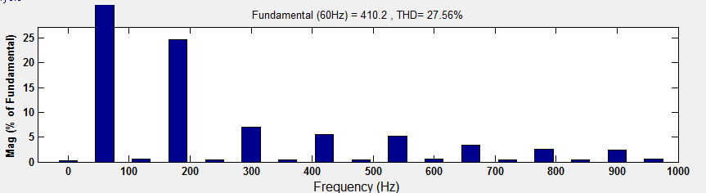
Fig.13. Simulated harmonic content of Arc Voltage of model 1.

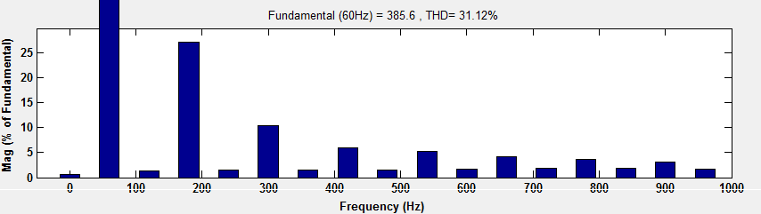

Fig.14. Simulated harmonic content of Arc Voltage of model 2.

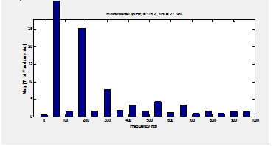

Fig.15. Simulated harmonic content of Arc Voltage of model 3.

- FFT Analysis of Voltage (V_{PCC}) Waveform.

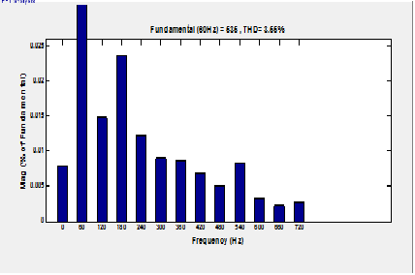

Fig.16. Simulated harmonic content of Voltage V_{pcc} for model 1.

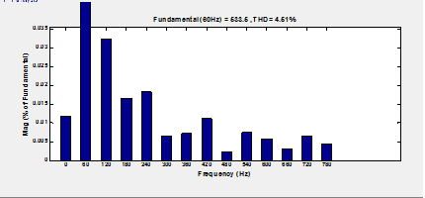

Fig.17. Simulated harmonic content of Voltage V_{pcc} for model 2.

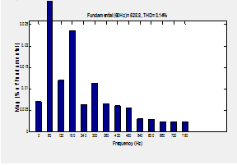

Fig.18. Simulated harmonic content of Voltage V_{pcc} for model 3.

Table I. Arc Voltage Harmonic content as a percentage of fundamental.

Harmonic | Model  1 | Model  2 | Model  3
Fundamental(V) | 290 | 272.7 | 266
3rd (%) | 0.35 | 0.38 | 0.36
5th (%) | 0.10 | 0.15 | 0.11
7th (%) | 0.08 | 0.08 | 0.05
9th (%) | 0.07 | 0.08 | 0.06
11th(%) | 0.05 | 0.06 | 0.05
13th (%) | 0.04 | 0.05 | 0.02

Table II. Harmonic content of Voltage at point of common coupling (V_{PCC}) as a percentage of fundamental.

Harmonic | Model  1 | Model  2 | Mode 3
Fundamental(V) | 378.3 | 377.2 | 373.9
3rd (%) | 0.02 | 0.02 | 0.02
5th (%) | 0.01 | 0.01 | 0.01
7th (%) | 0.01 | 0.02 | 0.02
9th (%) | 0.01 | 0.01 | 0.01
11th(%) | 0.01 | 0.01 | 0.01
13th (%) | 0.01 | 0.01 | 0.01

Note-all the values are with respect to base value taken as their fundamental.

Table III. Arc Current Harmonic content as a percentage of fundamental.

Harmonic | Model  1 | Model  2 | Model 3
Fundamental (KA) | 151.8 | 168.8 | 129.5
3rd (%) | 0.38 | 0.34 | 0.33
5th (%) | 0.07 | 0.09 | 0.07
7th (%) | 0.04 | 0.04 | 0.02
9th (%) | 0.03 | 0.03 | 0.02
11th (%) | 0.01 | 0.02 | 0.01
13th (%) | 0.01 | 0.01 | 0.01

Table IV. THD at V_{PCC}

 | Model  1 | Model  2 | Model  3
% THD | 3.55 | 4.51 | 3.14

VIII. Conclusion.

This study, firstly investigate three models of electric arc furnace. Piecewise linearization method is used to obtain the approximate models. These models do not require any initial conditions. In model 1 and model 2 arc voltage is taken as a function of arc current, whereas in model 3 arc resistances is taken as non-linear function of arc current. From figure 5, 6 and 7 we conclude that model 2 best fits to ideal V-I characteristic. Electric Arc Furnace can be best modeled as non-linear resistance using model 2. If we use Models 1 and 3 can to model EAF, compensator 1 need to be over-compensated. Harmonic analysis for source voltage and arc voltage is also done. For designing compensator 1 harmonic analysis of voltage at point of common coupling is essential. Similarly, for compensator 2 harmonic analysis of arc voltage is required.

IX. REFERENCES

[1] Medina, A., M.A. Gomez-Martinez and C.R. Fuerte-Esquivel Medina, A., M.A. Gomez-Martinez and C.R. Fuerte-Esquivel, 2005. Application of bifurcations theory to assess nonlinear oscillations produced by AC electric arc furnaces. IEEE. Trans. Power Delivery, 20:801-806.

[2] Collantes-Bellido, R. and T. Gomez, 1997.” Identification and modeling of a three phase arc furnace for voltage disturbance simulation”. IEEE Trans. Power Delivery, 12: 1812-1817.

[3] MAYORDOMO-J.G.-BEITES,L.F.-ASENSI-R.IZZ EDDINE, M. “A New Frequency Domain Arc Furnace Model for Iterative Harmonic Analysis”, IEEE Transactions on Power Delivery 12 No. 4(1997), 1771-1778.

[4] BEITES, L. F. –MAYORDOMO, J. G.-HERNANDES, A.-ASENSI, R.: “Harmonics, Inter Harmonic, Unbalances of Arc Furnaces: A New Frequency Domain Approach”, IEEE transactions on Power Delivery 16 No. 4(2001), 661-668.

[5] SCHAU, H-STADE, D.: “Mathematical modeling of Three Phase Arc Furnaces”, Proc. IEEE International Conference Harmonics Power System, Bologna (21-23 September, 1994), 422-428.

[6] PETERSEN, H.M.-KOCH, R.G.-SWART, P.H. HEERDEN, R.. “Modeling Arc Furnace Flicker Investigating Compensation Techniques, International Conference on Industry Applications” Conference, 1995. Thirtieth IAS Annual Meeting, IAS’95, pp. 1733-1740, 8-12 October 1995.

[7] ZHENG, T-MAKRAM, E.B.-GRRGIS, A. : “Effect of Different Arc Furnace Model on Voltage Distortion” IEEE Conference on Harmonics and Quality of Power, 1079-1085. 14-18 Oct 1998.

[8] MONTANARI, G.C.-LOGGINI, M.-CAVALLINI, “Arc furnace model for the study of flicker compensation in electrical networks,” IEEE Transactions on Power Delivery, Vol. 9, pp.2026– 2036, 1994.

[9] Mahdi Banejad, Rahmat-Allah Hooshmand and Mahdi Torabian Esfahani,“Exponential-Hyperbolic Model for Actual Operating conditions of Three Phase Arc Furnaces”, American Journal of Applied Scinces 6(*): 1539-1574, 2009.

[10] Alonso, M. A. P. & Donsion, M.P., “An improved time domain arc furnace model for harmonic analysis”, IEEE Transaction on Power Delivery, 19(1): 367-373, 2004.

[11] Balan, R., Hancu, O. & Stan, S., “Modeling and control of an electraic arc furnace”, The 9th Interbnational Conference-Electrical Power Quality and Utilisation: 411-416, Barcelona, Spian, 2007.

[12] M. A. Golkar, M. Tavakoli Bina, S. Meshi, “A Novel method Arc Furnace Modeling for Flicker Study” .

