OPTIMISING GAS METAL ARC WELDING
USING VARIOUS FERROUS MATERIALS
Mahima singh ¹, Research Scholar Aditya Chaubey SRIMT, K.G.Sinha Assistant Professor at SMS, LUCKNOW
Abstract—Gas Metal Arc Welding (GMAW) provides higher welding speeds, good deposition rates, less post welding cleaning and better welds pool visibility and incorporates it for large industrial application. The material and input parameters plays a vital role in weld quality, speed and cost for GMAW. The objective of this research was to investigate the optimization process parameters for GMAW. The work presents the influence of welding parameters like material, welding current, wire feed rate, and gas flow rate. Tests were performed to determine the effect on output parameters like bead geometry (Bead width, Bead height, Penetration), heat affected zone (HAZ) for quality target and hardness for the bond refinement. Feed Wire ER70S-6 was used to weld three different ferrous base metals of EN Series 3, EN Series 8 and EN Series 31 by using CO2 as shielding gas because of their wide usage in industries. Experimental layout was formulated using L9 orthogonal array to reduce number of operations. Taguchi Analysis was applied to understand the influence various parameters Signal to noise (S/N) ratio and analysis of variance (ANOVA) were employed to investigate and predict the percentage effect of each parameter on results. Finally the optimal test was conducted to verify the results.

Key words—MIG welding, EN series, GMAW, Bead geometry,
Taguchi orthogonal array, Analysis, of varianceANOVA.

I.INTRODUCTION

It was the beginning of the 19th century when discovery of electric arc by Humphrey Davy, sparked the developments in the principles of Gas Metal Arc Welding. Initially, carbon electrodes were preferred but by late 1800s, the invention of metal electrodes by N.G. eventually replaced them. The timeline for GMAW officially commences from 1948, when Batelle Memorial Institute had finally developed this new welding technique. In the current scenario, GMAW is recognized as one of the most prominently used welding techniques in the industry.“GMAW” work by creating an electrical connection between a continuous, consumable wire electrode and the work piece. The consumable wire which serves as both the energy source and filler material, is supplied through a gun, and forms a continuous weld (or puddle).
Higher welding speeds, greater deposition rates, lesser cleaning is required post welding, low skill factor needed to handle Metal Inert Gas welding torch, easily automated and ultra-low hydrogen process provide a uniform weld bead.
Higher cost for initial setup requires a stable ambience throughout the welding process, methodical and robust skills are essential for setting of the plant variables, less efficient at the requirement of high duty cycle.

Lower-current GMAW brazing finds its application on high-strength steels and thin-gauge. Automotive and general repair workshops are also one of the areas where GMAW is used extensively. Among these major applications, GMAW is prominently utilized in many other structural steelwork and spheres of construction industry such as bridges, wind turbine towers, assembly of white goods and office furniture etc.

II.Proposed Methodology
- Identified the importance of GMAW’s process parameters using extensive research.
- Studied the specification of “Swatic Welding Machine”.
- Found the upper and lower limits (i.e. range) of the identified process parameters.
- Selected the orthogonal array (design of matrix) using Taguchi technique on MINITAB software.
- Selection of base metal, filler metal, works piece size.
- Designing of special fixture using Solid works.
- Fixture was fabricated using different machining process.
- Conducted the experiments as per the selected orthogonal array
- Welded pieces were machined for testing.
- Etching was done usingNital solution to measure HAZ and Bead Geometry.
- Hardness was tested by Rockwell hardness Test.
- Analysis of data was done using Taguchi analysis by MINITAB software.
- A special piece was welded and tested to apply ANOVA by increases the number of experiments
- Optimal Experiment was conducted and verified by performing and testing optimal pieces as per Taguchi Graph.

III.TESTING
All the pieces were cut from transverse section using power hack saw from mid length. The ends of the weld piece were grinded and filled. The specimen’s faces were cleaned.

HAZ
The work piece was grinded and filed and rust was removed using HCLWork piece was cleaned with ethanol and finally scrubbed by Nital solution (5% volume) to observe HAZ.

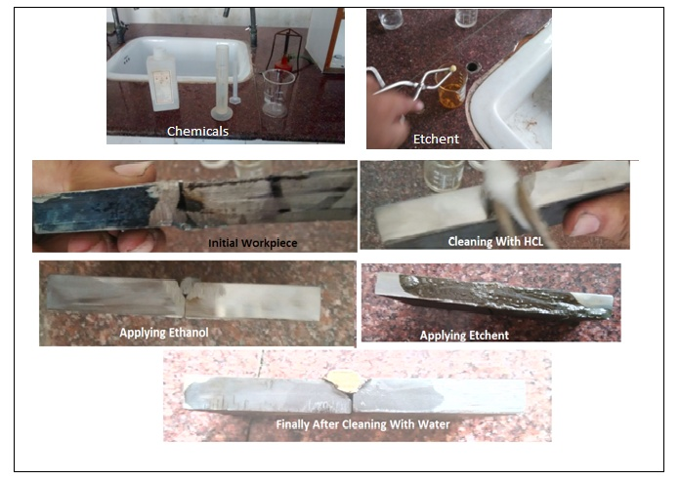
.

Fig :1Eatching process

Microscope with 10x optical zoom was used to measure HAZ
Range of Main Scale=50cm
Range of venire Scale=5unit
Least count of main scale=1/20=0.05cm
Least of venire scale=0.05/50=0.001cm
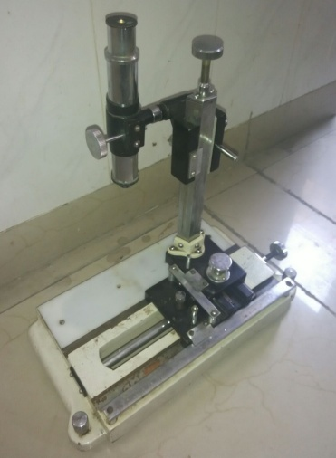

Fig:2 spectroscope

HAZ TEST
HEAT AFECTED ZONE
S.NO | Start  Cm | End  Cm | Final  Cm
1. | 1.127 | 2.149 | 1.022
2. | 1.549 | 2.457 | 0.908
3. | 1.428 | 2.300 | 0.872
4. | 1.162 | 2.316 | 1.154
5. | 1.458 | 2.356 | 0.898
6. | 1.481 | 2.327 | 0.846
7. | 1.127 | 2.149 | 1.022
8. | 0.937 | 2.287 | 1.350
9. | 1.334 | 2.593 | 1.259

Bead Geometry
Coc.HCL was applied to clean the work pieces
Bead Height from bottom=h-s
Penetration=s-b
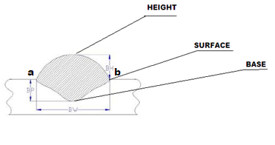

Fig:3 General geometry of beadLateral

Range of Main Scale =50cm
Range of venire Scale=5mm
Least count of main scale=1/20=0.05cm

Longitudinal

BEAD GEOMETRY
S.N.O |  |  |  | Bead Height from bottom | Penetration | Bead Width
 | (h) cm | (s)cm | (b)cm | (b.h)  Cm | (b.p)  cm | Start  cm | End  cm | Final  (bw)cm
1. | 9.578 | 9.472 | 8.616 | 0.962 | 0.856 | 1.327 | 0.577 | 0.750
2. | 10.116 | 9.916 | 9.383 | 0.733 | 0.533 | 1.857 | 1.154 | 0.703
3. | 9.816 | 9.500 | 8.994 | 0.822 | 0.506 | 2.050 | 1.392 | 0.658
4. | 8.894 | 9.138 | 8.583 | 0.311 | 0.555 | 1.558 | 0.96 | 0.598
5. | 9.71 | 9.651 | 9.010 | 0.7 | 0.641 | 8.530 | 7.777 | 0.753
6. | 9.783 | 9.661 | 9.149 | 0.634 | 0.512 | 1.657 | 0.945 | 0.712
7. | 9.816 | 9.783 | 8.983 | 0.833 | 0.800 | 1.149 | 0.454 | 0.695
8. | 10.238 | 10.063 | 9.554 | 0.684 | 0.509 | 1.428 | 0.805 | 0.623
9. | 10.261 | 10.194 | 9.272 | 0.989 | 0.922 | 1.472 | 0.522 | 0.950
Range of Main Scale =10cm
Range of venire Scale=5mm
Least count of main scale=1/20=0.05cm
(b)Hardness
All work pieces were grinded to make the surface smooth for Rockwell hardness test.
Hardness scale-HRC
Minor Load-10kgf
Indenter-120 Degree Diamond Indenter
Major Load-150Kgf

HARDNESS
S.No | Reading  1 | Reading  2 | Reading  3 | Average
1. | 46 | 46 | 49 | 47
2. | 43 | 42 | 45 | 43.33
3. | 40 | 37 | 36 | 37.66
4. | 28 | 29 | 24 | 27
5. | 45 | 44 | 40 | 43
6. | 45 | 39 | 40 | 41.33
7. | 32 | 40 | 36 | 36
8. | 59 | 60 | 52 | 57
9. | 48.5 | 46.5 | 61 | 52

GMAW is the widely used welding process for thicker metals and by this experimentation easy of welding and suitability welding on the bases of available base metal was studied as per the requirement welding fixture was designed and fabricated for better of welding finish.

1-First analysis shows that Material is most influencing factor by taking HAZ as quality parameter which contribute about 37.74% and error also contribute to same level followed by the Gas flow rate and then by feed rate. This influence of material on HAZ could be because as per different material has different effect on the HAZ because different composition reacts differently to heat due to their conductivity. Contribution of error signifies that there is some other factors which effect HAZ and are not included

Better weld quality is achieved by minimum HAZ and this study shows that at minimum carbon content this studyshows that percentage of carbon has maximum effect on HAZ. This is because thou carbon is good emitter and absorber but in ferrous it form oxides which leads to poor conductivity and hence more HAZ on the surface. Ghosh,A., Chattopadhyaya, S., and Sarkar, P.K., also showed that the chemical changes to the material’s microstructure can be reduced by using low-steel carbon alloys.

2-Second analysis shows thatMaterial is most influencing factor by taking Hardness as quality parameter which contribute about 32.75%followed by the Gas Flow rate which affects by 26.70% then current and feed wire which effect quality the least (18%) equally. The maximum carbon content the Hardest weld is achieved at EN31 which has maximum amount of carbon this because larger the carbon content more is the hardness. For better quality it is preferred to keep hardness maximum and hence as per Taguchi’s S/N ratio Graph optimal value of hardness can be achieved in EN31 with maximum gas flow rate as they provide maximum carbon content.

3-Third analysis shows that Feed wire rate is most influencing factor by taking Penetration as quality parameter which contribute about 66.86% followed by the Gas Flow rate , current and material which nearly effect equally about by 8% each.. This is because larger the metal melts more it will penetrate. S/N ratio graph shows that the maximum bead can be achieved by maximum Feed Wire rate and Gas flow rate hardly effects the penetration there for economical use it should be kept minimum. Current also influences the penetration greatly because it causes melting of wire but still the optimum value will be at 200A to melt the wire because excessive current leads to flatter bead so penetration decreases.9% contribution of error shows that there is interdependency between parameters. Ghosh et al. had found that the affect of input parameters on weld bead geometry. There is negative effect of increased welding speed on weld bead geometry. The depth of penetration increases but weld bead width decreases with increase in current because larger the metal melts more it will penetrate

4-Fourth analysis of shows that Feed wire is most influencing factor by taking bead width as quality parameter and influence contributes about 64% followed by current(24%) , gas flow rate(10%), and material which nominally effects the output. Bead width is affected as larger the arc length and larger feed leads to more melting of wire and excessive current leads to flatter bead so the S/N ratio graph shows that optimal value of bead can be obtained by taking current at 300A and feed at 6m/min that means higher feed and high current. This is also to be considered that excessive current should not be compensated by excessive travel speed this can result in slag inclusions due to rapid cooling of the weld.EN31 give the better bead width because of its poor conductivity greater fusion takes place.

IV. FUTURE SCOPE

- Spectroscopy of welded pieces can be done to understand changed composition due to welding
- L27 array can be used for better results
- Interdependence of parameter can be consider for better quality
- Grey relation can be applied for combined effects
- Tensile test can be performed to determine the joint strength
- Same experiment can be repeated by replacing Gas flow rate with other input parameter.

V. CONCLUSION

According to parametric analysis it has been concluded.
- For better HAZ and Bead Height Carbon content of base metal should be minimum and material mostly influences the results
- For better Hardness Material should have maximum carbon content but it has beenwhile machining that harder welds are not good for the purpose.
- For Penetration and Bead width it has been observed material and current influences the most. The excessive current leads to flatter bead
- By the experiment it is advised to keep Gas Flow nominal because it affects the weld least.
- Since experiments were performed within confidence level of 95% so error in results were mainly due to dependency within input parameters which is not considered as aspect while performing or due to the effect of some other noise parameters which were not considered as input variable.

REFERENCE
- Dinesh Mohan Arya, VedanshChaturvedi&JyotiVimal, “PARAMETRIC OPTIMIZATION OF MIG PROCESS PARAMETERS USING TAGUCHI AND GREY TAGUCHI ANALYSIS”,International Journal of Research in Engineering & Applied Sciences, Vol. 3/ Issue 6th, June (2013)/ 1-17.
- H.T. Zhang , J.Q. Song” MICROSTRUCTURAL EVOLUTION OF ALUMINUM/MAGNESIUM LAP JOINTS WELDED USING MIG PROCESS WITH ZINC FOIL AS AN INTERLAYER”
- M. Shome,“ METAL INERT GAS (MIG) BRAZING AND FRICTION STIR SPOT WELDING OF ADVANCED HIGH-STRENGTH STEELS (AHSS)”, Welding and Joining of Advanced High Strength Steels (AHSS), 2015, Pages 137-165
- UbertalliGraziano, DonatoFirrao , Gianmarcotaveri
  - “CHARACTERISTICS OF WELDED JOINTS OF MIG AND SAW WELDING ON
  - LDX2101 DUPLEX SS”PROCEDIA ENGINEERING, VOLUME
109, 2015, Pages 484- 4912101 duplex ssAvailable online 14 July 2015
- J.P. Ganjigatti,” APPLICATION OF STATISTICAL METHODS AND FUZZY LOGIC TECHNIQUES TOPREDICT BEAD GEOMETRY IN WELDING”, Ph. D. Thesis, IIT Kharagpur, India.
- AjitHooda, AshwaniDhingra&Satpal Sharma, “OPTIMIZATION OF MIG WELDING PROCESS PARAMETERS TO PREDICT MAXIMUM YIELD STRENGTH IN AISI 1040”, International Journal of Mechanical Engineering and Robotics Research,Vol. 1/No. 3/ October (2012)/ 203-213.
- N.B. Mostafa, M.N. Khajavi, “Optimization of welding parameters for weld penetration in FCAW” Achievements in material and Manufacturing Engineering Vol. 16 ISSUE 1-2 May-June 2006.
- TaoYuan,XiaoChai,ZhenLuoandSindoKou“Predicting susceptibility of magnesium alloys to weld-edge cracking” ActaMaterialia 90 (2015) 242–251
- Ajit Hooda1*, Ashwani Dhingra2 and SatpalSharma”OPTIMIZATION OF MIG WELDING PROCESS PARAMETERS TO PREDICT MAXIMUM YIELD STRENGTH IN AISI 1040 “ ISSN 2278 – 0149 www.ijmerr.com Vol. 1, No. 3, October 2012 © 2012 IJMERR
- VikasMukhraiya , Raj Kumar Yadav, Sanjay Jathar“ParametricOptimisation of MIG Welding Process with the Help of Taguchi Method” International Journal of Engineering Research & Technology (IJERT) Issue 1, January – 2014, ISSN: 2278-0181 Vol. 3 Issue 1, January – 2014
- N.B. Mostafa* , M.N. Khajavi“Optimisation of welding parameters for weld penetration in FCAW” Journal of Achievements in Materials and Manufacturing Engineering N.B. Mostafa , M.N. Khajavi Volume 16 Issue 1-2 May-June 2006

- MohitSinghmar , NishantVerma “Experimental study for welding aspects of austenitic stainless steel (aisi 304) on hardness by taguchi technique “Scientific Journal of Impact Factor (SJIF): 3.134

- http://www.arcspecialties.com/documents/Effects%20of%20process%20variables%20on%20HAZ.pdf

- https://inspectioneering.com/tag/heat+affected+zone

- Ghosh,A., Chattopadhyaya, S., and Sarkar, P.K., “Effect of input parameters on weld bead geometry of SAW process”, Proceeding of International Conference, 2007.

- https://explorable.com/p-value

- Bodo Winter “The F distribution and the basic principle behind ANOVAs”

