Sea water purification system based on Pascal’s law
Pankaj Kumar Yadav^{#1}, Mayank Shukla^{#2}, Ashish Singh^{#3}
1.Faculty Department of Mechanical Engineering, SMSIT, Lucknow U.P.India.E-Mail-yadav.pankaj21@gmail.com
2.B. Tech. Student, Department of Mechanical Engineering, SMSIT, Lucknow, U.P., India.E-Mail-mayankshukla039@gmail.com
3. B. Tech. Student, Department of Mechanical Engineering, SMSIT, Lucknow, U.P., India E-Mail-chauhan857466@gmail.com

ABSTRACT
This paper tells about the design of salt water purification system. It works on the principle of Pascal law where we suck the water from storage tank then this water suck by the pistonarrangement system after that this water goes to another tank where semipermeable membrane is present.Higher concentrated component stoppedby the membrane. The water which is filtered by membrane goes to the filter section then this water supply to the home and other places where requirement of clean water. The design of this system too easy and remove the extra cost and also reduce pollution.
Keywords:-semipermeable membrane, filter, piston cylinder arrangement,Reverse osmosis etc.
1.INTRODUCTION
As we know that water problem is a big problem in the word specially this problem is present near ocean cities. By this problem most of the population which is near to the ocean don’t get clean water to drink. Many technologiesare used to filter the salt water but this type of technology is less costly and poor people can afford this type of technology. We propose a model of the salt water purification system which is based on the mechanical power. This model will also reduce the environmental pollution as well as remove the cost of electricity.
Our model will help both environment and people who live nearest the ocean areas. Our main purpose is provide a suitable product to the customer and also providesa less costly product as compared to other market product.
2. OBJECTIVE
To make a Salt water purification system which will base on the fully mechanical powered system and filter the salt water without using electricity. The system uses Pascal law. We also use of pressure increasing or reducing valve, semipermeable membrane and filter etc. for clean the salt water.
2.1COMPONENT:
In this system we will use some component which is given below-
- Piston arrangement system.
- Semipermeable membrane.
- Pressure increasing and reducing valve.
- Filter.
- Storage tank.
3.1PRICIPLE OF OPERATION
Main principle which will used in this system are given below-
- Bernoulli’s principle.
- Pascal law
3.2Application of Pascal’s law in this process:
“It is a principal which states that pressure change anywhere in a incompressible fluid is transmitted whole the fluid and change occur everywhere.”
This principle basically works for incompressible fluid.
This principle also applied only on hydraulic devices not on pneumatic devices.
In the our project idea we are using Pascal law for applying a sufficient force for lift the water in the semipermeable membrane section for filter the water.
3.3 Application of Bernoulli’s principle in this process:
According to this principle, whenever there is an increase in the speed of the fluid or liquid there is a consecutively decrease in the potential energy of the liquid or we can say that there is a decrease in the pressure of liquid and also the summation of kinetic energy, pressure energy and potential energy will constant.
By using this principle we will calculate pressure energy, kinetic energy and potential energy.
By using this principle we will calculate the height of discharge, datum height.
By using this theorem we will calculate head loss and tail loss.

4.METHOLOGY:

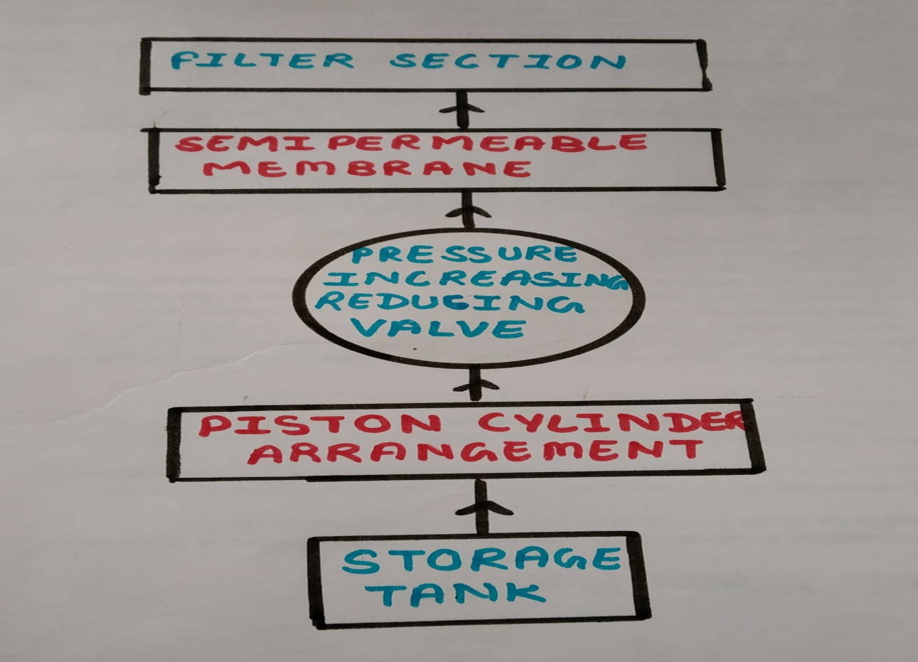
Figure 4.0
The block diagram shows a complete view of the final model:
- This system will drive by mechanical power which is based on Pascal Law.
- Water is suck by piston cylinder arrangement with the help of Bernoulli’s principle.
- By the piston arrangement water is going towards the semipermeable membrane.
- The controlling of pressure in the membrane by pressure increasing and reducing valve.
- Membrane stop the higher concentrated particle and this particle collect in the form of precipitate.
- Again this water is supply to the filter section where some harmful particle removes by the filter.
- This filter will consist of fine sand, charcoal, brick, filter paper etc.
5. REVERSE OSMOSIS
In osmosis water flows from higher concentration to lower concentration but in this technology we uses the process of reverse osmosis which means on application of pressure water flows from lower concentration to higher concentration.
5.1Semi permeable membrane
A semipermeable membrane is a polymer membrane which allows a certain ion or molecules to pass through them by diffusion. Semipermeable membrane is not same a selectively permeable membrane.
In semipermeable membrane, the particle when pass through it by size factor. In selectively permeable membrane size of particle is not factor.
One example of semipermeable is the layer water is present inside the egg.
Semipermeable membrane manufacture mainly for the desalination of water. The rate of passage of ions or molecules depends upon following factor:
i.Pressure of the molecules
ii. Concentration of the molecules
iii. Temperature of the molecules

In this phenomenon we use polyamide membrane which filters the salty water. Polyamide membrane rejects salt up to 98 percentages.
It can resists temperatureup to45 degree Celsius.
Feed pressure of water in semipermeable membrane varies from (145-400 psi).
Silica rejection percentage is of 96 percentages.
5.2FILTER:
The water which will come from the semipermeable membrane this water goes to the filter section. In the water many impurities present which will clean by the filter. Filter section also increase the taste of water because filter is remove the impurities. Many method for clean the water like-
i. Boiling
ii. Filter
iii. with the help of UV light
But we will use the filter in this system which is less costly and more effective than other method. Main purpose of using the filter method is removing the solid impurities and also removesthose impurities which are dangerous for the human body.Filter also removes the bacteria and microorganisms that produce disease.
This filter consist of sand, charcoal, gravel, napkin etc. by using these material we will filter the water and produce clean water. Arrangement of material will change when not get desired result.

Figure 5.2

6. Conclusion:
This system will more effective and less costly from other salt water purification system. This system does not require electricity. This system will free from pollution and also provide healthy exercise. This system will reduce the energy cost. This system will fully portable and easily move from one place to another place. This system will be too light from other salt water system

7. FUTURE SCOPE:
- When portable water is finished then by this project we can convert salty water into portable water.
- In disaster prone areas which is near the sea suffered from flood, earthquakes etc.
- In village where is no availability pure water and electric facilities.
- It can also use in house hold application where salt water present in a lot of amount.
- Also it can filter local source of water.
REFERENCES
1. GidwaniJayant,kesheorey Amit, Mishra Ratnesh, Lowanshi Rahul, nitesh lowanshi, “pedal powered water pumping and purification”.
2. Homemade water purifier
3.Water Filtration IV http://www.scienceinschool.org/2008/issue10/nextgeneration.
4. FUN SCIENCE: Filter Magic http://www.thefreelibrary.com/Fun+science%3A+filter+magic.-a0119071356.
5.Zoom Water Filter http://pbskids.org/zoom/activities/sci/waterfilter.html.
6. Basic Information about Pathogens and Indicators in Drinking Water http://water.epa.gov/drink/contaminants/index.cfm#Microorganisms.
7. Sanjay N.Havaldar†* , Altaf Somani ‡ , Anusha Pikle‡ , Yash Siriah‡ and Samiksha Patil‡ “Pedal Operated Water Filtration System (Mobifilt)”.
8. Curtis, V. And Cairncross (2003), S. Effect of Washing Hands with Soap on Diarrhoea Risk in the Community: A Systematic Review. Lancet Infectious Diseases 3, pp. 275– 281. Howard, G(2006).
9.Groundwater and Public Health, In: Schmoll O. et al. (eds). Protecting Groundwater for Health:Managing the Quality of Drinking-Water Sources, London, International Water Association Publishing, pp. 3−19.
10. Payment, P., Hunter, P. R. (2001), Endemic and Epidemic Infectious Intestinal Disease and Its Relationship to Drinking Water, In: Fewtrell L., Bartram J. (eds), Water Quality Guidelines, Standards and Health, London, International Water Association (IWA) Publishing, 61−88pp.
11.Garneau, C. McNamara, K. and Chung J. (2008), Peristaltic Pump Project,Unpublished Final Project Report, Team D, ME 340.4, 41pp.
12. B. Gonzalez ,S. Alzate, J. Cromartie ,K. Hernandez, Advisor: Dr. Andres Tremante (April 7, 2014), Bicycle Powered Water Filtration System, A B.S. Thesis prepared in partial fulfilment of the requirement for the Degree Of Bachelor Of Science In Mechanical Engineering, Florida International University
13. A. S. Akinwonmi, S. K. Adzimah, F. Oppong, Department of Mechanical Engineering, University of Mines andTechnology, Tarkwa, Ghana. 2012, Pedal Powered Centrifugal Pump Purified Water Supply System, Innovative Systems Design and Engineering ISSN 2222-1727 (Paper) ISSN 2222-2871 (Online) ,Vol 3, No.11 http://www.engineeringtoolbox.com/colebrook-equationd_1031.html http://www.engineeringtoolbox.com/dynamic-absolutekinematic-viscosity-d_412.html.
14. Wikipedia of Pascal law.
15. Wikipedia of Bernoulli’s theorem.

