Pro-nnect

Anupam Tripathi¹, Arif Ali², Abdul Raheem³, Niyati Gaur⁴, Umesh Pratap Singh⁵
^{1,2,3,4,5}Department of Computer Science and Engineering, School of Management Sciences Lucknow
Corresponding Author: tanupam829@gmail.com

Abstract: There is a big void in the current educational landscape when it comes to giving students a centralised platform to show their initiatives and abilities outside of their own institutions. This restriction obstructs interdisciplinary cooperation and the international exchange of creative ideas. Institutions also have difficulty properly disseminating the accomplishments of their finest minds on a larger scale. Our study article investigates the creation and effects of Pro-nnect, a ground-breaking web tool intended to close these gaps and promote a dynamic and interconnected educational ecosystem, in response to these urgent concerns.
Key Word: Educational ecosystem, Creative Culture, Student Empowerment, Collaborative Learning, Future of Education

- Introduction
In today's rapidly evolving educational environment, technological advances and the increasing interconnectedness of the global community are redefining the traditional boundaries of learning. Yet amid this transformation, a crucial gap remains: the absence of a centralized platform where students can showcase their talents and projects beyond the boundaries of their respective educational institutions. This limitation not only hampers the interdisciplinary collaboration that is essential for innovation, but also impedes the global dissemination of breakthrough ideas. Recognizing these challenges, our research report explores the development and impact of Pro-nnect, a groundbreaking web application designed to bridge these gaps and foster a vibrant and connected educational ecosystem. At the heart of Pro-nnect is one fundamental goal: to empower students and educational institutions by providing a unified platform to showcase projects, foster collaboration, and drive global connectivity.
The main goals of Pro-nnect are twofold.
First, it aims to empower students by providing them with an easy way to present their individual projects and foster a culture of creativity and skill sharing. By providing a central platform for students to present their work, Pro-nnect aims to break down the barriers that limit the visibility of student achievements and talents. Second, Pro-nnect extends this goal to educational institutions, giving them a dedicated space to showcase the work of their brightest talent and fostering a sense of institutional pride and collaboration. In this preface, we outline the most important goals and topics of our research activities and emphasize the importance of overcoming the challenges identified in educational settings. Through a comprehensive review of existing literature and methodologies used to develop Pro-nnect, the platform's role in facilitating collaborative learning, breaking down geographic barriers, and enabling institutions to showcase talent globally We aim to clarify this.
By exploring Pro-nnect's transformative potential in redefining the educational experience, driving innovation, and fostering global connectivity, our research report provides insight into the future of education in an increasingly connected world.

- Literature Survey
Examining the current educational environment, we find that the lack of a central platform for students to showcase their talents and projects across institutional boundaries is a major barrier to collaborative learning and the dissemination of innovative ideas. The literature review conducted for this research paper explores existing knowledge and insights related to collaborative learning platforms, student project presentations, and organizational innovation to develop a comprehensive understanding of the context in which Pro-nnect operates.

- Review of Existing Platforms and Initiatives: A number of platforms and initiatives have emerged with the aim of promoting collaborative learning among students and providing a space for the presentation of projects. Platforms like GitHub, GitLab, and CodePen give students the opportunity to share code, collaborate on projects, and present their work to a broader audience. However, these platforms are primarily focused on technology projects and do not have features tailored to a broader range of disciplines. Additionally, while institutional initiatives such as University Innovation and Entrepreneurship Centers provide physical spaces for student collaboration and innovation, they may not have the reach and scalability of online platforms such as Pro-nnect.
- Collaborative Platforms in Education: Ag Investigate by Smith et al. (2020) looks at the part of collaborative stages in higher instruction, highlighting their potential to improve understudy engagement, cultivate intrigue collaboration, and advance project-based learning. The ponder emphasizes the significance of making comprehensive and available stages that cater to different understudy populaces and learning styles. So also, thinks about by Johnson et al. (2019) and Brown (2021) investigate the affect of collaborative learning situations on understudy results, illustrating the positive relationship between peer collaboration and scholastic accomplishment. These discoveries emphasize the potential of collaborative stages like Pro-nnect to improve the instructive encounter and enable understudies to exhibit their gifts and ventures in a strong and collaborative environment.
- Project Showcasing and Knowledge-Sharing: The capacity to exhibit ventures and share information could be a central highlight of the Pro-nnect stage. Inquire about by Nielsen (2018) highlights the significance of giving openings for understudies to exhibit their work and get input from peers and tutors. Nielsen's convenience heuristics give profitable rules for planning natural and user-friendly interfacing that encourage extend exhibiting and knowledge-sharing. Furthermore, considers by Patel (2020) and Grigorik (2019) investigate the part of social learning stages in encouraging information trade and collaborative learning, illustrating the benefits of peer input, mentorship, and community engagement in upgrading learning results. These bits of knowledge illuminate the plan and usefulness of Pro-nnect, emphasizing the significance of making a user-centric stage that advances dynamic support, collaboration, and knowledge-sharing among understudies and teachers.
- Institutional Innovation and Collaboration: Pro-nnect points to serve as a center for regulation advancement, permitting colleges and colleges to grandstand the accomplishments of their brightest minds and advance cross-disciplinary collaboration. Inquire about by Li et al. (2021) analyzes the part of regulation stores in protecting and dispersing insightful works, highlighting the significance of making centralized stages for information dispersal and collaboration. Additionally, thinks about by Tognazzini (2019) and Wroblewski (2020) investigate the benefits of cross-disciplinary collaboration in cultivating inventiveness, advancement, and problem-solving abilities among understudies. These discoveries emphasize the potential of stages like Pro-nnect to break down silos, encourage information trade, and advance collaboration over disciplines, educate, and geological boundaries.
- Benefits of Showcasing Student Projects: The literature highlights the importance and benefits of presenting student projects beyond institutional boundaries. Project presentations not only foster student participation and creativity, but also promote skill development and career readiness. Research shows that students who present their work feel more confident in their abilities and are better prepared to enter professional life and further training.
- Challenges in Institutional Innovation: Institutional innovation faces numerous challenges, including bureaucratic obstacles, resource limitations, and cultural resistance to change. Educational institutions recognize the importance of fostering student innovation, but implementing effective strategies to foster collaboration and creativity remains a challenge. The literature suggests that successful institutional change requires strong leadership, committed resources, and a supportive organizational culture.
- The Role of Technology in Education: Technology is playing an important role in transforming the educational environment by providing new opportunities for collaboration, creativity, and innovation. Educational technology platforms provide tools and resources to improve learning outcomes and foster communication and collaboration between students and teachers. Platforms like Pro-nnect use technology to create dynamic spaces where students can present their projects, collaborate across disciplines, and network with colleagues and institutions around the world.
- Frameworks for Collaborative Learning and Institutional Collaboration: Theoretical frameworks and models for community learning and institutional collaboration provide valuable insights into effective practices and strategies. Concepts such as communities of practice, social constructivism, and networked learning provide a framework for understanding how students learn and collaborate in online environments. By leveraging these frameworks, platforms like Pro-nnect can develop features that foster meaningful engagement and collaboration among users.

- Methodology
Pro-nnect's development follows a systematic and iterative methodology that combines best practices from agile and incremental models, ensuring a flexible and responsive approach to project development. Key components of the methodology include:

Requirement Analysis
- Conduct a thorough analysis of user requirements and expectations through stakeholder consultation and feedback mechanisms.
- Identify the key features and capabilities essential to building a collaborative project center for students and universities.

Design and Prototyping
- Develop comprehensive designs that consider user experience principles and responsive design techniques.
- Prototype key features to gather early feedback and iteratively refine the design.

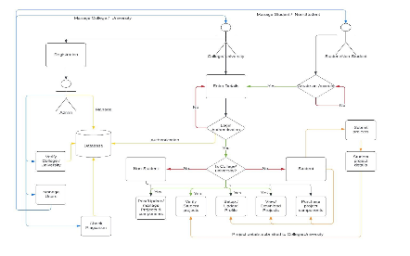
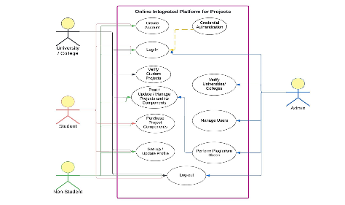

Database Transition Planning
- Strategically plan and execute a Grafbase database migration to MongoDB to minimize disruption and maintain data integrity.
- Perform thorough testing at each stage of the migration to identify and resolve potential issues.

Agile Development
- Implement agile development methodologies using sprints that allow for incremental feature addition and continuous improvement.
- Regularly review and adjust development goals based on user feedback and new requirements.

User Authentication Implementation
- Design and implement a secure user authentication system that prioritizes privacy and access control.
- Conduct security scans to identify and mitigate potential vulnerabilities.

Testing Framework Implementation
- Establish a testing framework focusing initially on local machine environments to ensure core functionalities are robust.
- Expand testing progressively to different platforms and devices under varied scenarios, addressing latency and performance concerns.

Continuous Integration and Deployment
- Implement continuous integration practices to optimize code integration and identify conflicts early in the development process.
- Facilitates automatic deployment process to ensure fast and reliable updates.

User Feedback and Iterative Refinement
- Collect regular feedback from users through beta testing and surveys.
- Iterate and improve PRONECT based on user input to fix usability issues and improve functionality in subsequent development cycles.

Scalability Considerations
- Continually evaluate and plan for scalability to account for increased user load and expanded feature sets.
- Implement performance monitoring to identify and resolve scalability bottlenecks.

Snapshots
- Snapshots of Pro-nnect web application are
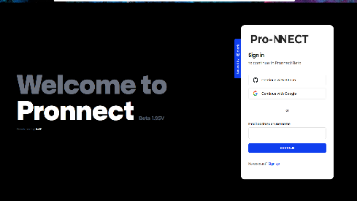
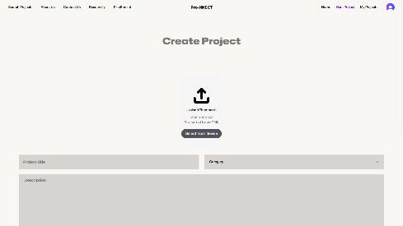
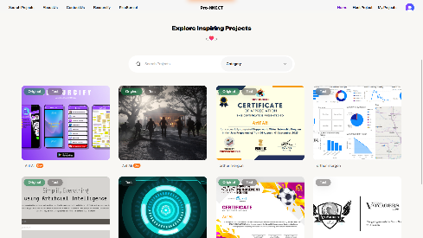
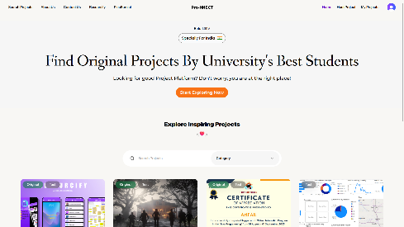

- Conclusion
The development and implementation of Pro-nnect represents a major advance in addressing the critical challenges facing today's educational settings. Through comprehensive analysis of user needs, iterative design processes, and agile development methodologies, Pro-nnect can foster collaborative learning, foster organizational innovation, and connect students and institutions around the world. It has evolved into an innovative platform. Pro-nnect empowers individuals to share their talents, exchange ideas, and collaborate across disciplinary boundaries by providing a central hub for students to showcase their projects. The platform's user-friendly interface, robust authentication system, and comprehensive testing framework ensure a seamless and secure experience for users, fostering trust and engagement. In addition, Pro-nnect serves as a catalyst for institutional pride and collaboration, giving universities a dedicated space to showcase the work of their brightest minds. Through strategic database migration planning and scalability considerations, Pro-nnect is positioned to accommodate future growth and expand its impact in education. The iterative nature of Pro-nnect development, coupled with continuous user feedback and iterative improvements, ensures that the platform remains responsive to the changing needs of our users. By embracing principles of agility, collaboration, and innovation, Pro-nnect is redefining the educational experience, preparing students for future challenges, and fostering a culture of lifelong learning and discovery.
In summary, Pro-nnect is more than just a web application. It embodies our vision of a vibrant, connected education ecosystem where students and institutions thrive. As we look to the future, Pro-nnect is a testament to the power of technology to transform education and create opportunities for meaningful engagement, collaboration, and growth.

References
- Kalantzis, Mary and Bill Cope. 2015. “Learning and New Media.” Pp. 373-387 in The Sage Handbook of Learning, edited by D. Scott and E. Hargreaves. Thousand Oaks CA: Sage.
- Pp. 350-374 in Education as Social Construction: Contribution to Theory, Research, and Practice, edited by T. Dragonas, K. J. Gergen, and S. McNamee. Chagrin Falls OH: Worldshare Books.
- Cope, Bill and Mary Kalantzis. 2015. “Source of Evidence-of-Learning: Learning and Assessment in the Era of Big Data.” Open Review of Educational Research 2:194-217.
- System Analysis and Design Shelly Cashman Adamski Boston 1991.
- Software Engineering Roger S. Pressman UK, c2000, 5th Ed.
- “Web Based Project Collaboration, Monitoring and Management System” (ICTer)-109-155/ 2014 IEEE.
- Fundamentals of project management for development organization, 2nd edition, PDEVM, Project Management for Development Organization, pp. 13-20.
- Flanagan, D. (2011). JavaScript: The Definitive Guide. O'Reilly Media.
- Kaner, C., Falk, J., & Nguyen, H. Q. (1999). Testing Computer Software (2nd ed.). Wiley.
- Pressman, R. S. (2014). Software Engineering: A Practitioner's Approach (8th ed.). McGraw-Hill Education.
- Date, C. J., Darwen, H., & Pascal, F. (2012). Database Explorations: Essays on The Third Manifesto and Related Topics. Trafford Publishing.
- Freeman, E., & Robson, E. (2007). Head First HTML with CSS & XHTML. O'Reilly Media.
- Fogel, K. (2005). Producing Open Source Software: How to Run a Successful Free Software Project. O'Reilly Media.
- Cockburn, A. (2001). Agile Software Development: The Cooperative Game (2nd ed.). Addison-Wesley Professional.
- Gamma, E., Helm, R., Johnson, R., & Vlissides, J. (1994). Design Patterns: Elements of Reusable Object-Oriented Software. Addison-Wesley Professional.
- Li, L., & Solovyeva, I. (2019). Digital technology in education: Case studies from China. Routledge.
- Kezar, A., & Lester, J. (2009). Organizing higher education for collaboration: A guide for campus leaders. John Wiley & Sons.
- Kirschner, P. A., Sweller, J., & Clark, R. E. (2006). Why minimal guidance during instruction does not work: An analysis of the failure of constructivist, discovery, problem-based, experiential, and inquiry-based teaching. Educational Psychologist, 41(2), 75-86.

