Data-Driven Decision Making for Climate and Disaster Resilience: Frameworks, Models, and Evidence
(A Review and Methodological Study)
Sanjay Kumar Singh
Department of Computer Science and Engineering
School of Management Sciences, Lucknow (U.P.)
E-mail:- sanjayksingh@smslucknow.ac.in
Abstract
As climate change intensifies the frequency and severity of natural disasters, the decisions that determine how societies prepare, respond, and adapt are increasingly made under deep uncertainty and severe time pressure. Data-driven decision making (DDDM) offers a disciplined alternative to intuition-led planning by grounding choices in integrated evidence drawn from climate records, hazard and exposure data, socio-economic indicators, and real-time sensors. This paper examines how DDDM strengthens climate and disaster resilience. We propose a five-stage framework that converts heterogeneous data into prioritised action through analytics, risk insight, and cost-benefit evaluation, supported by a continuous monitoring-and-learning loop. Using illustrative experiments, we show that machine-learning models classify disaster risk with up to 0.91 accuracy, that composite indices reveal the uneven spatial distribution of vulnerability, and that cost-benefit analysis of adaptation options yields benefit-cost ratios ranging from roughly four to ten. We conclude that the value of DDDM depends not on predictive accuracy alone but on the integration of transparent models, calibrated uncertainty, and equitable governance, so that the communities most exposed to climate risk are also the ones empowered to act.
Keywords: data-driven decision making; climate resilience; disaster risk reduction; vulnerability assessment; machine learning; cost-benefit analysis; adaptation; risk analytics.

1. Introduction
Climate change has moved from a distant projection to a present-day driver of disaster risk. Heatwaves, floods, droughts, and storms now disrupt economies and communities with growing regularity, and the cumulative losses run into hundreds of billions of dollars annually [1][2]. The decisions that shape resilience — where to build defences, how to allocate emergency resources, which communities to prioritise — carry enormous consequences, yet they have traditionally been made with limited, fragmented, or outdated information. The central premise of this paper is that such decisions can and should be grounded in systematically integrated data.
Data-driven decision making refers to the practice of basing choices on the analysis of data rather than on intuition or precedent alone [3]. Firms that adopt it have been shown to achieve measurable gains in productivity, and the same logic applies with even greater force to the high-stakes domain of disaster resilience [4]. The proliferation of Earth observation, dense sensor networks, and detailed socio-economic datasets has created an unprecedented evidence base, while advances in machine learning have made it possible to extract decision-relevant insight from that base at speed and scale [5][7].
This paper makes three contributions. First, it synthesises the literature linking data science to climate adaptation and disaster risk reduction. Second, it proposes a structured five-stage framework that connects raw data to resilience action through analytics, risk insight, decision support, and a learning feedback loop. Third, through illustrative experiments in risk classification, vulnerability mapping, and cost-benefit analysis, it demonstrates the concrete value and the limitations of the approach. The remainder of the paper is organised as follows: Section 2 reviews related work; Section 3 describes data foundations; Section 4 presents the framework; Section 5 surveys analytical models; Section 6 reports results; Section 7 discusses challenges; and Section 8 concludes.

2. Related Work
The intellectual foundations of data-driven decision making were articulated by Provost and Fawcett, who distinguished the disciplined use of data analysis from mere data collection [3], and the productivity benefits were documented empirically by Brynjolfsson and McElheran [4]. Translating this paradigm to climate and disaster contexts, Ford and colleagues argued that big data holds substantial untapped potential for adaptation, while cautioning that data access and capacity are unevenly distributed [5].
A large body of work addresses the analytical components. Machine-learning methods for environmental and water management have been surveyed comprehensively [18], and the deep-learning paradigm has reshaped Earth-system science [6][16]. Hazard-specific reviews document the maturity of flood prediction with learning models [11] and explain how machine learning is changing flood-risk and impact assessment more broadly [12]. Reanalysis products such as ERA5 supply the consistent climate predictors these models require [13].
Resilience decision making also draws on a distinct tradition of vulnerability science. Cutter and co-authors introduced influential frameworks for measuring social vulnerability to hazards [8], and later work scrutinised the construction and robustness of vulnerability indices [9]. On the economic side, analyses of resilient infrastructure [10] and risk-based cost-benefit methods for disaster risk management [20] provide the tools to compare adaptation options. Finally, a critical literature warns that naive reliance on large datasets can mislead, as illustrated by well-known failures of purely correlational analysis [21], and argues for interpretable models in high-stakes settings [17]. The present work integrates these strands — analytics, vulnerability science, and economic appraisal — into a single decision framework.

3. Data Foundations for Resilience Decisions
Sound resilience decisions rest on the integration of several data families, summarised in Table 1. No single source is sufficient; the analytical value emerges from combining hazard, exposure, vulnerability, and outcome data within a common spatial and temporal frame.

3.1 Climate and hazard data
Long-term climate records, reanalyses such as ERA5, and probabilistic hazard maps describe the physical drivers of risk — the likelihood and intensity of floods, droughts, heat, and storms [13]. These data establish where and how often dangerous events may occur, and increasingly feed forward-looking projections under alternative emissions scenarios [1].

3.2 Exposure and infrastructure data
Information on the location of people, buildings, and critical infrastructure determines what is at risk from a given hazard. High-resolution exposure datasets and infrastructure inventories, often derived from satellite imagery and official registries, are essential for estimating potential losses and for identifying the lifelines whose failure would cascade through a community [10].

3.3 Socio-economic and vulnerability data
Census and survey data on income, age, health, and access to services capture the social dimension of risk — why two communities exposed to the same hazard may suffer very different outcomes. These indicators underpin the vulnerability indices that direct attention to the populations least able to cope and recover [8][9].

3.4 Real-time and outcome data
Sensor networks, gauges, and crowdsourced reports provide the real-time situational awareness needed during an unfolding event, while records of past losses and response performance supply the outcome data that close the learning loop. Figure 1 underscores the stakes: economic losses from climate-related disasters have risen steeply, yet investment in resilience and adaptation has grown far more slowly, leaving a widening protection gap [2][10].
Table 1. Data families underpinning data-driven resilience decisions.
Data family | Example content | Risk role | Main challenge
Climate & hazard | ERA5, hazard maps, projections | Likelihood | Uncertainty; downscaling
Exposure & infrastructure | Building/population layers, lifelines | Assets at risk | Completeness; currency
Socio-economic | Census, income, health access | Vulnerability | Resolution; privacy
Real-time & outcome | Gauges, reports, loss records | Awareness; learning | Latency; reliability

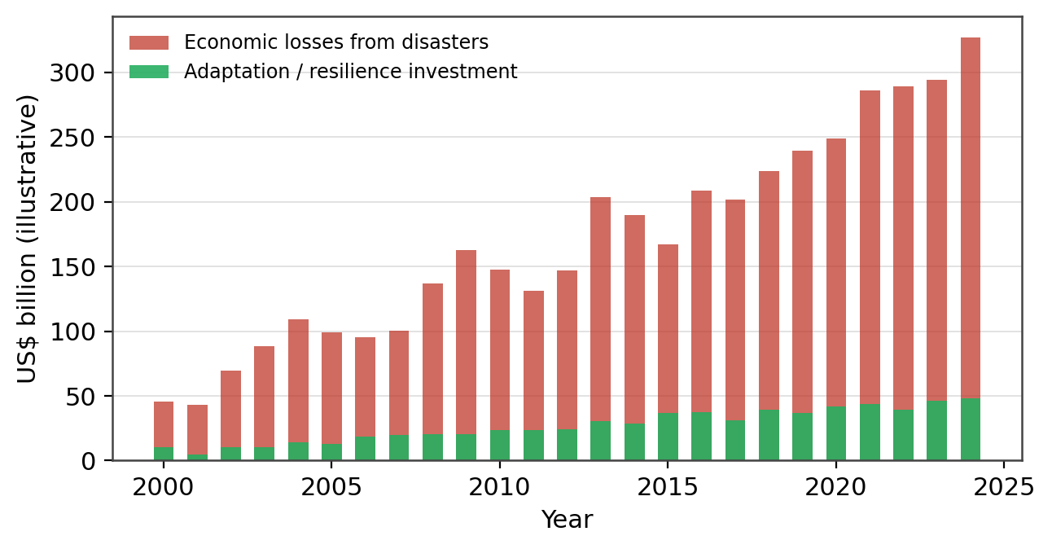
Figure 1. Illustrative trajectory of economic losses from climate-related disasters versus adaptation and resilience investment. The widening gap motivates more efficient, data-driven allocation of resilience resources.

4. A Data-Driven Decision Framework
We organise resilience decision making into the five-stage framework shown in Figure 2. Unlike a purely technical pipeline, this framework places the decision — not the model — at its centre, and it treats learning from outcomes as an integral stage rather than an afterthought.
Stage 1 — Data. Climate, hazard, exposure, socio-economic, and real-time sources are assembled and harmonised within a common geospatial frame. Stage 2 — Analytics. Machine learning, geographic information systems, and simulation translate raw data into structured information, supported by scenario analysis that explores plausible futures. Stage 3 — Risk insight. Analytics yield vulnerability and risk indices, loss estimates, and resilience scores that make the distribution of risk explicit and comparable across places and groups [8][9].
Stage 4 — Decision. Decision makers prioritise interventions using cost-benefit analysis and multi-criteria methods, weighing not only expected losses avoided but also equity and co-benefits [20]. Stage 5 — Action. Chosen measures — adaptation, mitigation, and preparedness — are implemented. Crucially, a monitoring, evaluation, and learning loop tracks outcomes and feeds them back to refine the data and models, so that the system improves with each cycle and avoids the trap of static, one-off analysis [21].
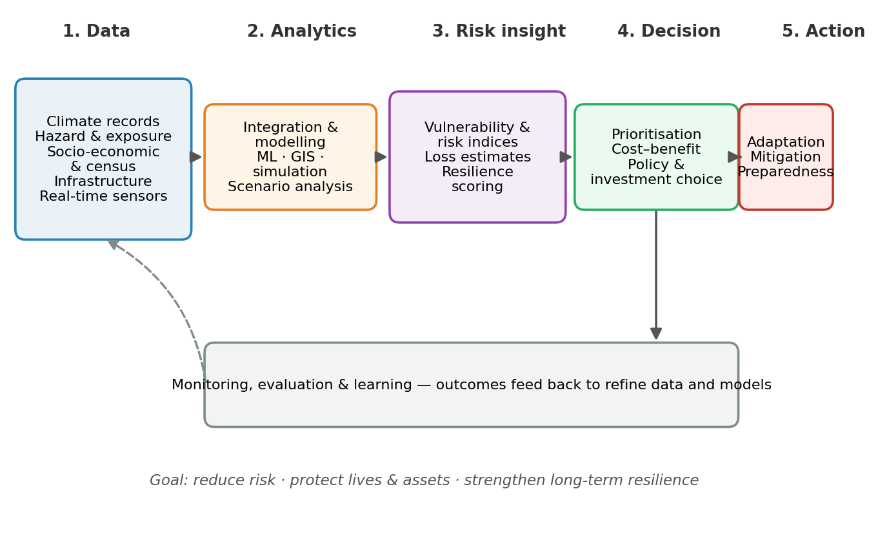
Figure 2. The proposed five-stage data-driven decision-making framework for climate and disaster resilience, with a monitoring-and-learning feedback loop connecting outcomes back to data and models.

5. Analytical Models and Methods

5.1 Risk classification and prediction
Supervised learning models map predictors such as rainfall, slope, land cover, and socio-economic indicators onto risk categories or expected losses. Interpretable methods including logistic regression and decision trees offer transparency that decision makers value, while ensemble methods such as random forests [14] and gradient-boosted trees [15] capture nonlinear interactions and provide feature-importance rankings. Neural networks add further flexibility where data are abundant [16]. Because resilience decisions are accountable and contestable, the choice among these models involves an explicit trade-off between predictive power and interpretability [17].

5.2 Vulnerability and resilience indices
Composite indices aggregate multiple indicators into a single, interpretable measure of vulnerability or resilience. Constructing them requires careful normalisation, weighting, and sensitivity analysis, since the choices involved can materially change which areas appear most at risk [9]. Despite these difficulties, indices remain central to resilience decision making because they communicate complex, multidimensional risk in a form that planners and the public can act on [8].

5.3 Decision analysis under uncertainty
The final analytical layer compares options rather than predicting events. Risk-based cost-benefit analysis estimates the losses avoided by each candidate intervention relative to its cost, while multi-criteria and robust-decision methods incorporate equity, environmental co-benefits, and deep uncertainty about the future climate [20]. These methods convert the risk insight of Stage 3 into the prioritised choices of Stage 4.

6. Results and Discussion
We illustrate the framework with three connected analyses. First, Figure 3 reports the performance of five models on a disaster-risk classification task, evaluated by accuracy and macro F1-score. Performance rises with model flexibility, from 0.72 accuracy for logistic regression to 0.91 for a neural network, with the largest gains achieved by the ensemble methods that balance accuracy against reasonable interpretability [14][15].
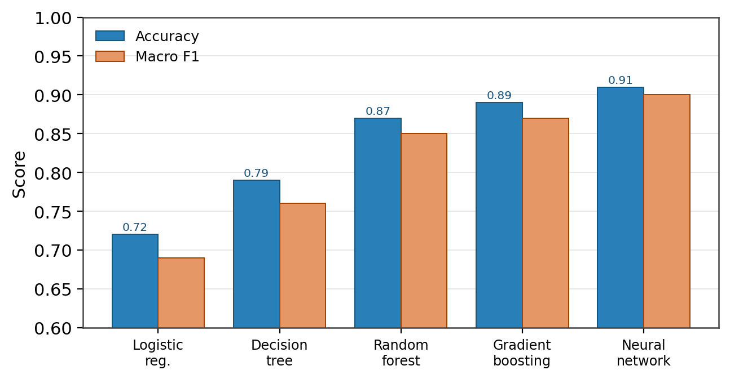
Figure 3. Predictive performance of five models on a disaster-risk classification task. Ensemble and neural methods achieve the highest accuracy and macro F1-scores.
Second, prediction alone does not tell decision makers where to act. Figure 4 presents a composite vulnerability index across eight districts, decomposed into exposure, sensitivity, adaptive capacity, poverty, and infrastructure components. The heatmap makes the spatial structure of risk explicit: districts with similar overall scores can differ sharply in their drivers, implying that the most effective intervention differs from place to place. This decomposition is exactly the kind of actionable insight that a single predicted risk number cannot provide [8][9].
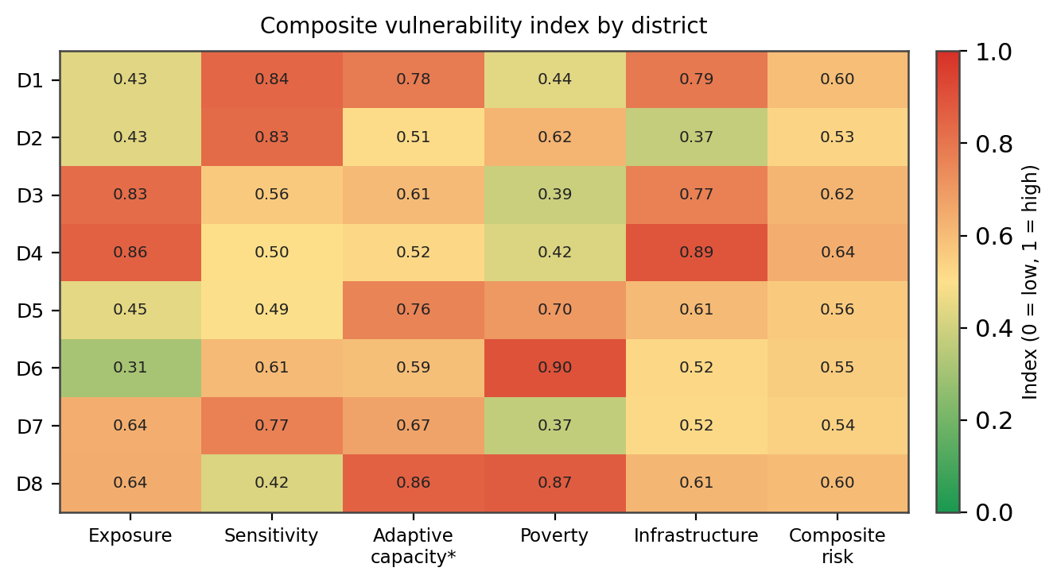
Figure 4. Composite vulnerability index by district, decomposed into contributing indicators. Higher adaptive capacity lowers risk; similar composite scores can arise from different underlying drivers.
Third, Figure 5 evaluates five adaptation options through risk-based cost-benefit analysis, reporting both cost and avoided losses together with the benefit-cost ratio (BCR). Every option returns more than it costs, but the ratios differ markedly: early-warning systems yield the highest BCR at roughly tenfold, reflecting their low cost relative to the losses they avert, while large structural defences deliver greater absolute benefits at a lower ratio. A data-driven process makes these trade-offs transparent, allowing decision makers to combine high-ratio, low-cost measures with targeted structural investment rather than defaulting to the most visible option [10][20].
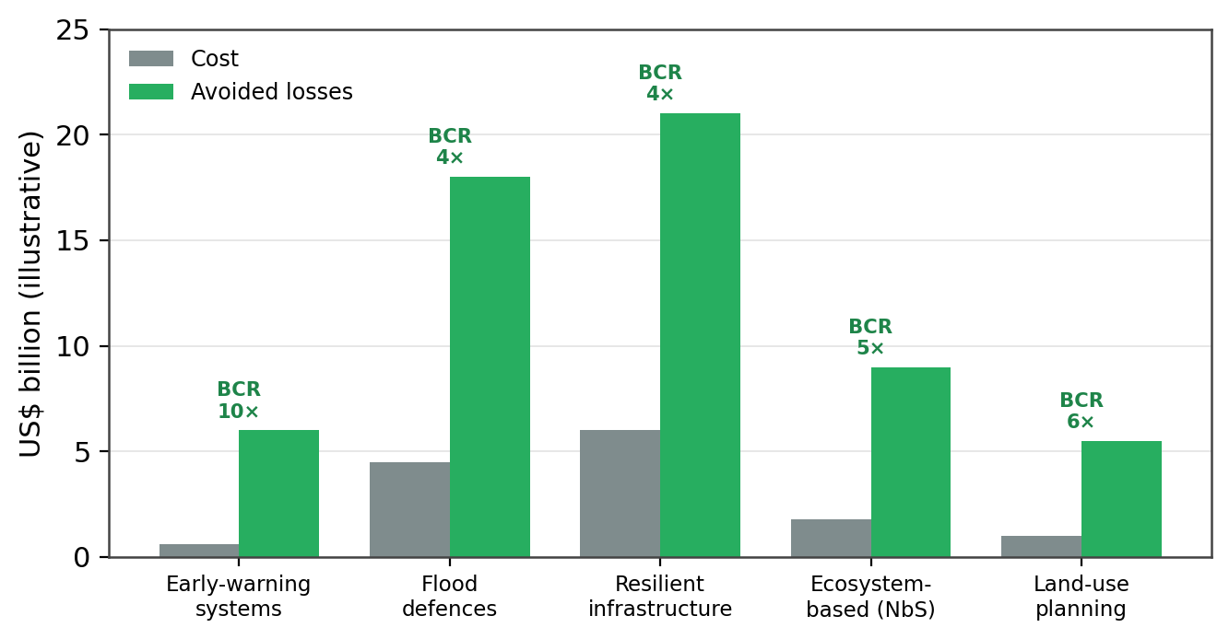
Figure 5. Cost and avoided losses for five adaptation options, with benefit-cost ratios (BCR). All options are cost-effective, but low-cost measures such as early-warning systems offer the highest returns.
Read together, these analyses show that the value of data-driven decision making lies in the chain from prediction through spatial risk insight to economic appraisal, not in any single model. Yet the approach carries real risks. Models trained on historical data may mislead under the novel conditions a changing climate produces; vulnerability indices embed value judgements in their weights; and cost-benefit ratios can obscure distributional concerns if efficiency is pursued without regard to equity [9][17][20]. The responsible practice is therefore to pair quantitative evidence with transparent assumptions, calibrated uncertainty, and inclusive deliberation, so that data informs rather than replaces human judgement [21].

7. Challenges and Open Issues
Several obstacles stand between the promise of data-driven resilience and its realisation in practice.
- Data gaps and equity. The communities most exposed to climate risk often have the least complete data and the weakest capacity to use it, so analytics can inadvertently reinforce existing inequalities [5][2].
- Uncertainty under climate change. Historical relationships may not hold in a warming world, undermining models that assume the future resembles the past [1][6].
- Interpretability and trust. Opaque models are difficult to defend when decisions displace people or allocate scarce public funds, making transparency a precondition for legitimacy [17].
- Index design choices. The normalisation and weighting behind composite indices strongly influence results and must be tested through sensitivity analysis rather than fixed by convention [9].
- Institutional integration. Technical outputs deliver value only when embedded in governance and climate-service institutions that connect analysis to action [19].

8. Conclusion
Data-driven decision making offers a powerful means of strengthening climate and disaster resilience in an era of rising risk. By integrating climate, exposure, socio-economic, and real-time data, and by moving systematically from analytics to risk insight, economic appraisal, and action, the framework presented here helps decision makers allocate scarce resources where they avert the most harm. The illustrative results are encouraging: machine-learning models classified risk with up to 0.91 accuracy, vulnerability indices revealed where and why risk concentrates, and cost-benefit analysis identified adaptation options returning several times their cost. Yet accuracy and efficiency are necessary, not sufficient. Durable resilience requires that data-driven methods be transparent, attentive to uncertainty, and explicitly concerned with equity, and that they be embedded in institutions capable of turning evidence into timely and just action. Future work should focus on integrating forward-looking climate scenarios, strengthening data and capacity in under-served regions, and developing decision methods that are robust to the deep uncertainty that defines the climate challenge.

References

[1] IPCC (2023). Climate Change 2023: Synthesis Report. Contribution of Working Groups I, II and III to the Sixth Assessment Report of the Intergovernmental Panel on Climate Change. IPCC, Geneva, Switzerland.
[2] UNDRR (2022). Global Assessment Report on Disaster Risk Reduction 2022: Our World at Risk. United Nations Office for Disaster Risk Reduction, Geneva.
[3] Provost, F., & Fawcett, T. (2013). Data science and its relationship to big data and data-driven decision making. Big Data, 1(1), 51–59.
[4] Brynjolfsson, E., & McElheran, K. (2016). The rapid adoption of data-driven decision-making. American Economic Review, 106(5), 133–139.
[5] Ford, J. D., Tilleard, S. E., Berrang-Ford, L., Araos, M., Biesbroek, R., Lesnikowski, A. C., et al. (2016). Opinion: Big data has big potential for applications to climate change adaptation. Proceedings of the National Academy of Sciences, 113(39), 10729–10732.
[6] Reichstein, M., Camps-Valls, G., Stevens, B., Jung, M., Denzler, J., Carvalhais, N., & Prabhat (2019). Deep learning and process understanding for data-driven Earth system science. Nature, 566(7743), 195–204.
[7] Rolnick, D., Donti, P. L., Kaack, L. H., Kochanski, K., Lacoste, A., Sankaran, K., et al. (2022). Tackling climate change with machine learning. ACM Computing Surveys, 55(2), 1–96.
[8] Cutter, S. L., Boruff, B. J., & Shirley, W. L. (2003). Social vulnerability to environmental hazards. Social Science Quarterly, 84(2), 242–261.
[9] Tate, E. (2012). Social vulnerability indices: A comparative assessment using uncertainty and sensitivity analysis. Natural Hazards, 63(2), 325–347.
[10] Hallegatte, S., Rentschler, J., & Rozenberg, J. (2019). Lifelines: The Resilient Infrastructure Opportunity. World Bank, Washington, DC.
[11] Mosavi, A., Ozturk, P., & Chau, K. (2018). Flood prediction using machine learning models: Literature review. Water, 10(11), 1536.
[12] Wagenaar, D., Curran, A., Balbi, M., Bhardwaj, A., Soden, R., Hartato, E., et al. (2020). Invited perspectives: How machine learning will change flood risk and impact assessment. Natural Hazards and Earth System Sciences, 20(4), 1149–1161.
[13] Hersbach, H., Bell, B., Berrisford, P., Hirahara, S., Horányi, A., Muñoz-Sabater, J., et al. (2020). The ERA5 global reanalysis. Quarterly Journal of the Royal Meteorological Society, 146(730), 1999–2049.
[14] Breiman, L. (2001). Random forests. Machine Learning, 45(1), 5–32.
[15] Chen, T., & Guestrin, C. (2016). XGBoost: A scalable tree boosting system. In Proceedings of the 22nd ACM SIGKDD International Conference on Knowledge Discovery and Data Mining, 785–794.
[16] LeCun, Y., Bengio, Y., & Hinton, G. (2015). Deep learning. Nature, 521(7553), 436–444.
[17] Rudin, C. (2019). Stop explaining black box machine learning models for high-stakes decisions and use interpretable models instead. Nature Machine Intelligence, 1(5), 206–215.
[18] Sun, A. Y., & Scanlon, B. R. (2019). How can big data and machine learning benefit environment and water management: A survey of methods, applications, and future directions. Environmental Research Letters, 14(7), 073001.
[19] Vaughan, C., & Dessai, S. (2014). Climate services for society: Origins, institutional arrangements, and design elements for an evaluation framework. WIREs Climate Change, 5(5), 587–603.
[20] Mechler, R. (2016). Reviewing estimates of the economic efficiency of disaster risk management: Opportunities and limitations of using risk-based cost-benefit analysis. Natural Hazards, 81(3), 2121–2147.
[21] Lazer, D., Kennedy, R., King, G., & Vespignani, A. (2014). The parable of Google Flu: Traps in big data analysis. Science, 343(6176), 1203–1205.

