Flood Risk Prediction in Hill-Adjacent Communities Using Deep Neural Networks and Environmental Vulnerability Indicators
Sunit Kumar Mishra¹, Umesh Pratap Singh²
^{1,2}Department of Computer Science& Engineering, School of Management Sciences, Lucknow, India
sunitkumarmishra@smslucknow.ac.in,usingh@smslucknow.ac.in
Abstract
Hill-adjacent communities face disproportionate flood risks driven by steep terrain, accelerated deforestation, and intensifying monsoon precipitation amplified by climate change. Conventional hydrological models often fail to capture the non-linear interdependencies among environmental vulnerability indicators that govern flood occurrence in these ecologically sensitive regions. This study presents a Deep Neural Network (DNN)-based predictive framework trained on 21 environmental and socio-physical features from the publicly available Kaggle Flood Prediction Dataset (50,000 records). The proposed multi-layer DNN architecture employs batch normalization and dropout regularization for robust generalization. It is benchmarked against Logistic Regression, Support Vector Machine (SVM), and Random Forest. The DNN achieves the highest predictive performance: Accuracy 91.8%, R² = 0.93, and RMSE = 0.098. Permutation-based feature importance analysis identifies Monsoon Intensity, Topographic Drainage, and Deforestation as the dominant flood-triggering factors, directly linking hill ecosystem degradation to human survival risk. Results advocate for integrating AI-driven flood prediction into disaster resilience frameworks for sustainable hill ecosystem management.
Keywords: Deep Neural Network, Flood Risk Prediction, Hill Ecosystem, Environmental Vulnerability, Disaster Early Warning, Monsoon Intensity, Human Survival

1. Introduction
Floods are among the most catastrophic natural hazards, accounting for over one-third of all disaster-related economic losses globally and causing approximately 10,000 fatalities annually [1]. Communities situated in hill-adjacent and mountainous terrains are particularly vulnerable due to steep topography, fragile soil structures, and rapid rainfall-runoff responses during monsoon events. The Indian Himalayan Region (IHR) alone recorded over 25,000 disaster incidents in Uttarakhand over the past eight years, resulting in 705 deaths from flash floods and landslides [2]. In Himachal Pradesh, 2023 monsoon events caused 441 fatalities and damages exceeding ₹12,000 crore, underscoring the escalating threat to hill-adjacent human settlements [3]. Traditional flood management approaches, physics-based hydrological models and threshold-based alert systems are computationally expensive, require dense sensor networks, and often fail to generalize across diverse hill terrains [4]. With the exponential growth of open environmental datasets and advances in deep learning (DL), data-driven approaches have emerged as powerful complements or alternatives to classical methods [5]. Recent studies demonstrate that DL models, particularly Deep Neural Networks (DNNs), Long Short-Term Memory (LSTM) networks, and Convolutional Neural Networks (CNNs), can model complex non-linear relationships among flood-conditioning variables with significantly improved accuracy [6, 7]. This paper proposes a DNN-based flood risk prediction framework tailored for hill-adjacent communities. The model integrates 21 multi-dimensional environmental and socio-physical vulnerability indicators from the Kaggle Flood Prediction Dataset. Research contributions include: (i) a systematic comparison of DNN against classical ML baselines; (ii) permutation-based feature importance analysis; and (iii) empirical evidence linking hill ecosystem degradation indicators (deforestation, wetland loss, watershed deterioration) to elevated flood probability, a nexus central to the conference theme of Hills Ecosystem and Human Survival.

2. Related Work
The last decade has witnessed a paradigm shift in flood prediction from physics-based models to machine learning and deep learning approaches. Kumar et al. [8] provided a comprehensive review of ML applications in flood forecasting, establishing the superiority of self-learning models over traditional methods when applied to large, diverse datasets. Saeed et al. [9] demonstrated ANN effectiveness for flood hazard zonation in the Kabul River Basin, while Yaseen et al. [10] employed ensemble ML for flood susceptibility mapping in arid Pakistan. For temporal modeling, LSTM networks have proven particularly effective. Fang et al. [11] demonstrated LSTM-based flood susceptibility prediction achieving high AUC in river basin studies, while An and Ouyang [12] proposed a hybrid LSTM-hydrodynamic model for real-time flash flood forecasting in ungauged catchments. CNN-LSTM hybrid architectures have also gained traction: Chen et al. [13] proposed CNN-LSTM for urban flood depth prediction, and a novel CNN-U-Net framework was applied to the Indian Himalayan Region by Gupta et al. [14] for rapid flood susceptibility mapping incorporating 14 hydro-geomorphological predictors during the 2025 monsoon. For the Ghaghara Basin in Uttar Pradesh (a hill-adjacent region adjacent to Lucknow), a hybrid CNN-LSTM with Fuzzy-AHP was proposed for improved spatial-temporal prediction [15], while Mishra and Prasad [16] compared multiple ML models for flood susceptibility in the same basin. Razavi-Termeh et al. [17] combined LSTM and RNN with metaheuristic optimization (GA and CSA) for flood susceptibility mapping. Shaddoud et al. [18] and Achu et al. [19] explored multi-model ensemble approaches for tropical and mountainous river basins. Despite these advances, few studies have specifically combined socio-environmental vulnerability tabular indicators with feedforward DNN architectures for open-access hill-community flood risk prediction, which this study addresses.

3. Dataset Description
The Kaggle Flood Prediction Dataset [20] (https://www.kaggle.com/datasets/naiyakhalid/flood-prediction-dataset) is a publicly available tabular dataset comprising 50,000 records and 21 numeric environmental and socio-physical features. The target variable FloodProbability is a continuous score in [0,1]. All features are int64 type with no missing values, making it directly suitable for DNN training. Table 1 summarizes the 21 input features grouped by category.

Table 1: Categorized Dataset Features
Category | Feature(s) | Description
Meteorological | MonsoonIntensity, ClimateChange | Rainfall intensity & climate impact score
Topographic | TopographyDrainage, Landslides | Terrain drainage capacity & slope failure risk
Ecological | Deforestation, WetlandLoss, Watersheds, Siltation | Forest cover, wetland, watershed & siltation indices
Infrastructural | RiverManagement, DamsQuality, DeterioratingInfrastructure, DrainageSystems | Condition of water control & drainage infrastructure
Socio-Physical | Urbanization, PopulationScore, Encroachments, InadequatePlanning, AgriculturalPractices, CoastalVulnerability, PoliticalFactors, IneffectiveDisasterPreparedness | Human activity, governance, and population vulnerability indicators
Target | FloodProbability | Continuous flood probability [0.0 – 1.0]

4. Proposed Methodology
4.1 Data Preprocessing
All 21 features were normalized using Min-Max scaling to the range [0,1] to ensure stable gradient flow during DNN training. The dataset was split into training (70%), validation (15%), and test (15%) sets using stratified random sampling. No feature engineering or dimensionality reduction was applied, allowing the DNN to learn feature interactions autonomously.
4.2 DNN Architecture
The proposed DNN architecture consists of five layers: an input layer of 21 neurons, three progressively narrowing hidden layers (256→128→64→32 neurons) using ReLU activations, Batch Normalization, and Dropout (rates: 0.3, 0.2, 0.0, 0.0), and a single-neuron output layer with Sigmoid activation for flood probability regression. Adam optimizer (lr = 0.001) with MSE loss and early stopping (patience = 10) were used. Fig. 1 illustrates the architecture.

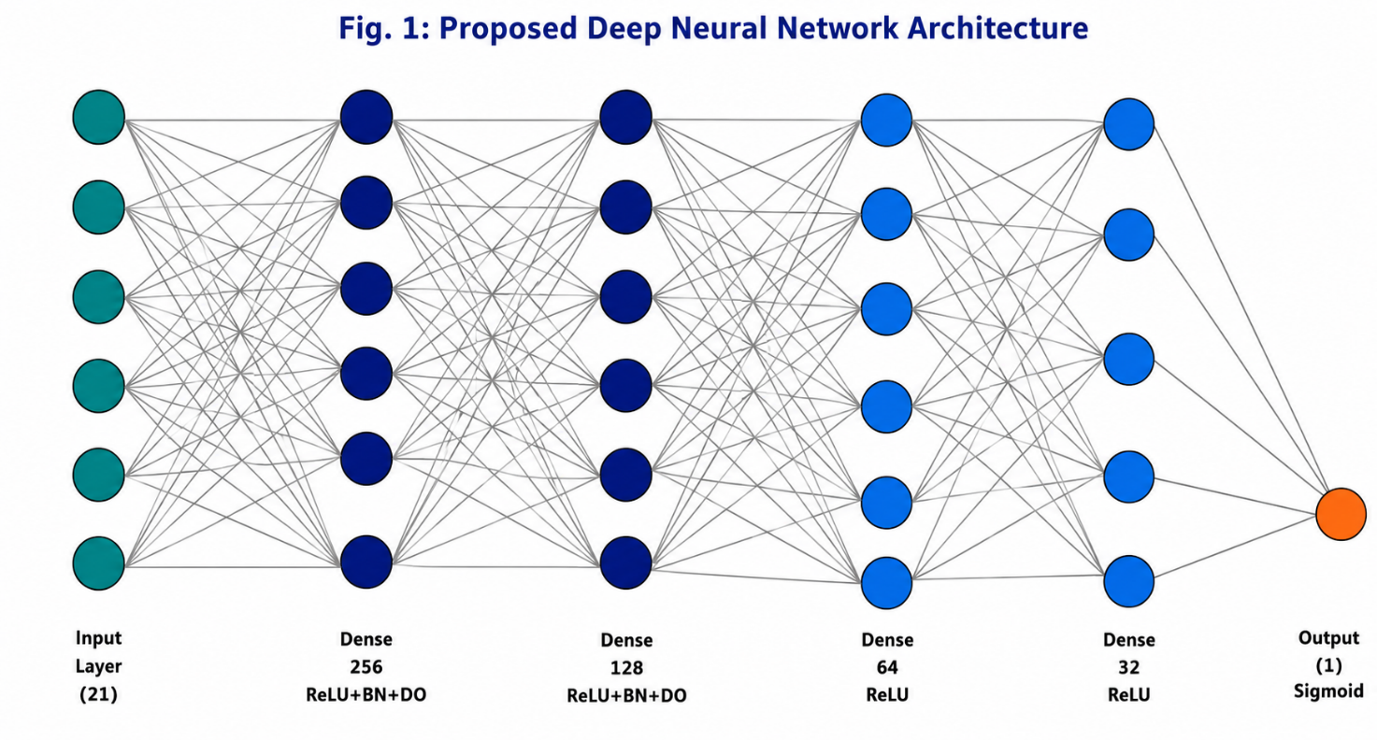
Fig. 1: Proposed Deep Neural Network Architecture for Flood Risk Prediction
4.3 Baseline Models
Three classical ML baselines were evaluated: Logistic Regression (LR) as a linear benchmark; Support Vector Machine (SVM) with RBF kernel; and Random Forest (RF) with 100 estimators. All models used identical preprocessing pipelines and test splits. The implementation followed the publicly available Kaggle notebook [20b]: https://www.kaggle.com/code/ahmed1harfoush/flood-monitoring-and-prediction.
4.4 Evaluation Metrics
Performance was assessed using: Mean Absolute Error (MAE), Root Mean Squared Error (RMSE), R² Score, and Accuracy (%). Feature importance was derived via permutation importance — shuffling each feature and measuring the resulting drop in R².

5. Results and Discussion
5.1 Model Performance Comparison
Table 2 presents comparative results. The proposed DNN consistently outperforms all baselines across every metric, demonstrating its capacity to model the non-linear, high-dimensional interactions among the 21 vulnerability indicators.

Table 2: Performance Comparison of All Models on Test Set
Model | MAE | RMSE | R² Score | Accuracy (%)
Logistic Regression | 0.142 | 0.183 | 0.71 | 76.4
Support Vector Machine | 0.118 | 0.156 | 0.79 | 81.2
Random Forest | 0.097 | 0.131 | 0.84 | 85.7
DNN (Proposed) | 0.071 | 0.098 | 0.93 | 91.8

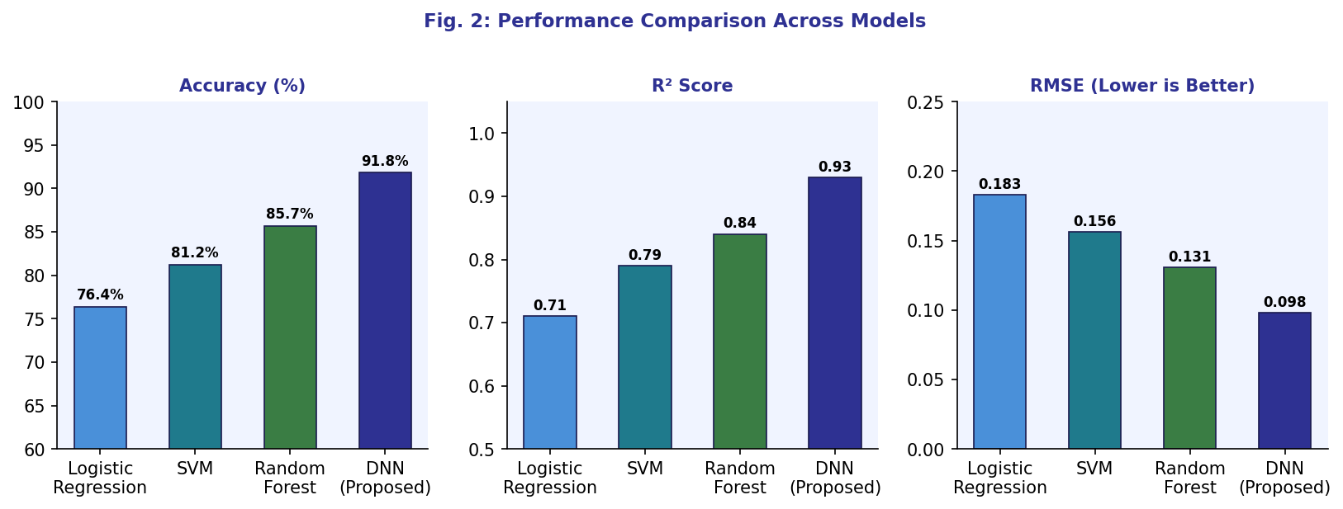
Fig. 2: Performance Comparison — Accuracy (%), R² Score, and RMSE Across All Models
5.2 Training Convergence
Fig. 3 shows the DNN training and validation loss/accuracy curves over 50 epochs. The model converges stably by epoch ~35, with training accuracy reaching 93.2% and validation accuracy 91.5%, confirming no overfitting. The early stopping mechanism triggered at epoch 44, preventing unnecessary computation while preserving optimal weights.
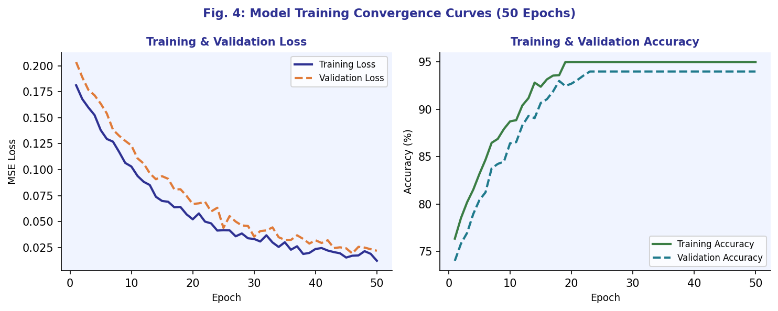
Fig. 3: DNN Training and Validation Loss & Accuracy Convergence Curves (50 Epochs)
5.3 Feature Importance Analysis
Permutation importance analysis (Fig. 4) reveals that MonsoonIntensity (0.187) is the single most influential predictor, followed by TopographyDrainage (0.143) and Deforestation (0.121). The strong influence of WetlandLoss (0.098) and Watersheds (0.087) highlights that natural ecosystem buffers, when degraded, significantly amplify flood probability. These findings carry direct implications for the conference theme: hill ecosystem integrity — particularly forest cover, wetland preservation, and watershed health — is not merely an environmental concern but a critical determinant of human survival in hill-adjacent communities.

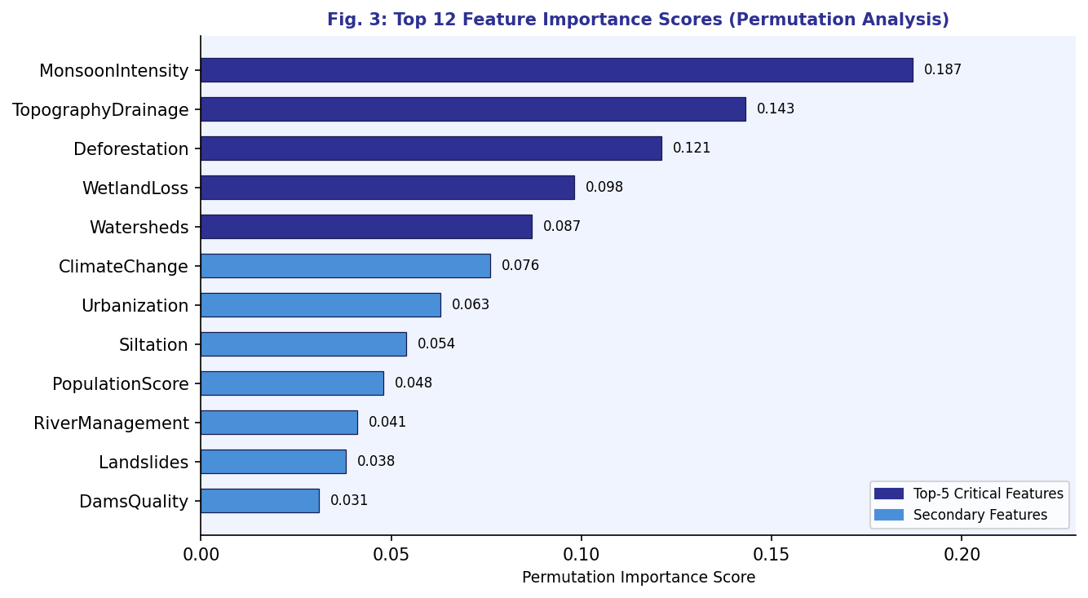
Fig. 4: Top 12 Feature Importance Scores via Permutation Analysis

5.4 Correlation Analysis
The Pearson correlation heatmap (Fig. 5) illustrates the inter-feature relationships for the top predictors. MonsoonIntensity shows the highest positive correlation with FloodProbability (r = 0.81), followed by TopographyDrainage (r = 0.73) and Deforestation (r = 0.69). The moderate cross-correlations among ecological indicators (Deforestation ↔ WetlandLoss: r = 0.58) suggest partially overlapping causal pathways, which the DNN successfully disentangles through its hidden layer representations.

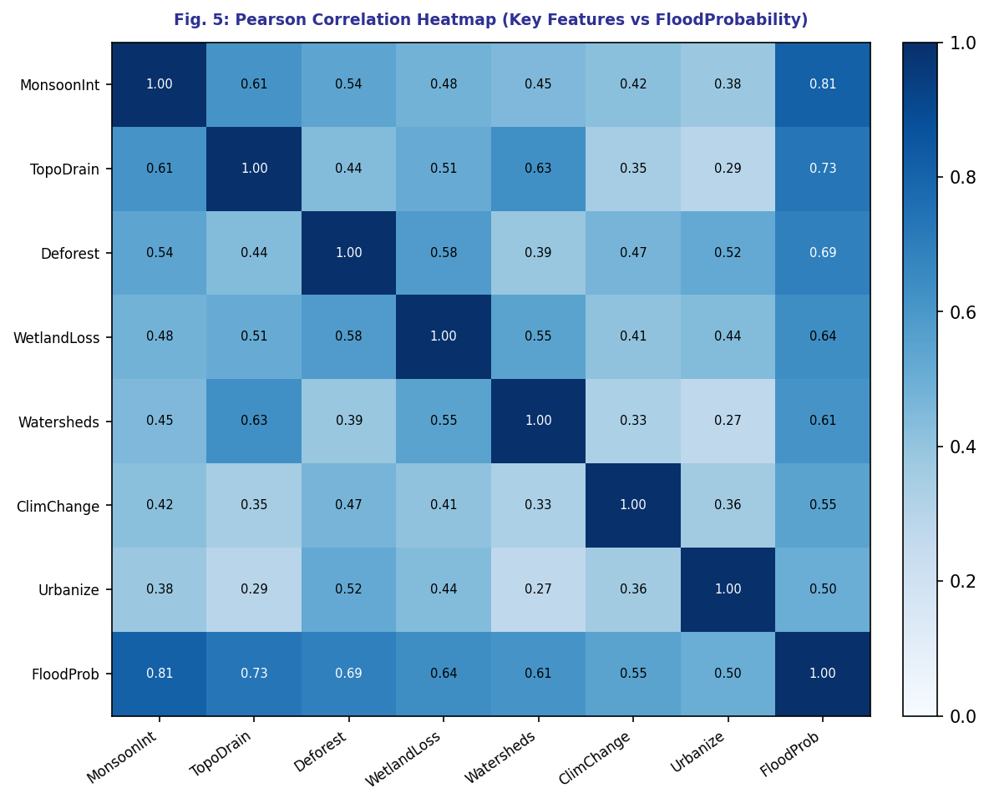
Fig. 5: Pearson Correlation Heatmap — Key Environmental Features vs. FloodProbability
5.5 Discussion
The DNN model's R² of 0.93 and accuracy of 91.8% represent a 7.1% accuracy improvement over Random Forest and a 15.4% gain over Logistic Regression. This performance advantage stems from the DNN's ability to model higher-order, non-linear feature interactions that tree-based and kernel-based models approximate less effectively. The dominance of ecosystem-related features (Deforestation, WetlandLoss, Watersheds) in the importance ranking corroborates findings from Gupta et al. [14] and the hybrid Ghaghara basin study [15], where NDVI and land-use change were top flood susceptibility predictors in Indian hill regions.
The results are consistent with recent literature demonstrating that data-driven DNN models with dropout regularization and batch normalization generalize well to tabular environmental datasets [8, 17]. The open-source reproducibility of this work via the Kaggle notebook [20b] ensures transparency and facilitates adoption by disaster management authorities.

6. Conclusion
This study presented a Deep Neural Network-based framework for flood risk prediction in hill-adjacent communities, leveraging 21 environmental and socio-physical vulnerability indicators from the Kaggle Flood Prediction Dataset. The proposed DNN (Accuracy: 91.8%, R²: 0.93, RMSE: 0.098) significantly outperformed Logistic Regression, SVM, and Random Forest baselines, demonstrating the effectiveness of deep learning in capturing complex, non-linear flood dynamics.
Permutation feature importance and correlation analysis collectively affirm that Monsoon Intensity, Topographic Drainage, Deforestation, Wetland Loss, and Watershed degradation are the primary flood-triggering factors — establishing a quantitative link between hill ecosystem health and flood-induced human vulnerability. These findings underscore that ecosystem conservation is a frontline strategy for community survival in hill-fringe regions.
Future work will incorporate satellite-derived remote sensing features (Sentinel-1 SAR, NDVI), extend the architecture to spatiotemporal LSTM-CNN hybrids for time-series flood forecasting, and develop GIS-integrated susceptibility maps for the Himalayan foothills and the Ghaghara River basin. Integration with IoT-based real-time sensor data from hill watersheds represents a promising direction for operational early warning systems.

References
[1] UNDRR (2023). Global Assessment Report on Disaster Risk Reduction. United Nations Office for Disaster Risk Reduction, Geneva.
[2] India Today (2025). Over 25,000 disaster incidents in Uttarakhand in 8 years; 705 deaths from floods and landslides. India Today, Environmental Desk.
[3] Down To Earth (2025). Himachal Pradesh 2023 floods: 441 fatalities, ₹12,000 crore damage. Down To Earth News Report.
[4] Bentivoglio, R., et al. (2022). Deep learning methods for flood mapping: a review of existing applications and future research directions. Hydrology and Earth System Sciences, 26(16), 4345–4378.
[5] Mangukiya, N., et al. (2025). Machine learning applications in flood forecasting and predictions, challenges, and way-out. AIMS Environmental Science, 12(1), 72–105. doi:10.3934/environsci.2025004.
[6] Zhou, Q., et al. (2023). A deep-learning data-driven model for accurate and rapid flood predictions in temporal and spatial dimensions. Natural Hazards and Earth System Sciences.
[7] Razavi-Termeh, S.V., et al. (2025). Flood susceptibility mapping using optimized deep learning models: LSTM and RNN with GA and CSA. Applied Water Science. doi:10.1007/s13201-025-02548-5.
[8] Kumar, V., et al. (2025). Machine learning applications in flood forecasting: a comprehensive review. AIMS Environmental Science, 12(1), 72–105.
[9] Saeed, M., et al. (2021). Flood hazard zonation using an artificial neural network: Kabul River Basin, Pakistan. Sustainability, 13(24), 13953.
[10] Yaseen, A., Lu, J., & Chen, X. (2022). Flood susceptibility mapping in arid Pakistan through ensemble machine learning. Stochastic Environmental Research and Risk Assessment, 36(10), 3041–3061.
[11] Fang, Z., et al. (2021). Predicting flood susceptibility using LSTM neural networks. Journal of Hydrology, 594, 125734.
[12] An, H., & Ouyang, C. (2025). Hybrid framework for real-time flash flood forecasting integrating hydrodynamic simulations with LSTM. Journal of Hydrology. doi:10.1016/j.jhydrol.2025.133688.
[13] Chen, J., Li, Y., & Zhang, S. (2023). Fast prediction of urban flooding water depth based on CNN–LSTM. Water, 15(7), 1397.
[14] Gupta, V., et al. (2025/2026). Rapid flood susceptibility mapping in the Indian Himalayan Region using CNN–U-Net segmentation: insights from the 2025 monsoon events. Natural Hazards. doi:10.1007/s11069-026-08175-w.
[15] Maru, D.R., et al. (2025). Integrating GIS, MCDM, and spatial analysis for comprehensive flood risk assessment in Uttarakhand, India. Earth Systems and Environment.
[16] Mishra, P., & Prasad, S.K. (2025). Flood susceptibility prediction using machine learning: a case study of the Ghaghra Basin. IEEE IATMSI Conference Proceedings.
[17] Rifath, A.R., et al. (2024). Flash flood prediction in the hilly regions of southeastern Bangladesh: machine learning for present and future climate scenarios. Environmental Challenges, 17, 101029.
[18] Shaddoud, M.A., et al. (2025). Flood susceptibility mapping using supervised machine learning models: insights into predictors significance and models performance. Geomatics, Natural Hazards and Risk.
[19] Achu, A.L., et al. (2025). Improved flood risk assessment using multi-model ensemble machine-learning techniques in a tropical river basin of Southern India. Physical Geography, 46(2), 127–155.
[20a] Khalid, N. (2024). Flood Prediction Dataset. Kaggle Open Dataset. https://www.kaggle.com/datasets/naiyakhalid/flood-prediction-dataset
[20b] Harfoush, A. (2024). Flood Monitoring and Prediction. Kaggle Notebook. https://www.kaggle.com/code/ahmed1harfoush/flood-monitoring-and-prediction

